224g1a05a6 (CSE) M.SREENIVAS

# EXPERIMENT-1

CREATE PARTS TABLE

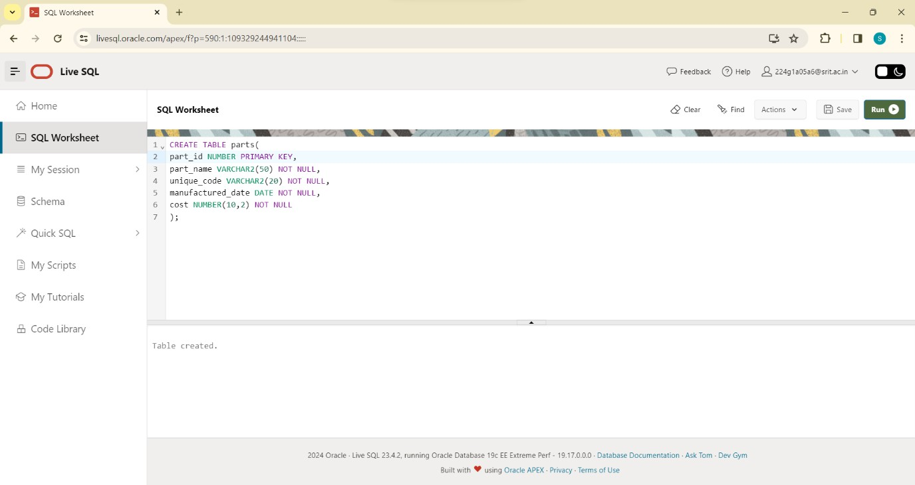

DESC PARTS:

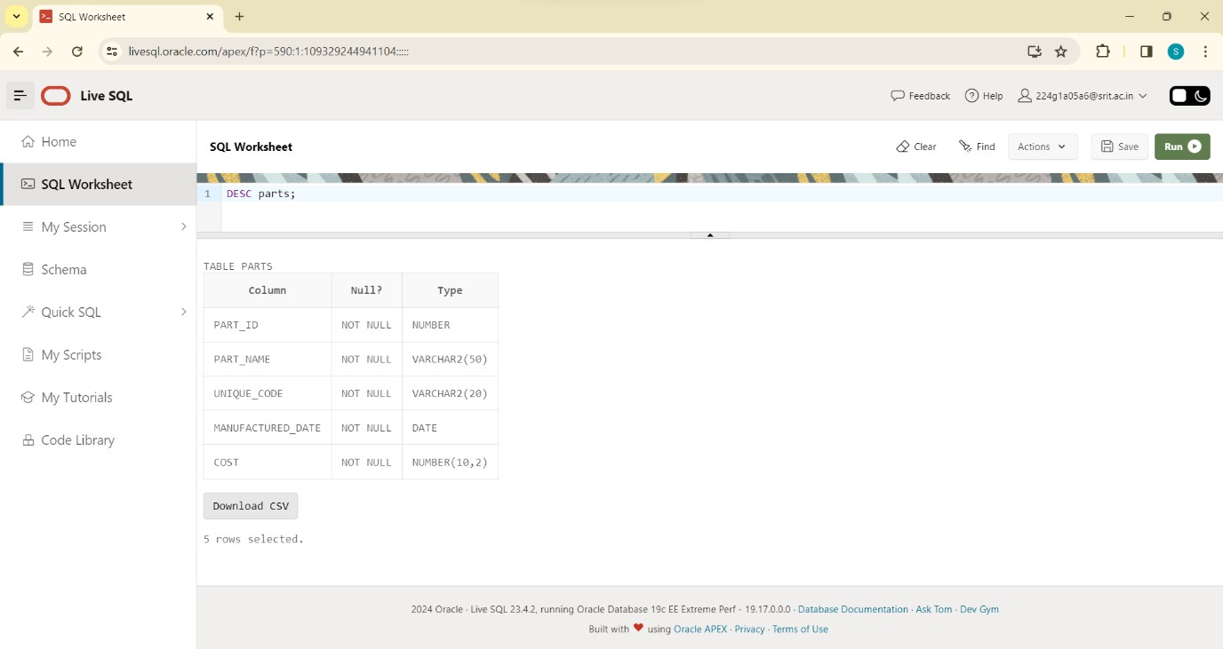

ALTER TABLE PARTS BY ADDING QUANTITY :

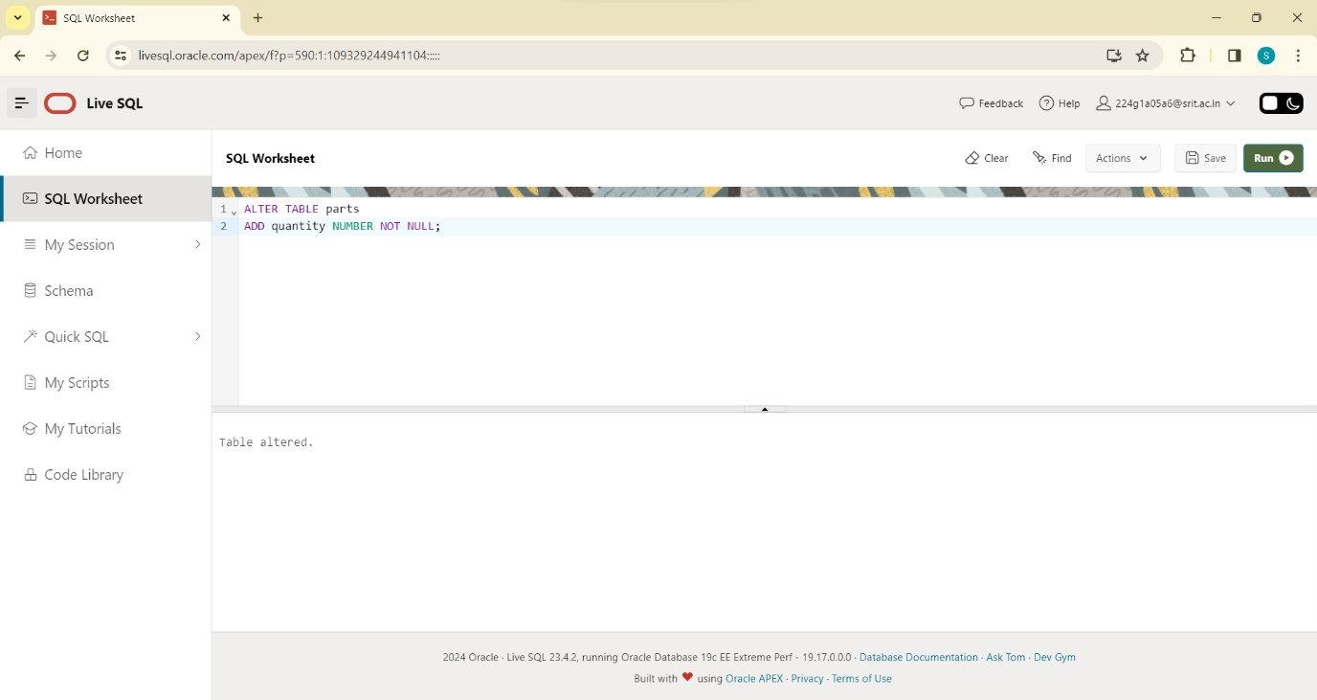

ALTER TABLE PARTS BY MODIFYING PART_NAME VARCHAR2(50) TO VARCHAR2(30):

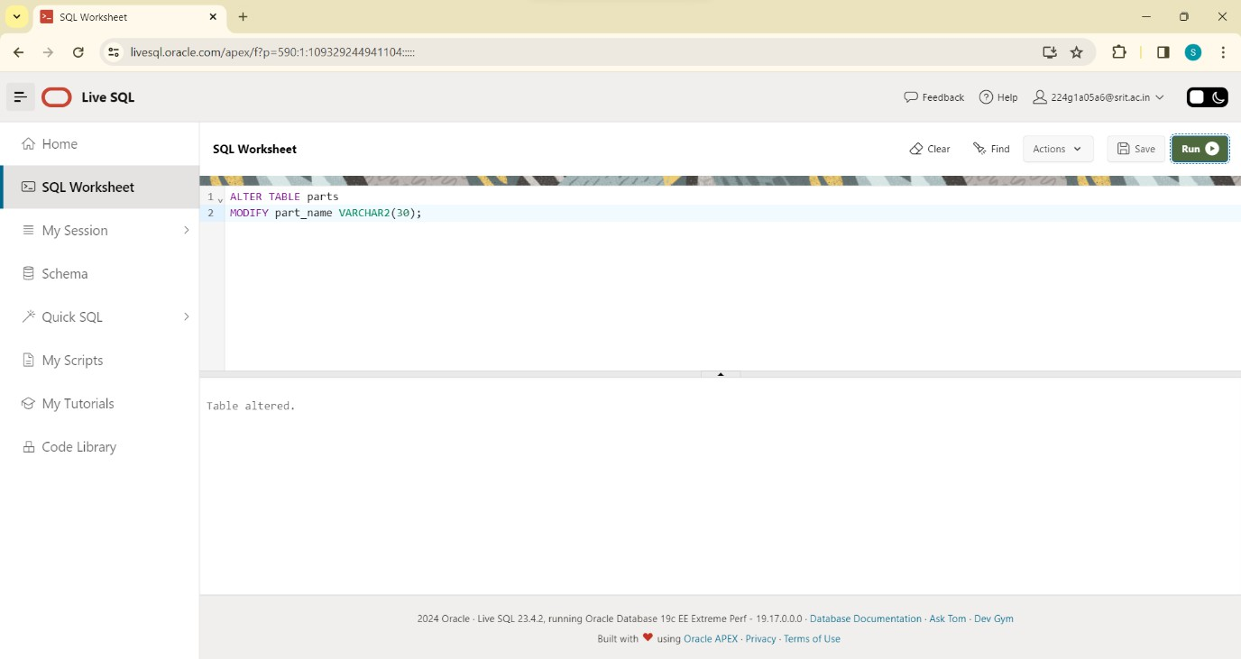

DESC PARTS AFTER MODIFYING:

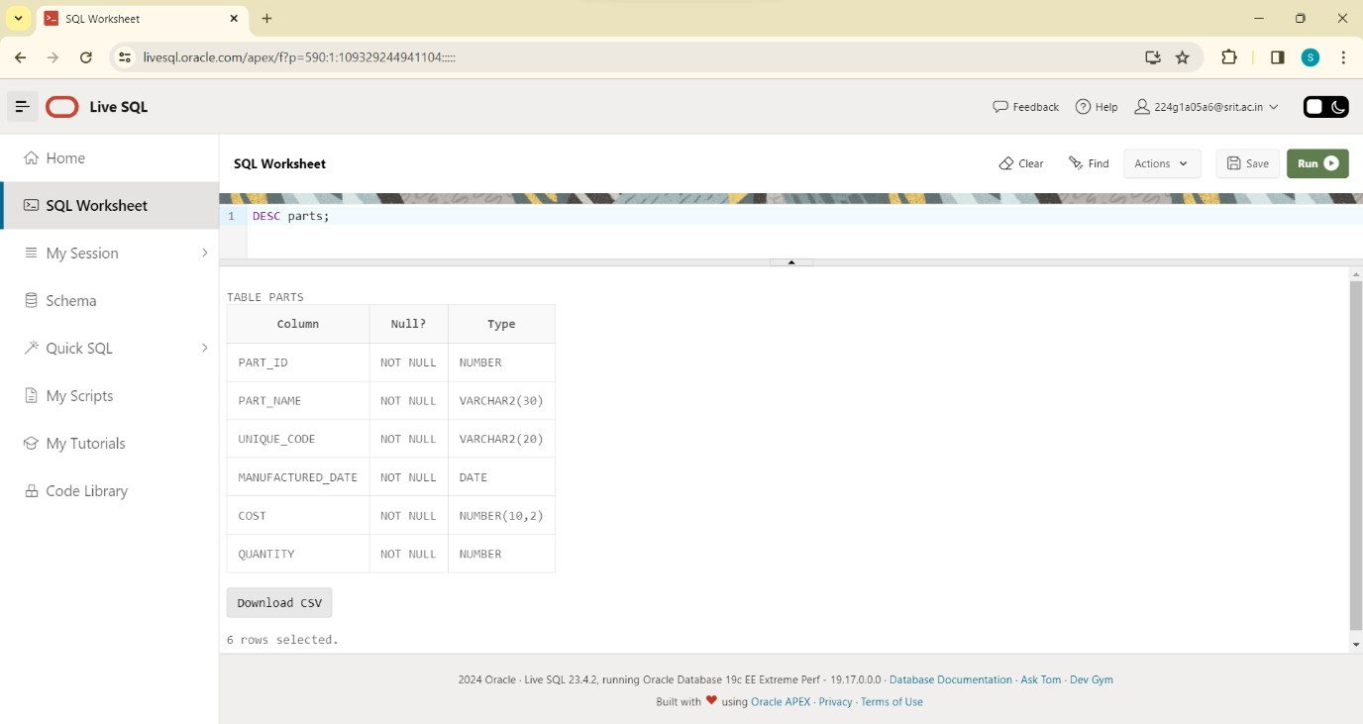

ALTER TABLE PARTS DROP COLUMN MANUFACTURED_DATE:

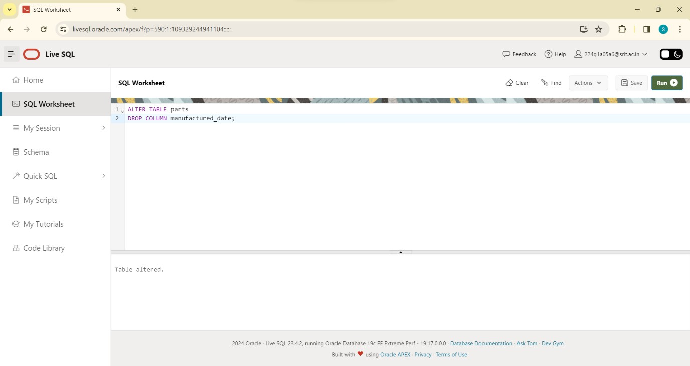

DESC PARTS AFTER DROPING MANUFACTURED_DATE:

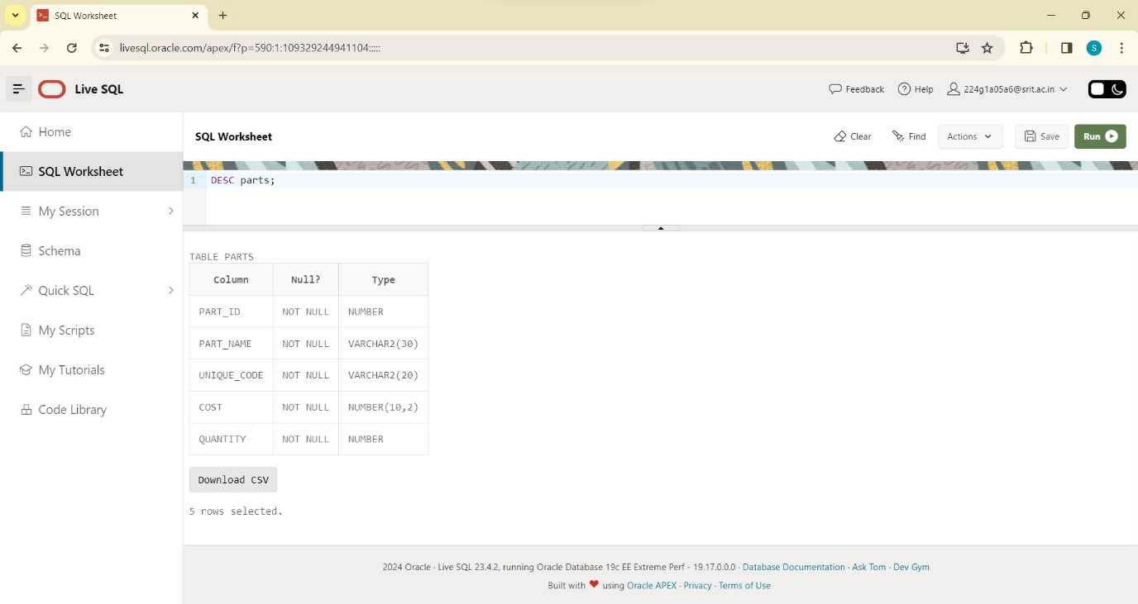

CREATE BOATS TABLE :

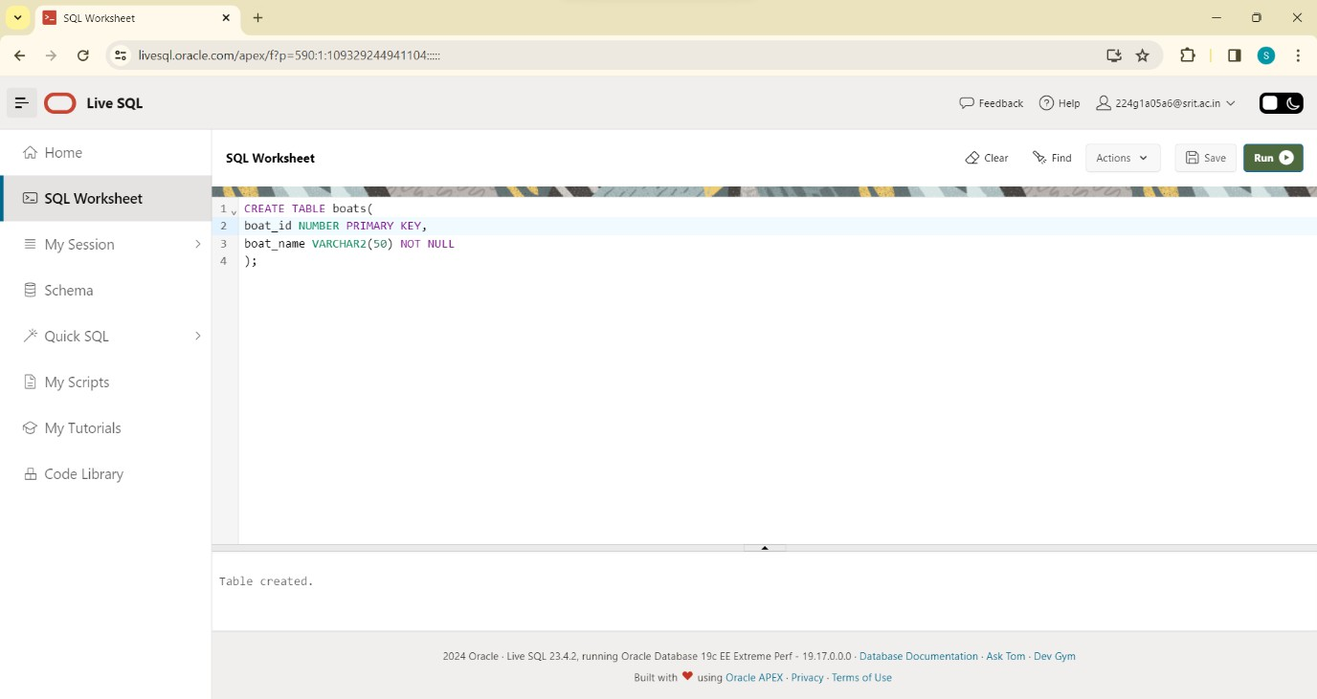

DROP BOATS TABLE :

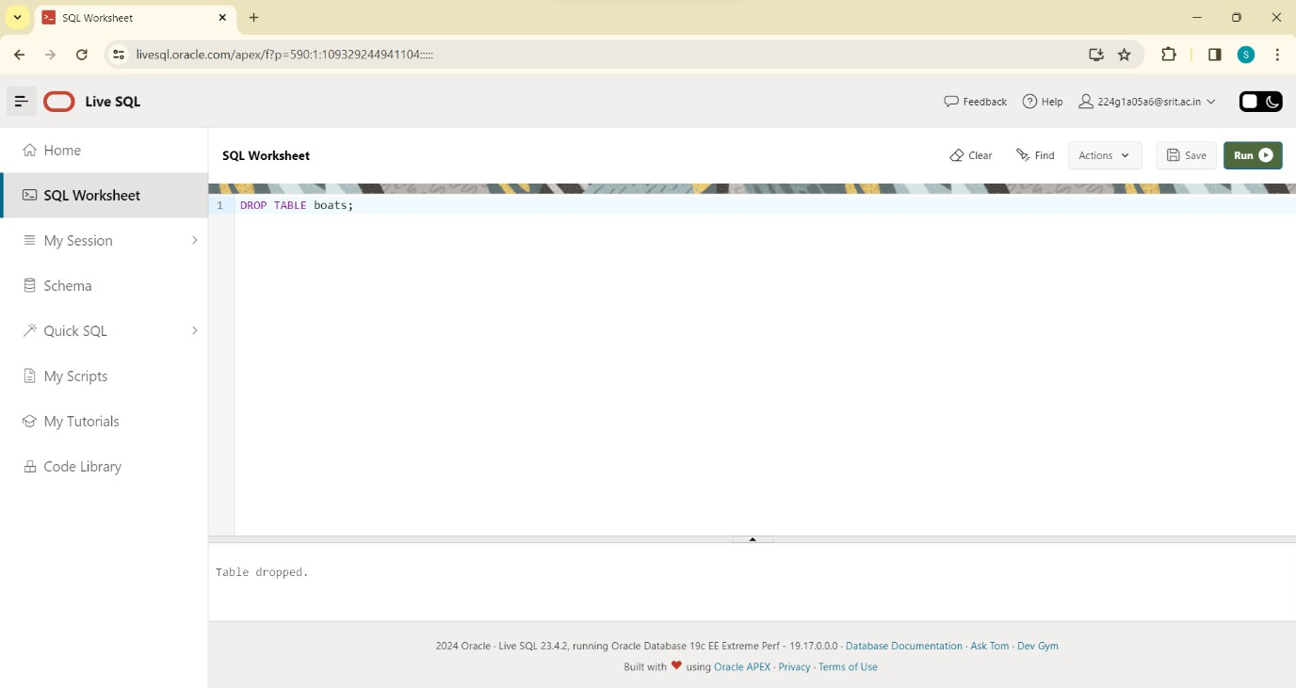

DESC BOATS:

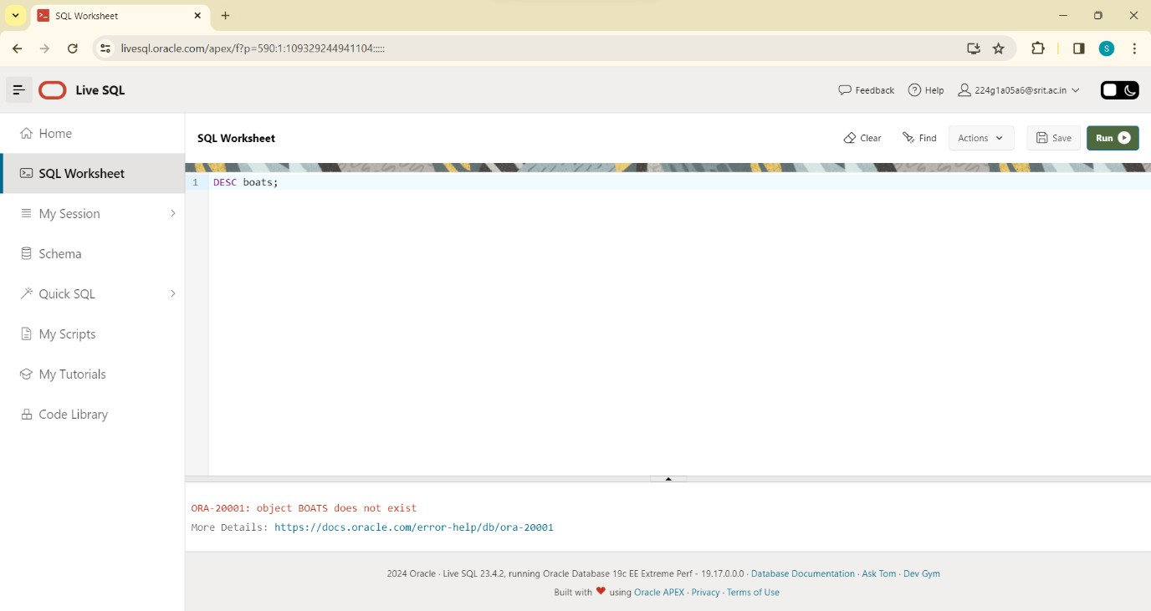

INSERTING VALUES INTO PARTS:

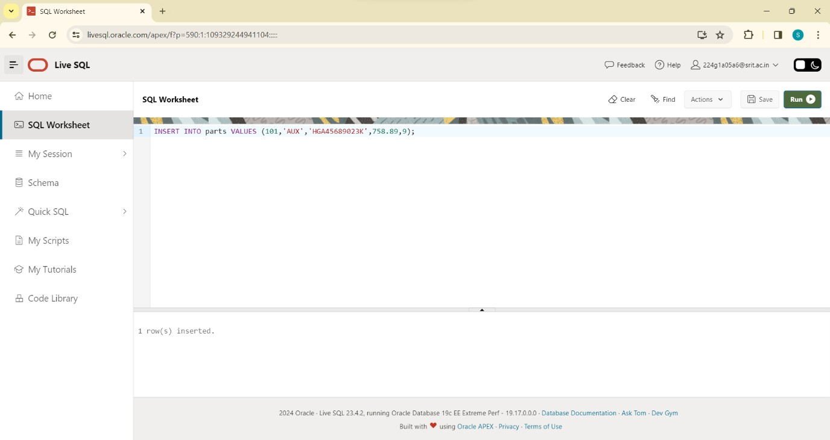

SELECT * FROM TABLE PARTS:

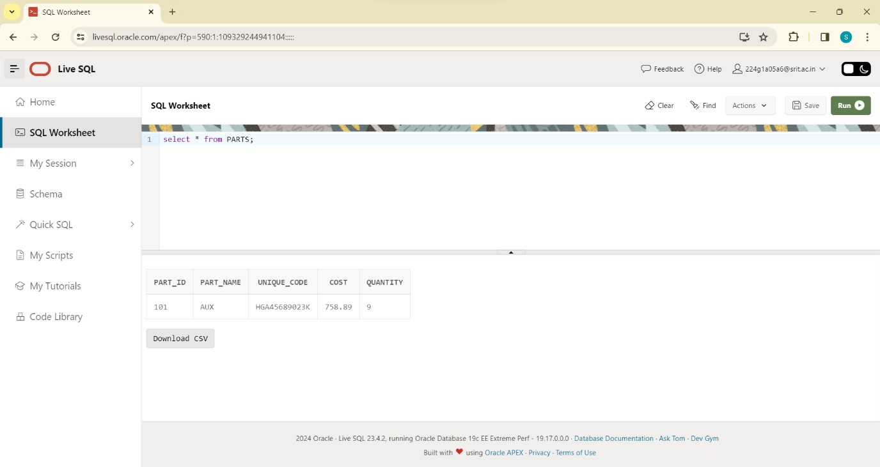

TRUNCATE TABLE PARTS:

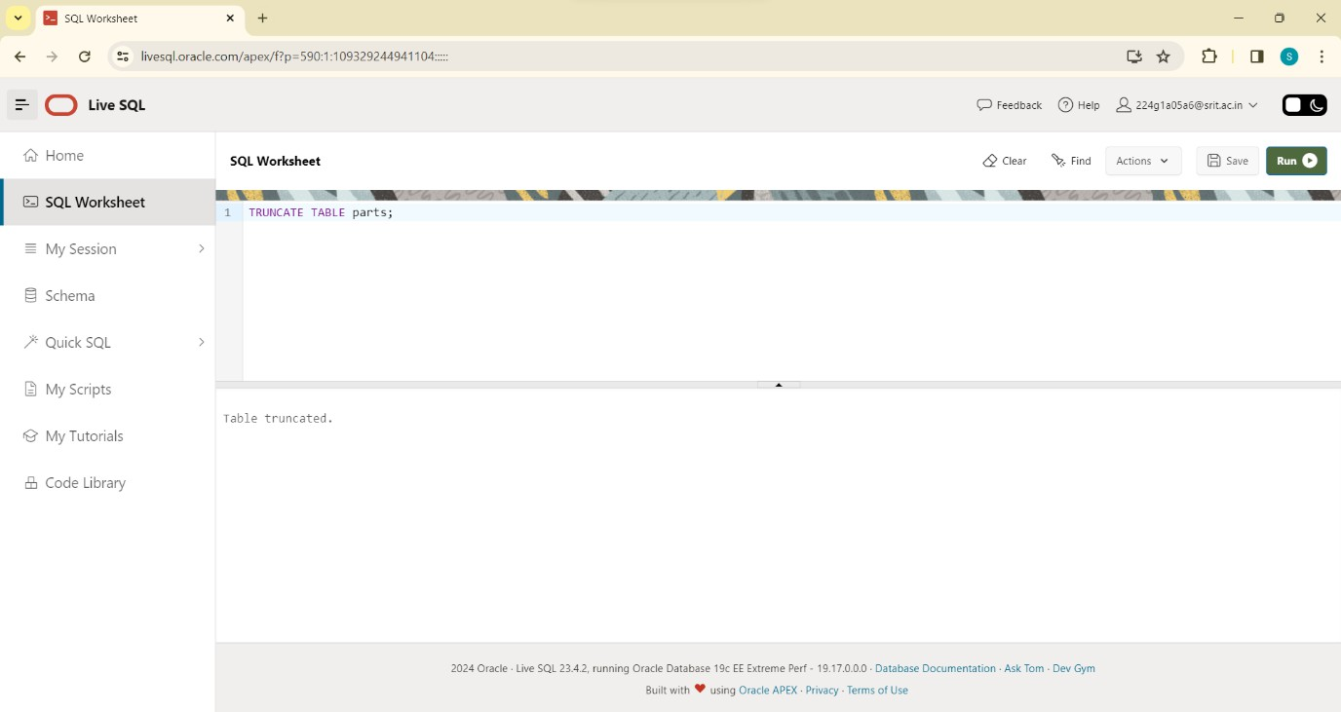

SELECT * FROM PARTS:

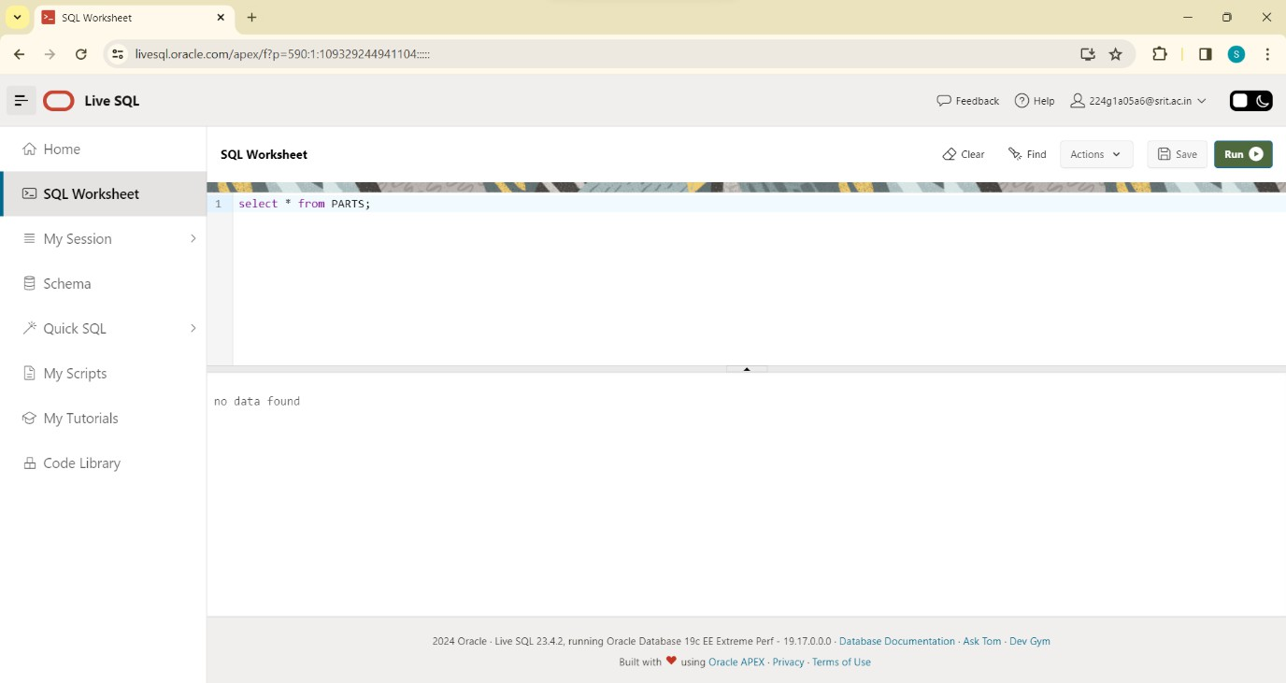

CONCLUSION:

In this lab, we successfully practised and executed SQL Queries to perform DDL Commands

# EXPERIMENT-2

CREATE TABLE PERSONS:

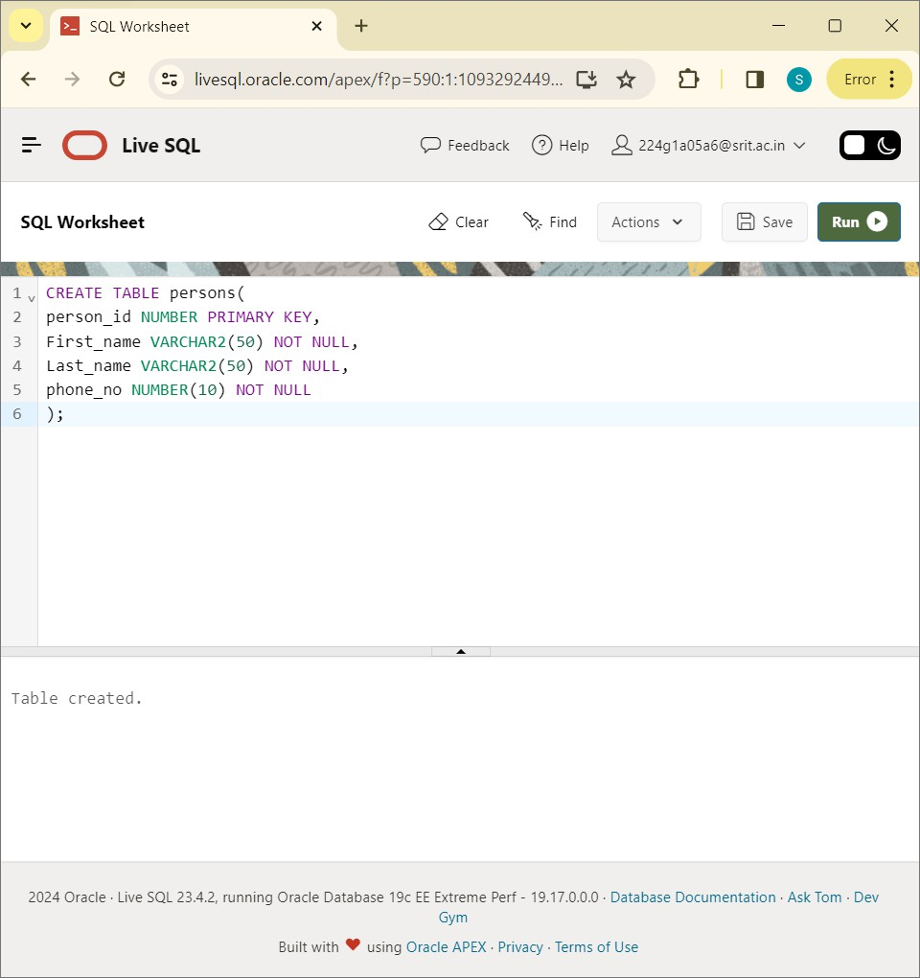

DESC PERSONS:

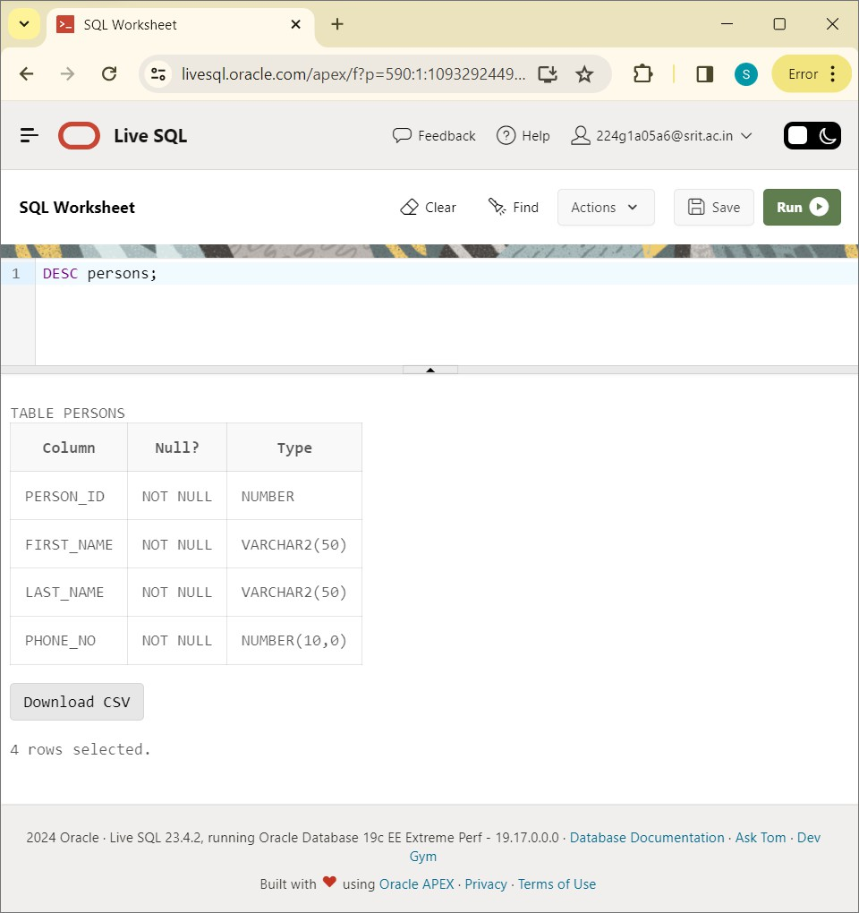

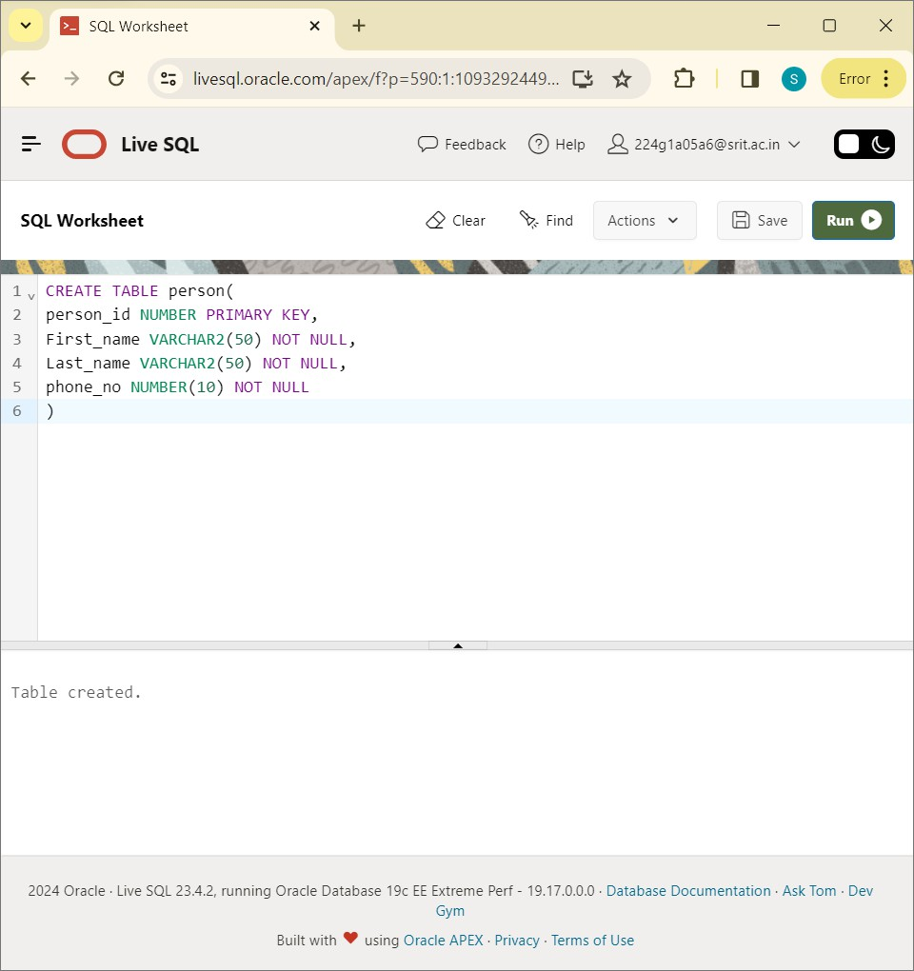

DESC PERSON:

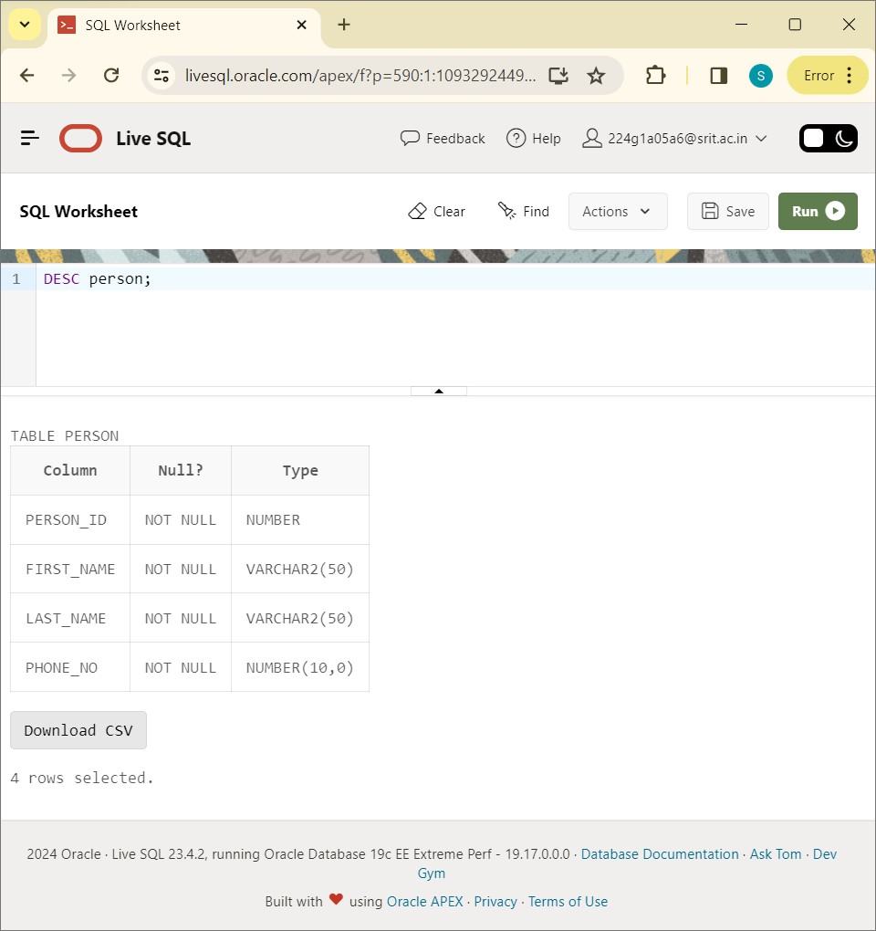

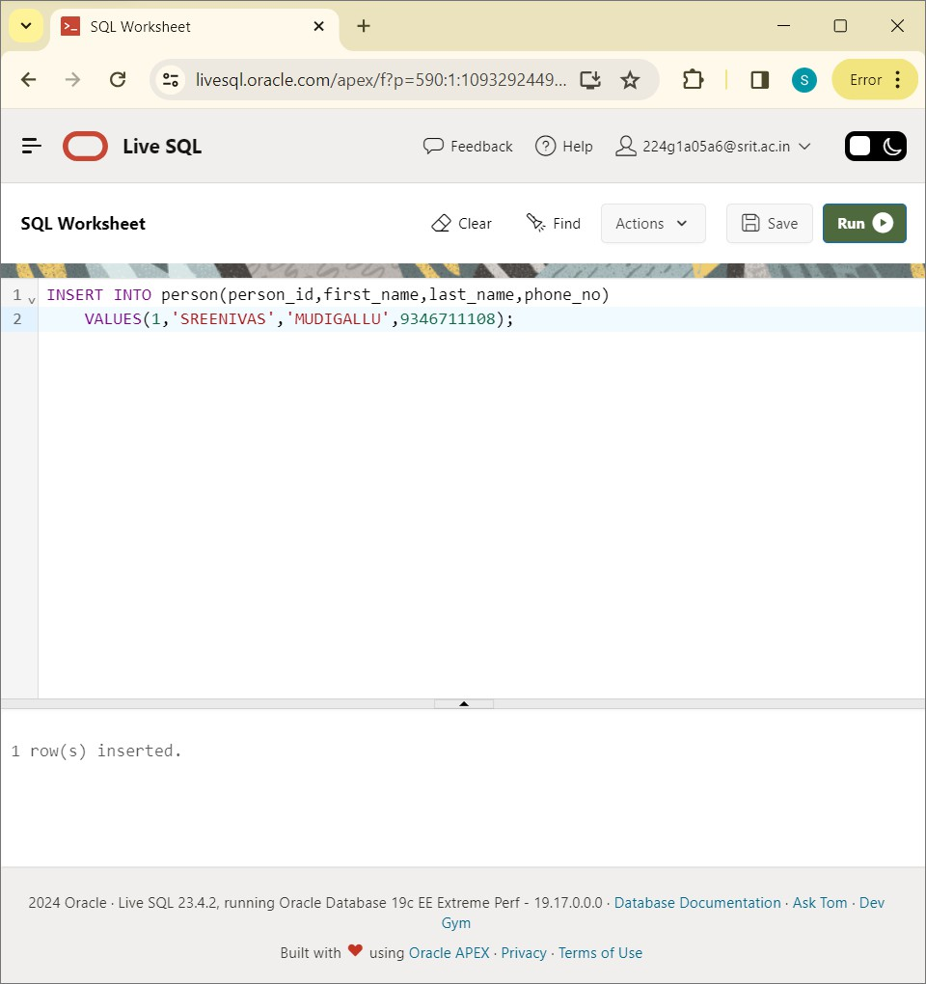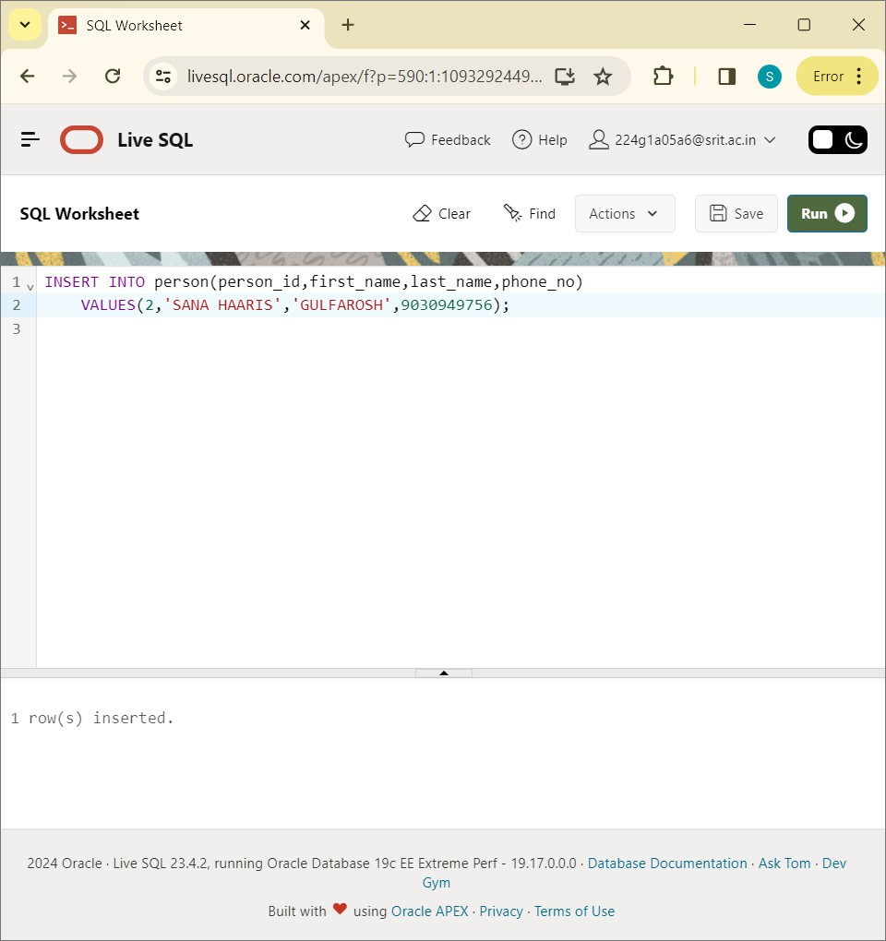

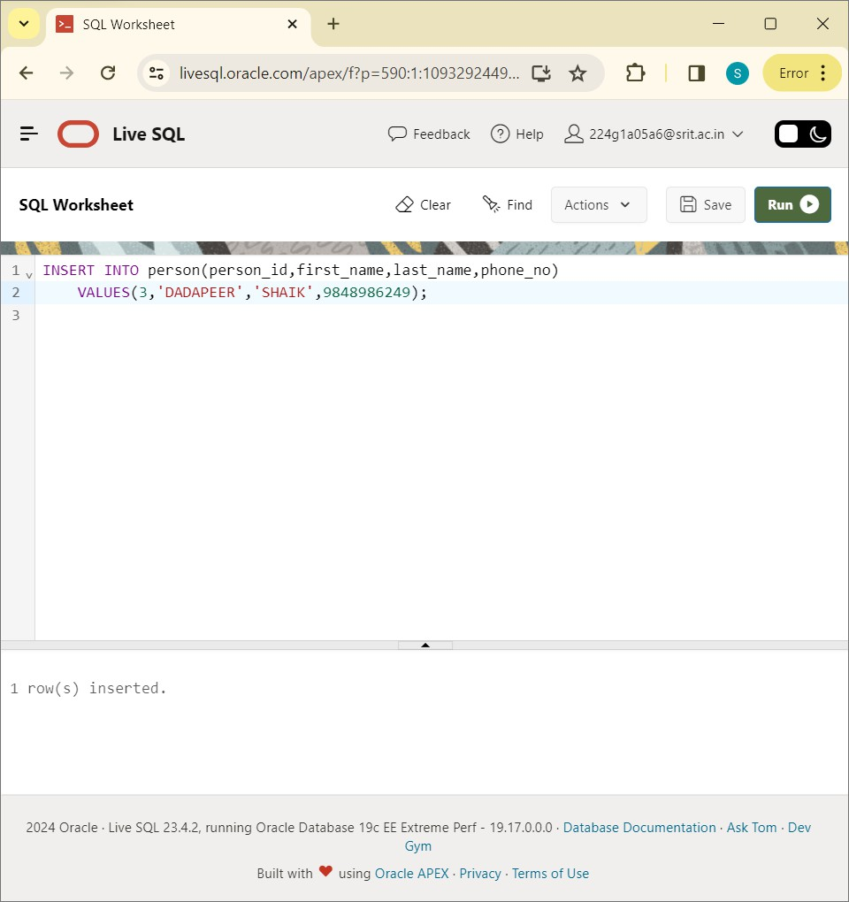

SELECT * FROM person

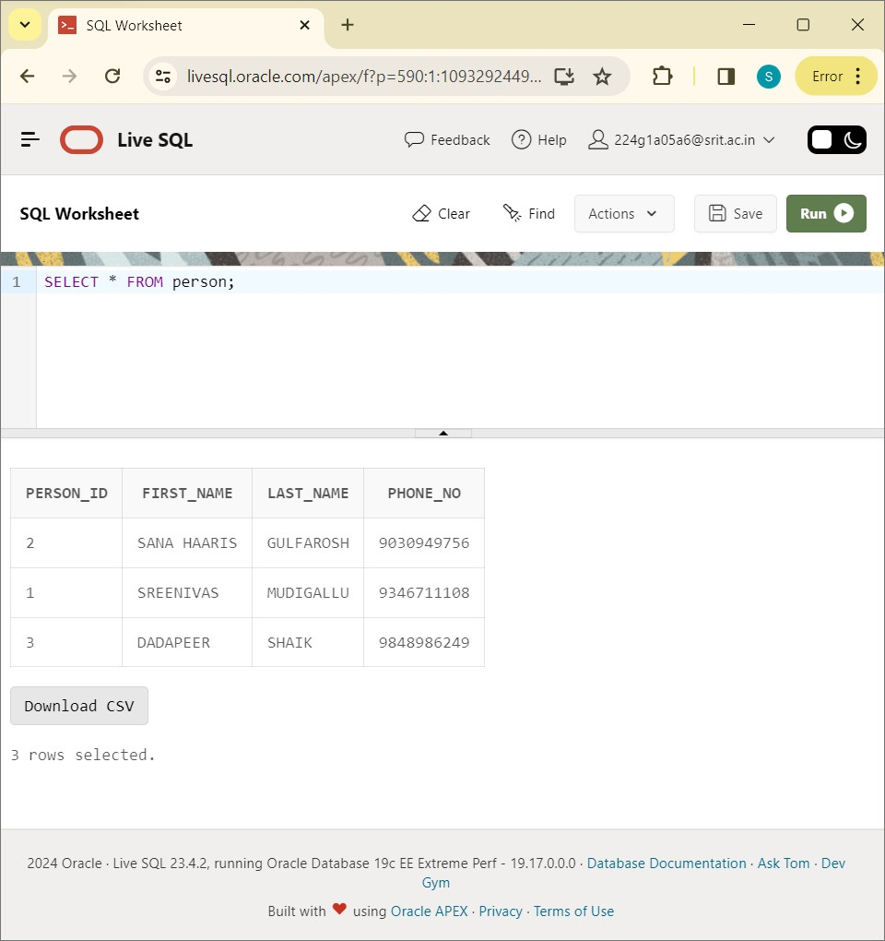

CREATE TABLE DISCOUNTS:

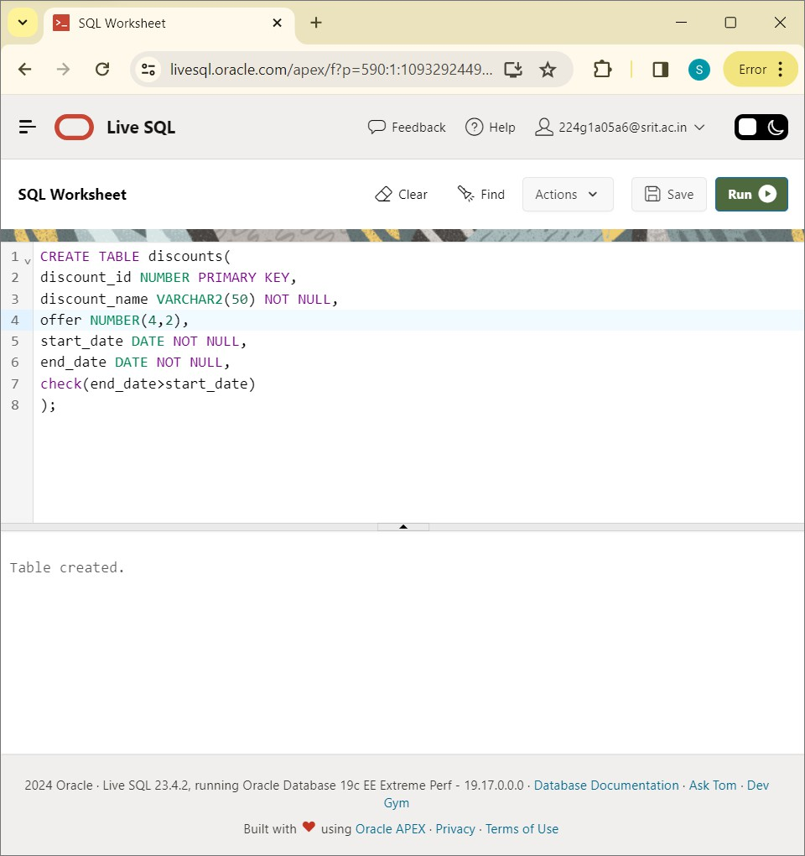

DESC DISCOUNTS:

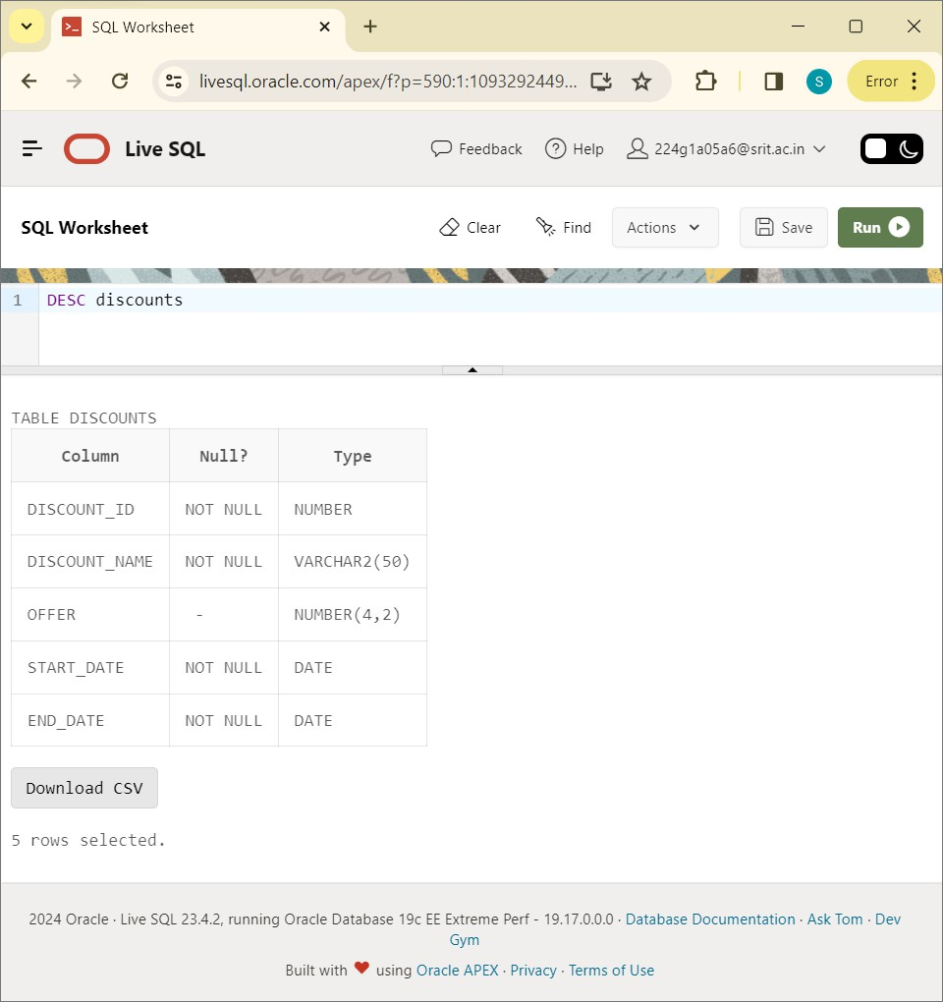

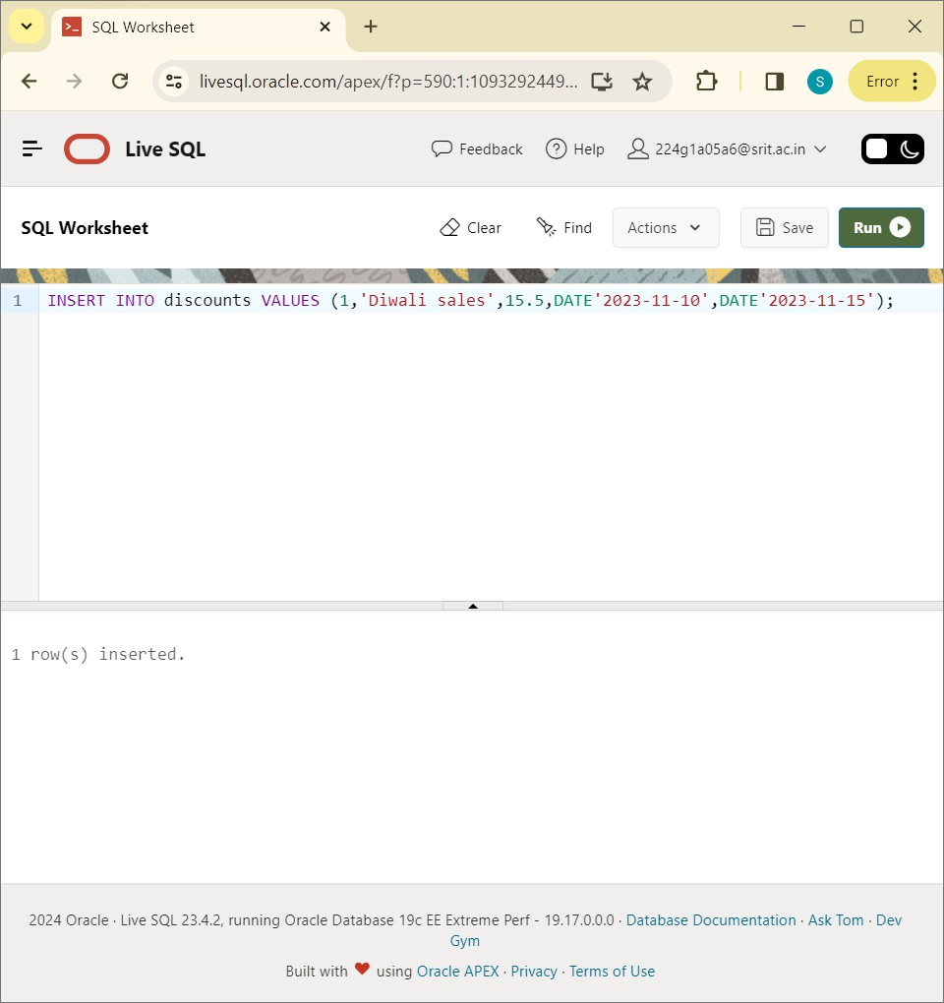

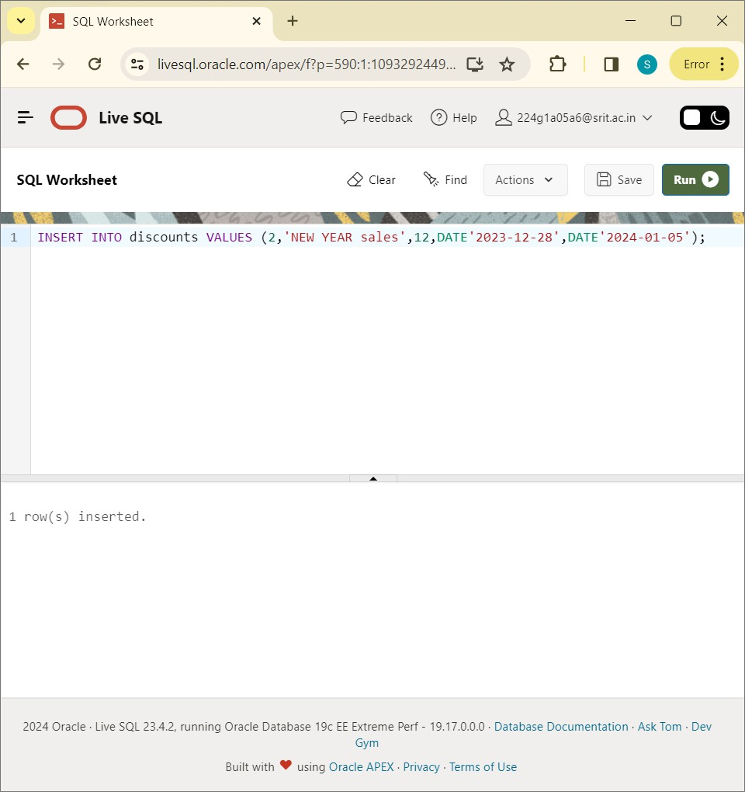

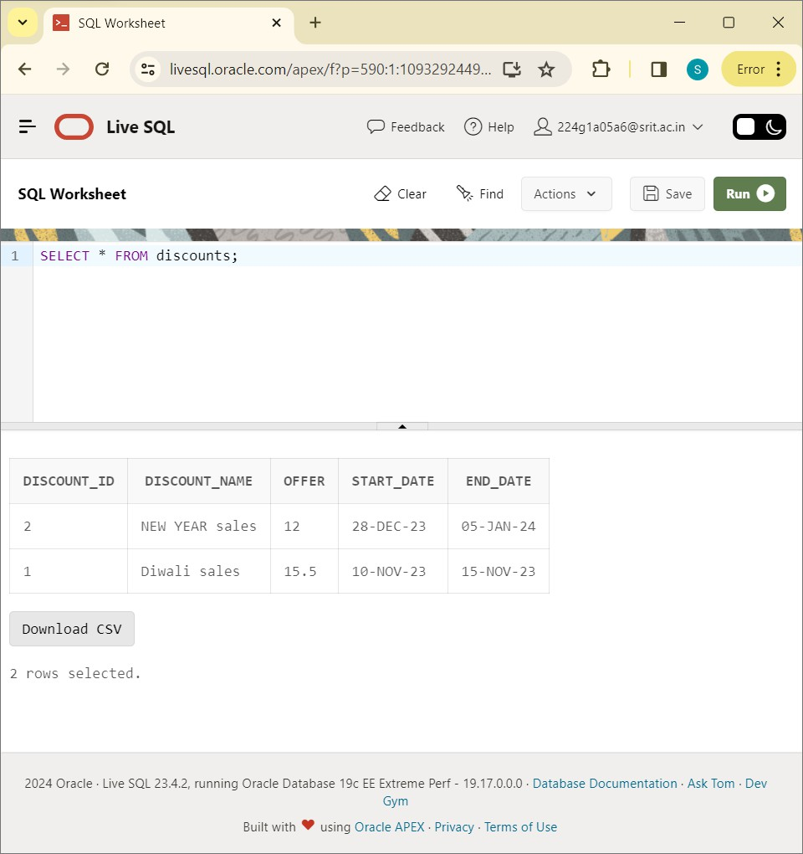

CREATE TABLE original_bill:

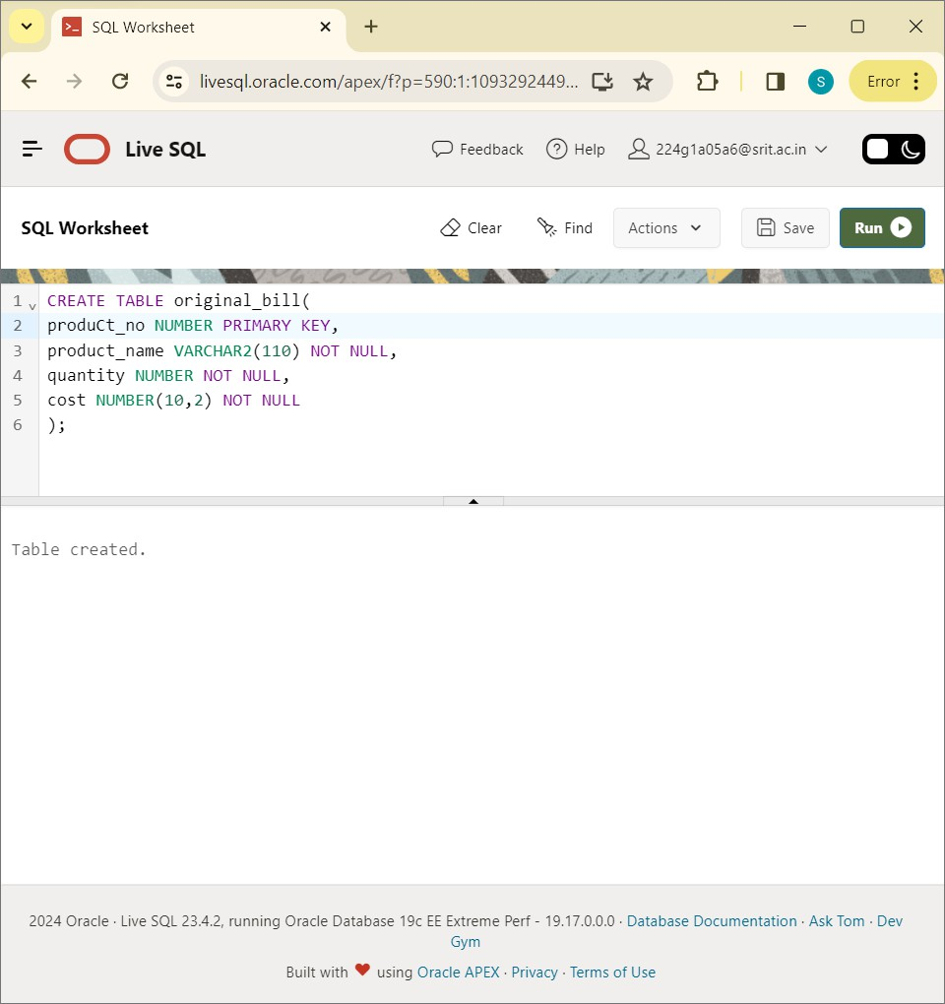

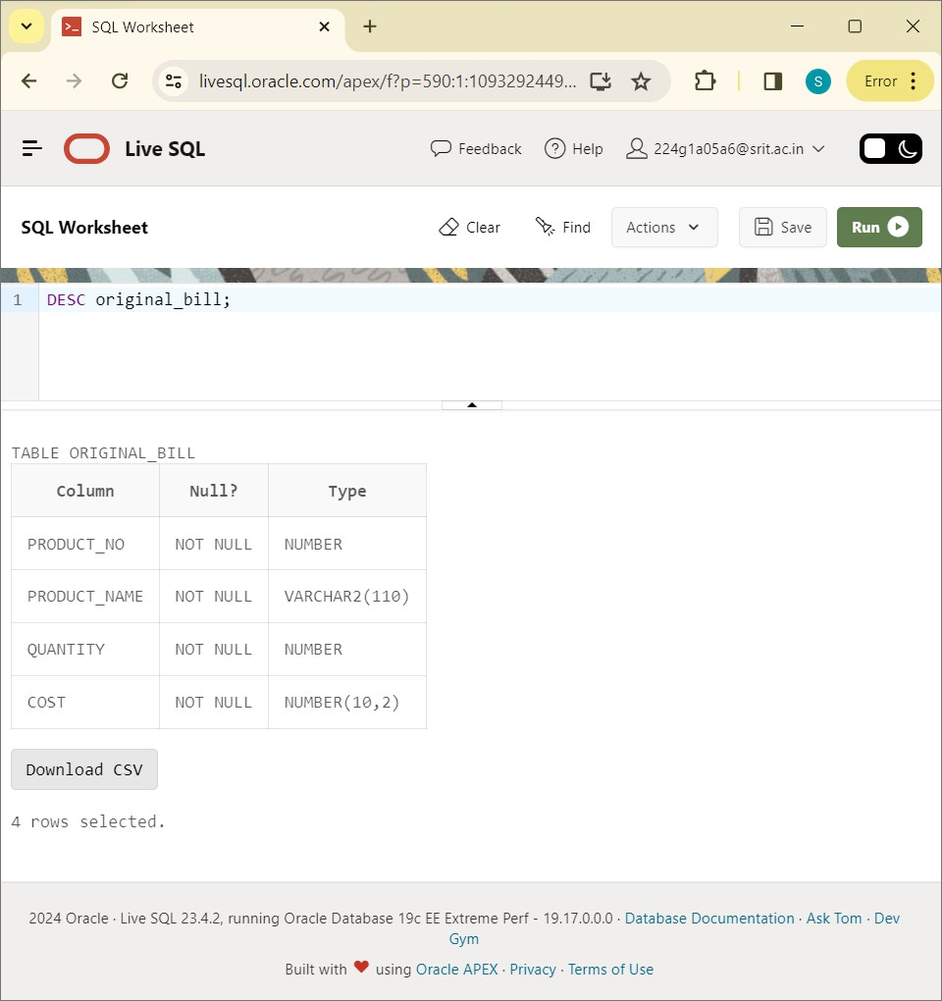

INSERT VALUES INTO ORIGINAL_BILL:

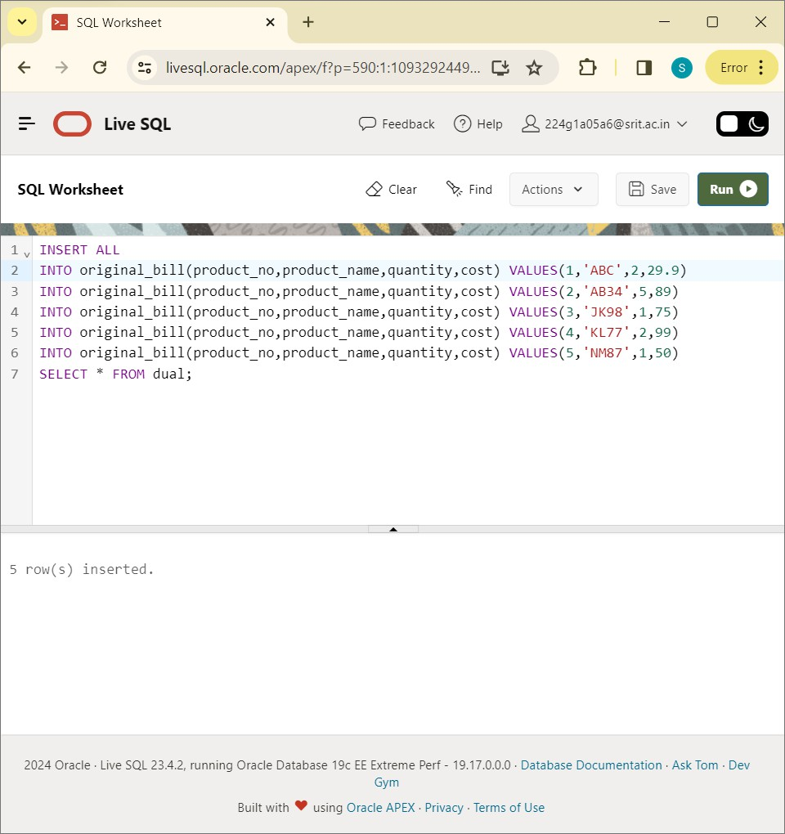

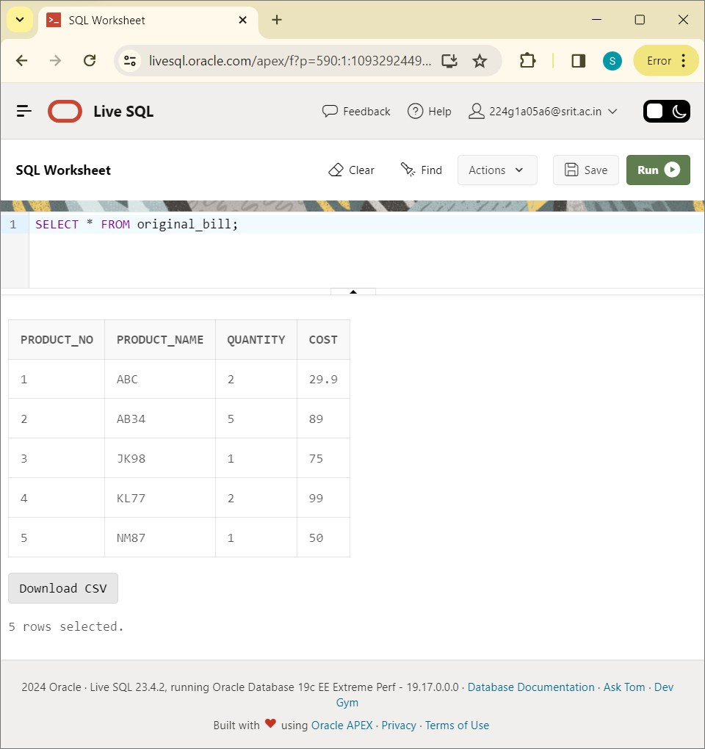

CREATE TABLE copy_bill :

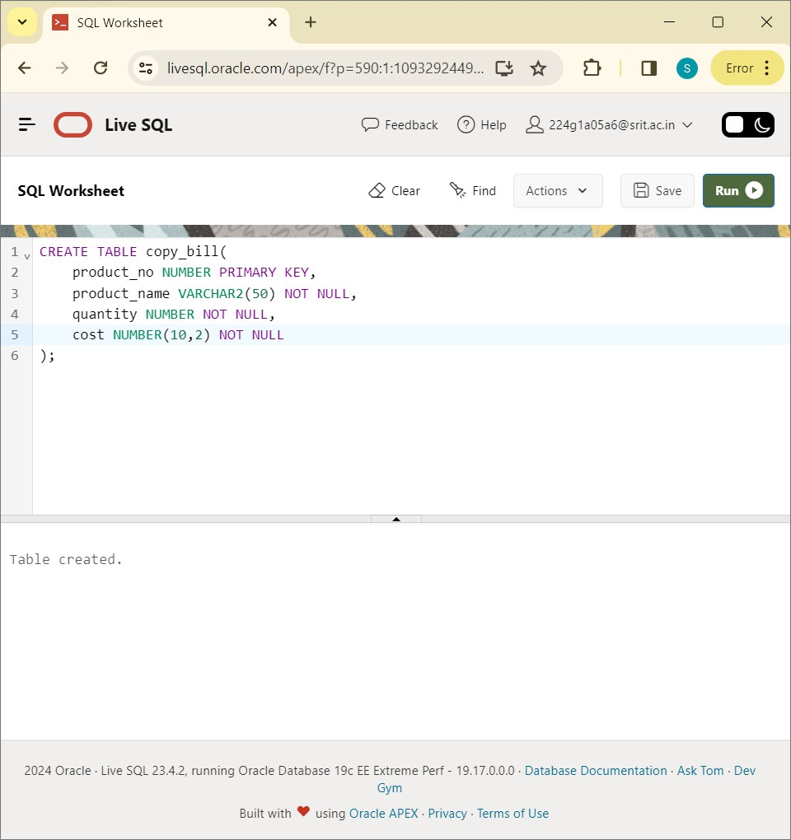

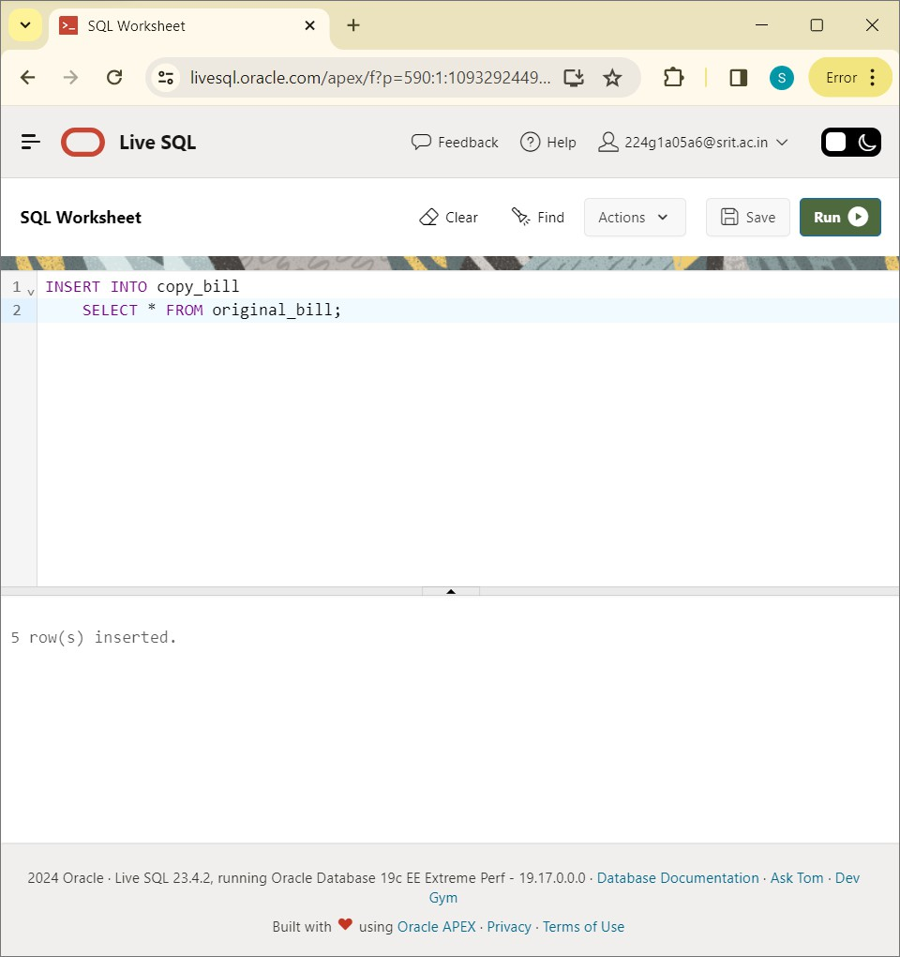

DESC copy_bill:

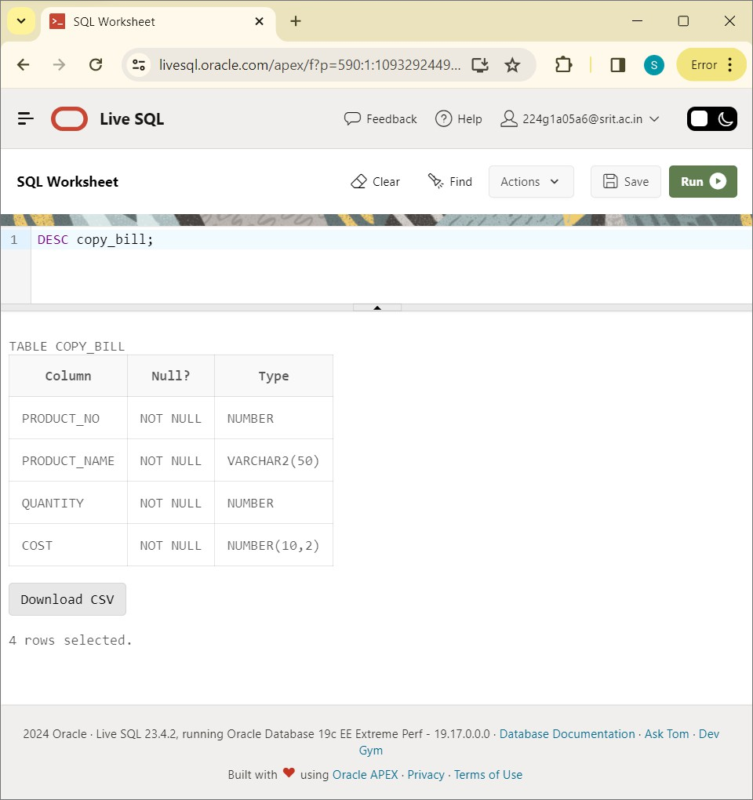

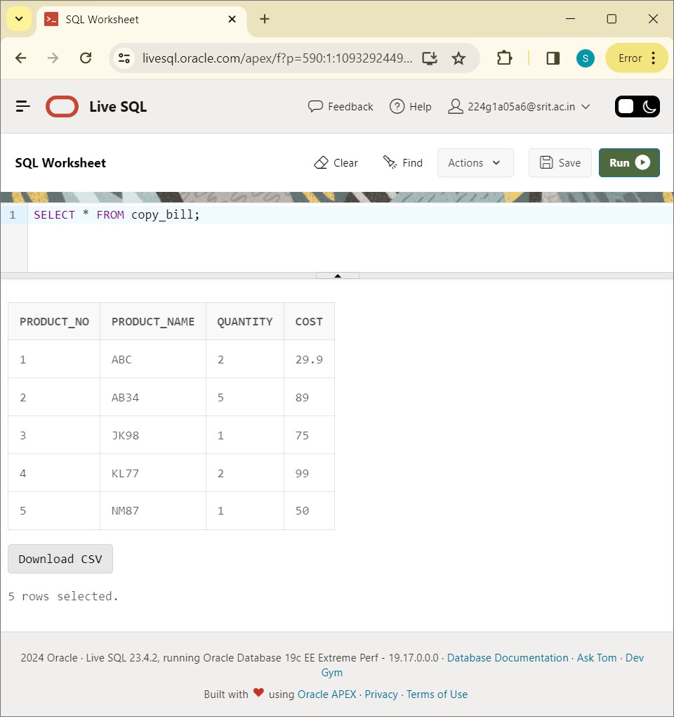

UPDATE copy_bill:

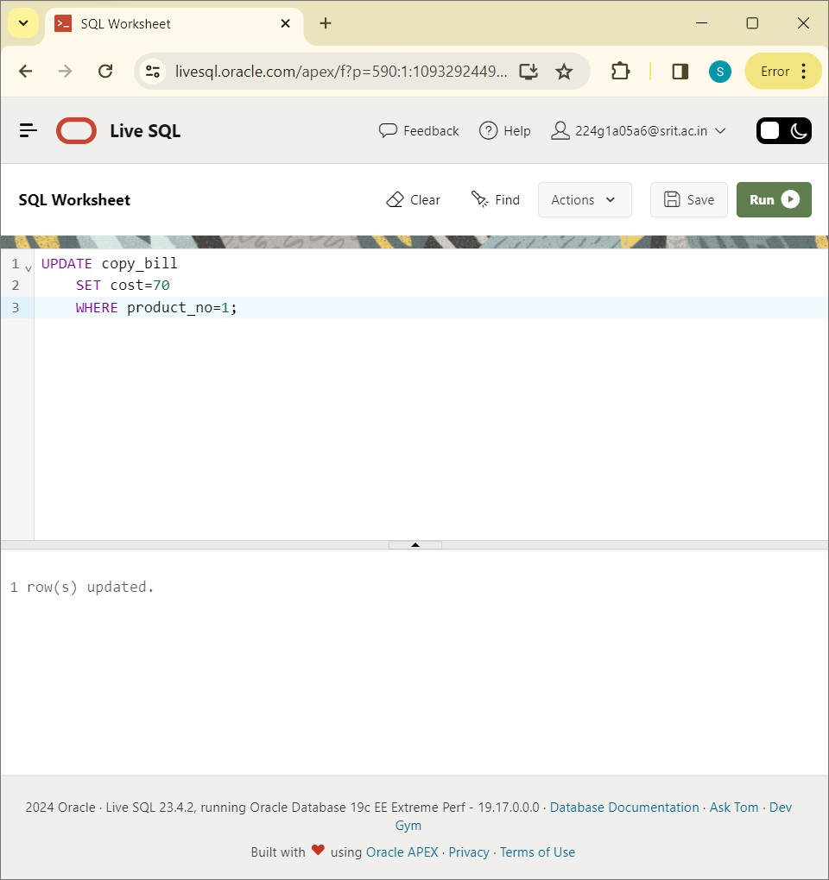

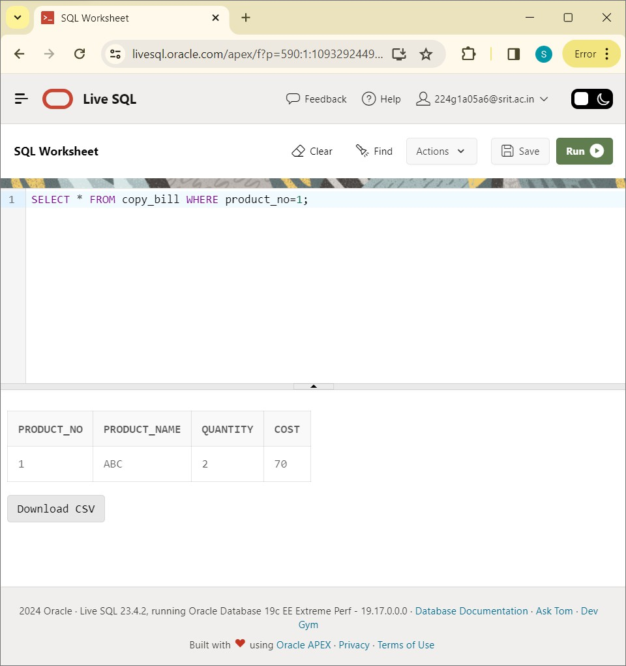

UPDATE copy_bill:

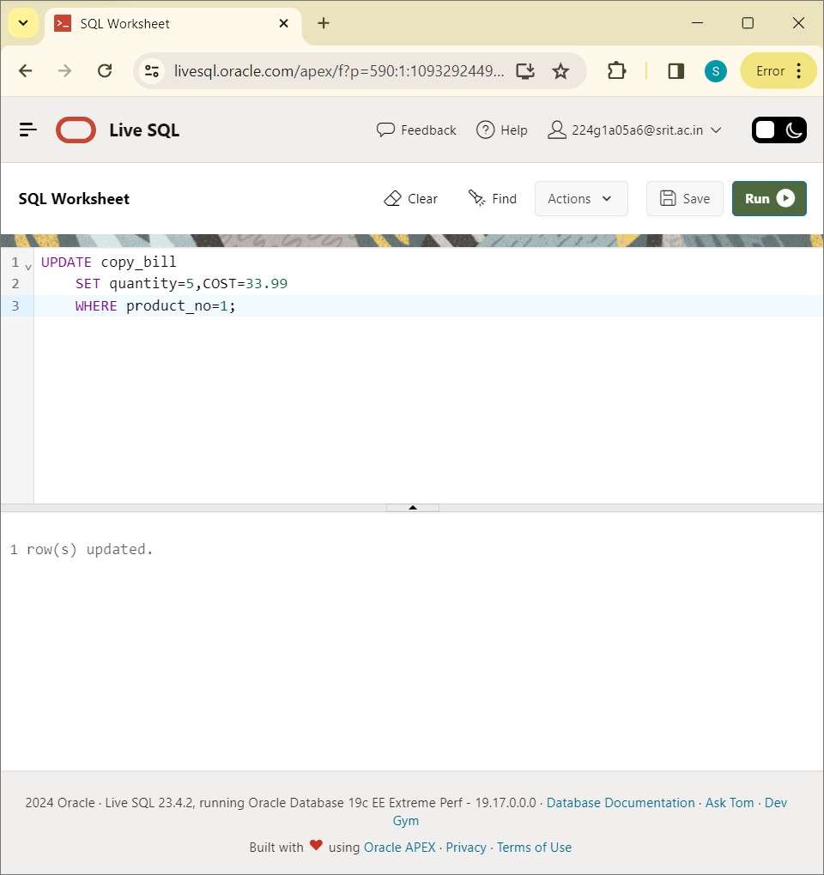

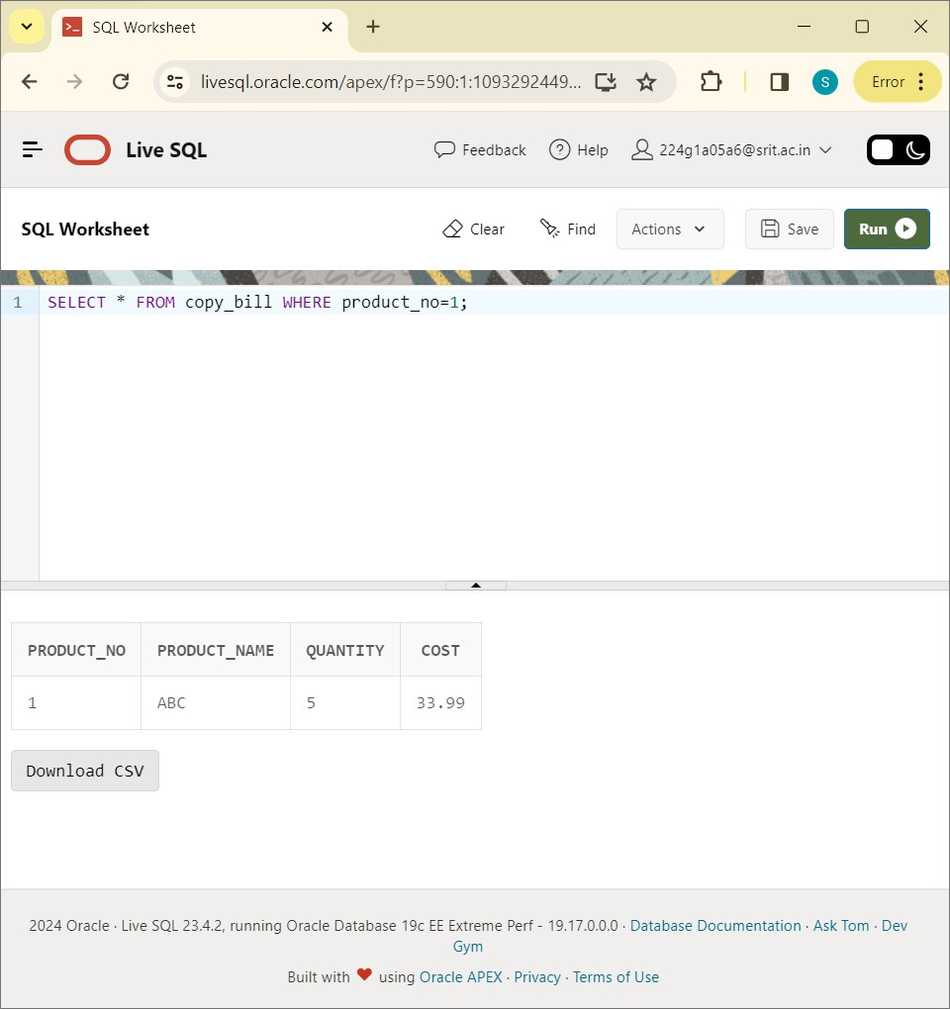

SELECT * FROM copy_bill:

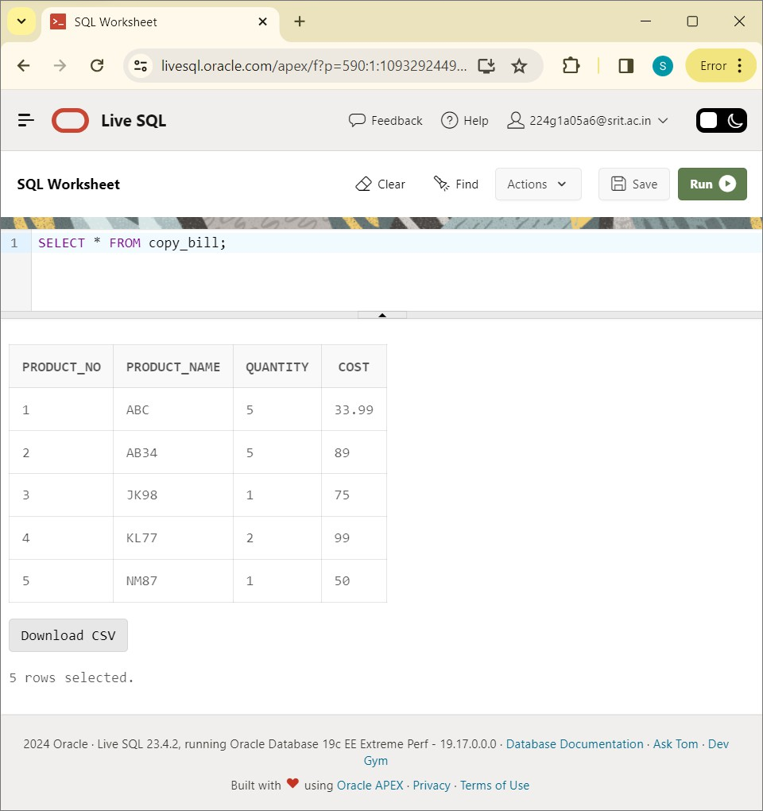

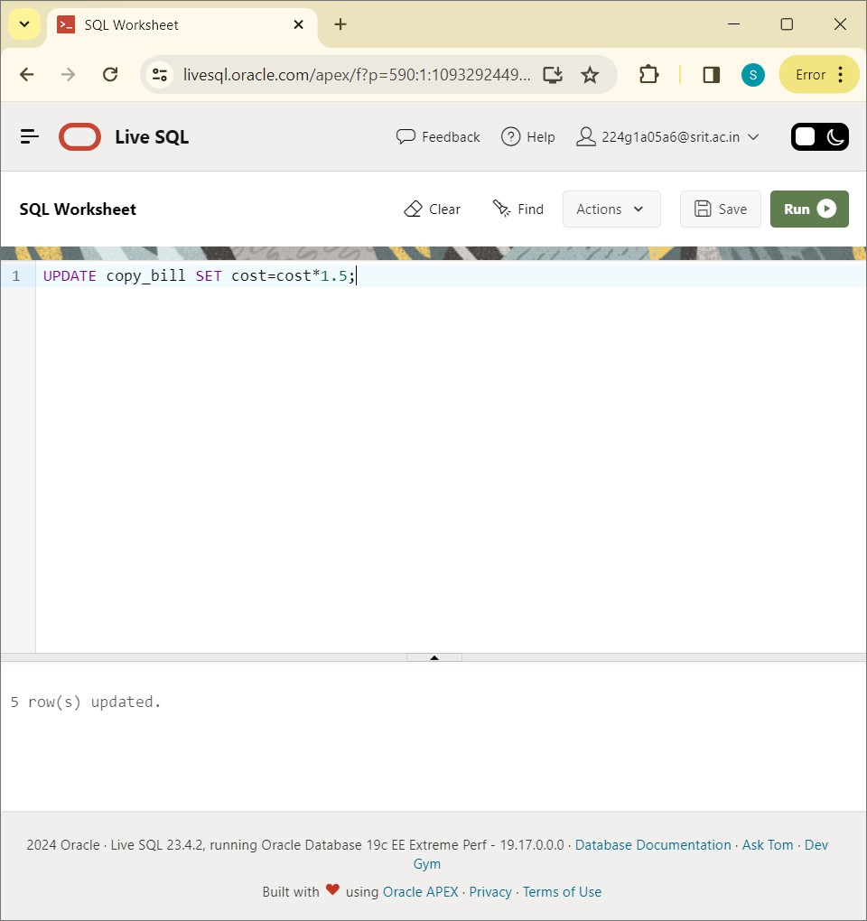

SELECT * FROM copy_bill:

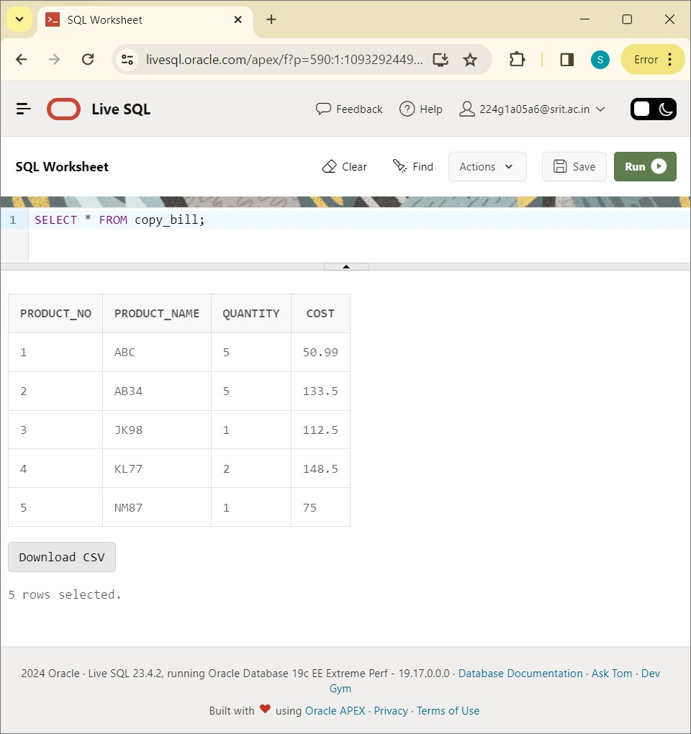

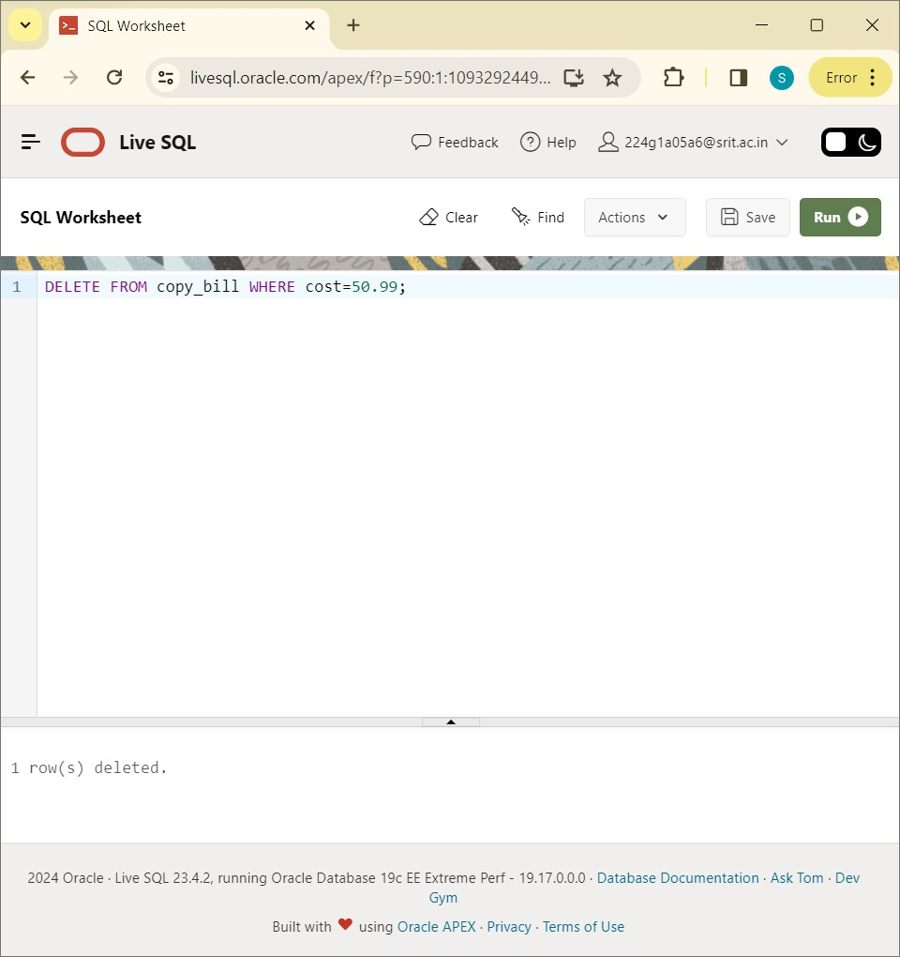

SELECT * FROM copy_bill;

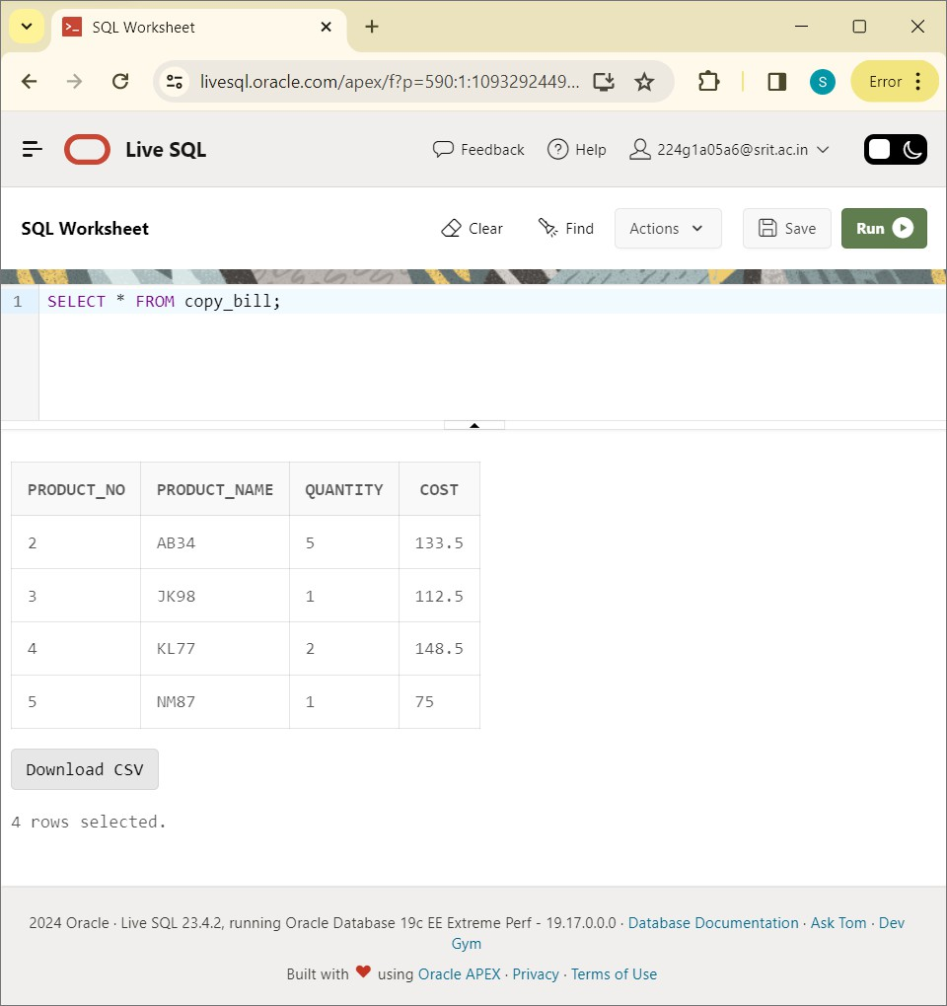

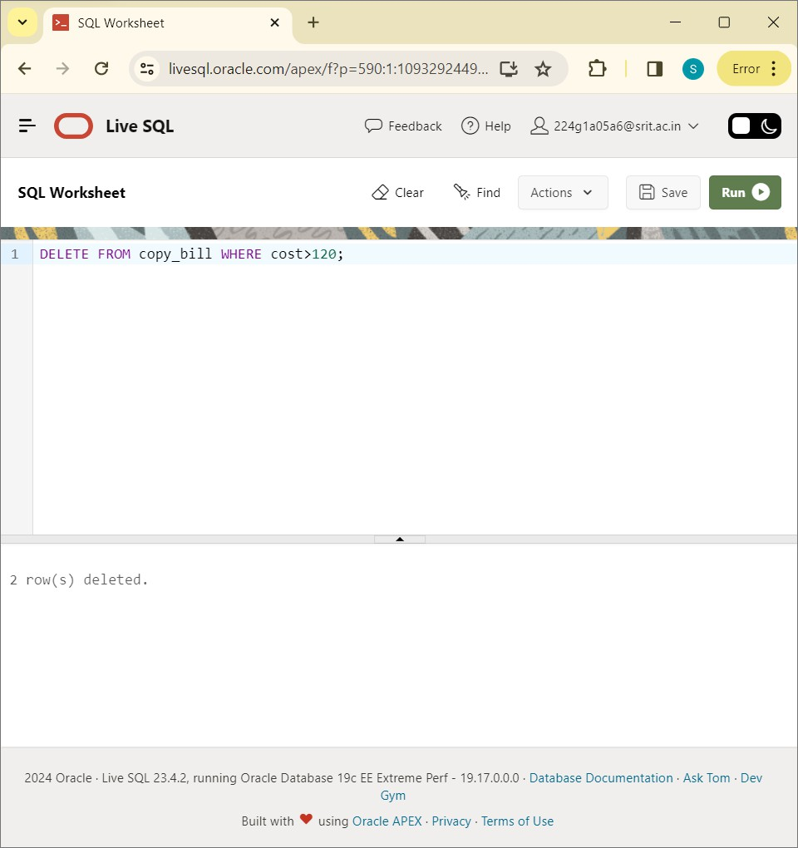

SELECT * FROM copy_bill:

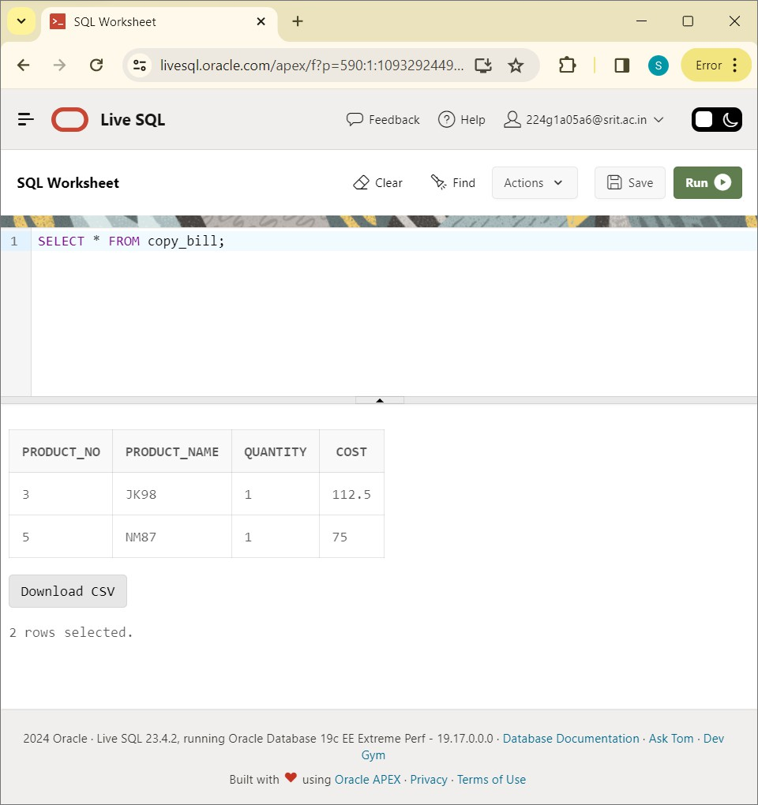

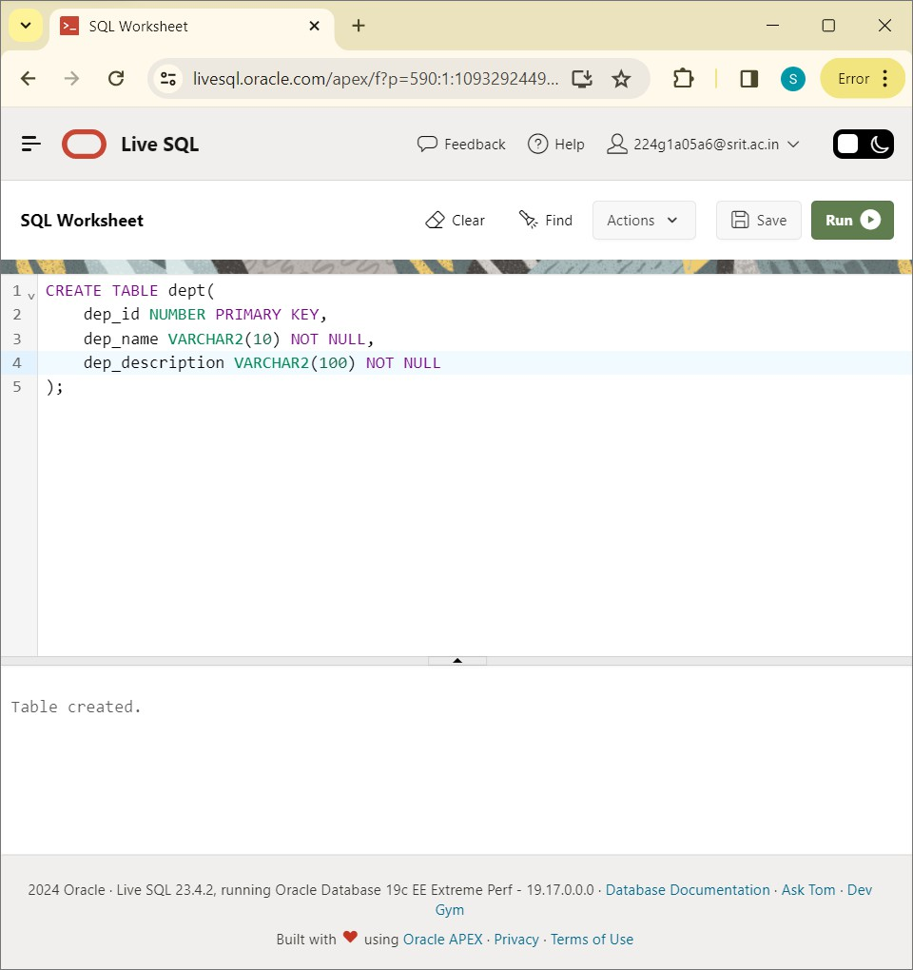

INSERT ALL VALUES INTO DEPT VALUES:

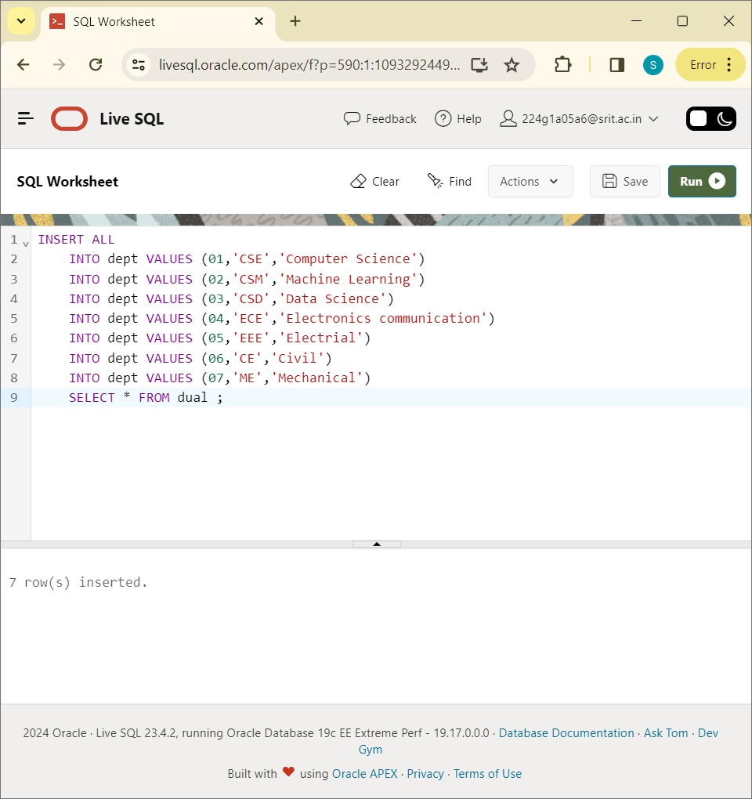

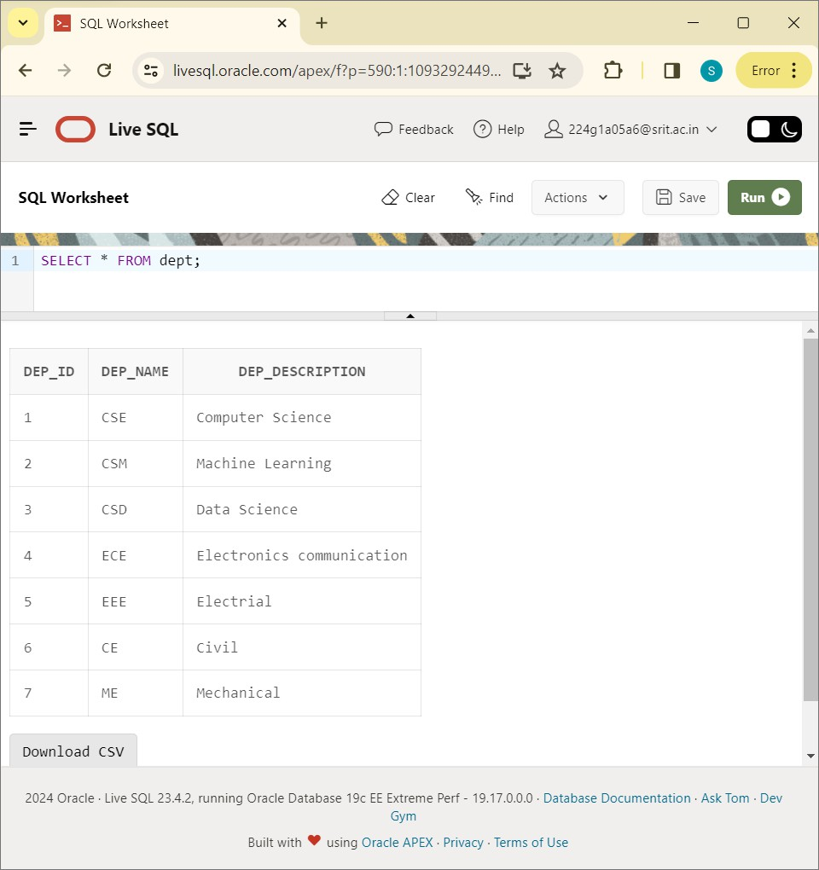

SELECT dep_name from dept:

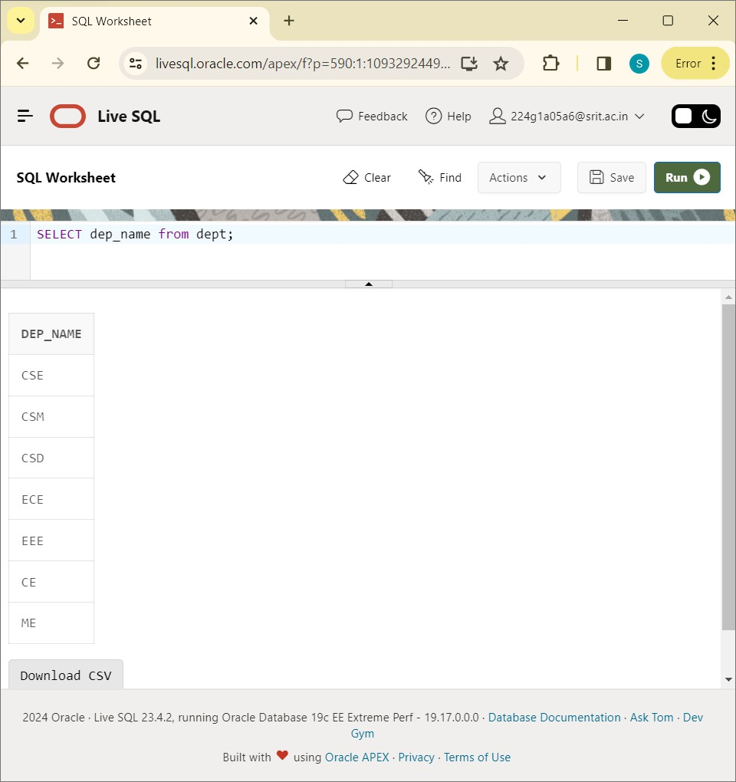

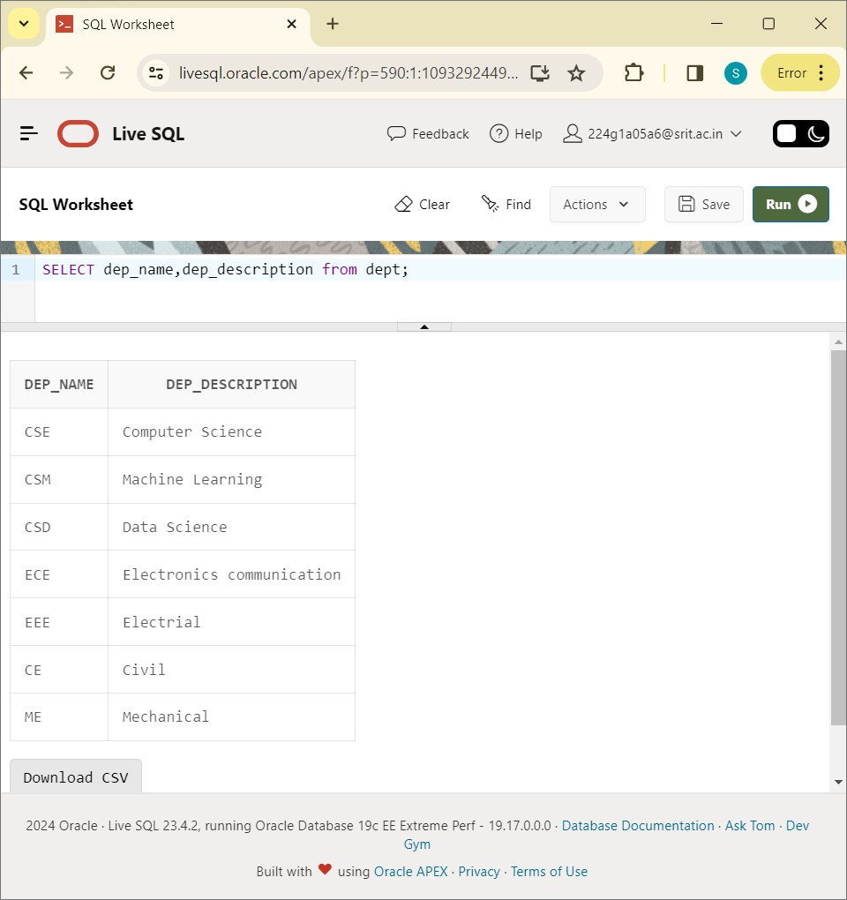

SELECT * FROM dept:

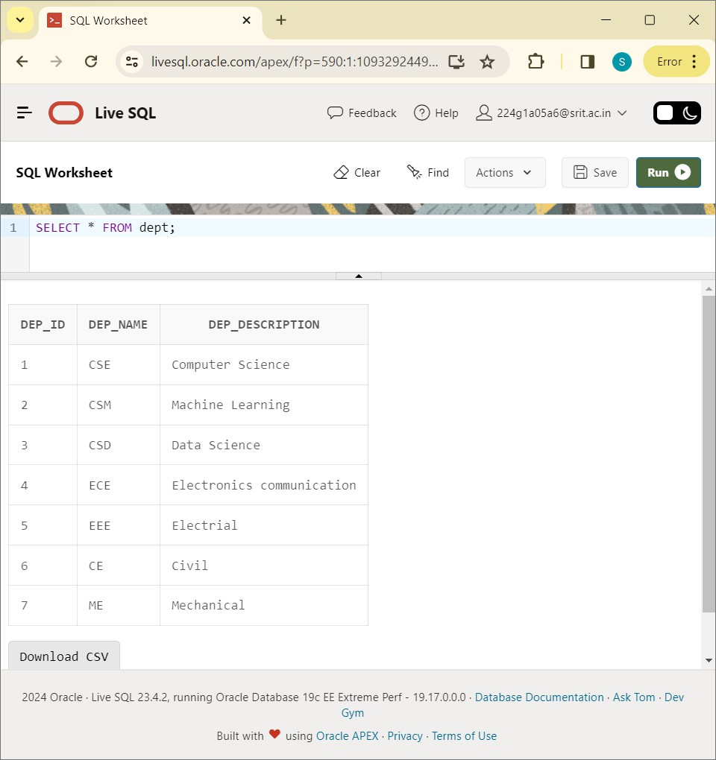

# EXPERIMENT-3:

Write SQL Queries to create VIEWS for various databases ( i.e CREATE VIEW,UPDATE VIEW, ALTER VIEW. And DELETE VIEW)?

CREATE TABLE students:

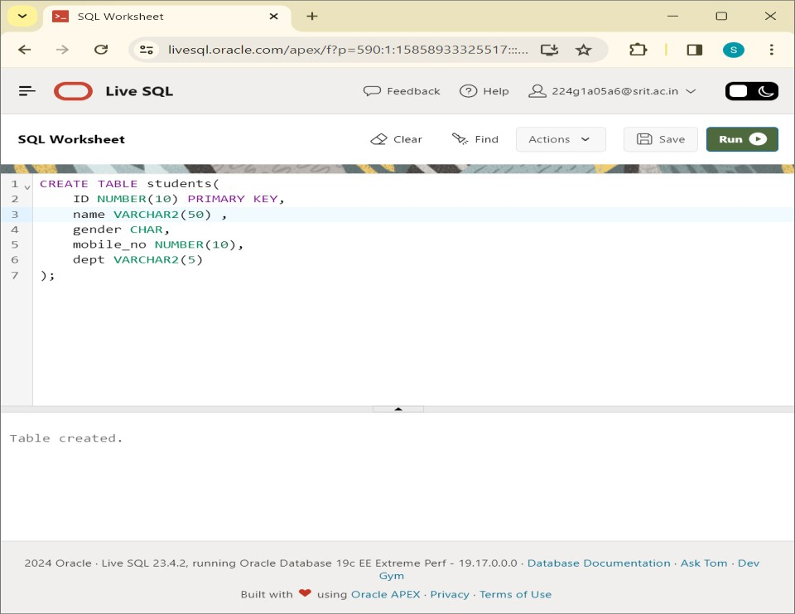

DESC STUDENTS:

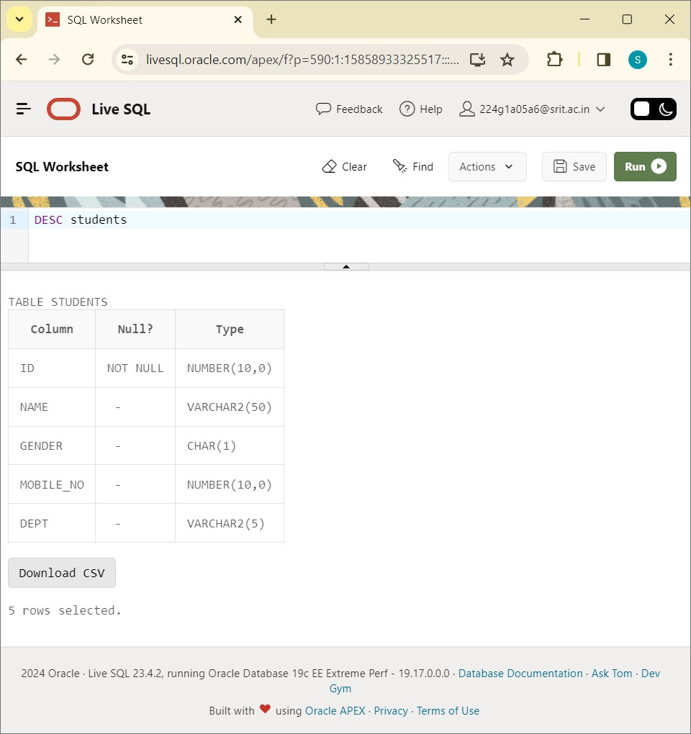

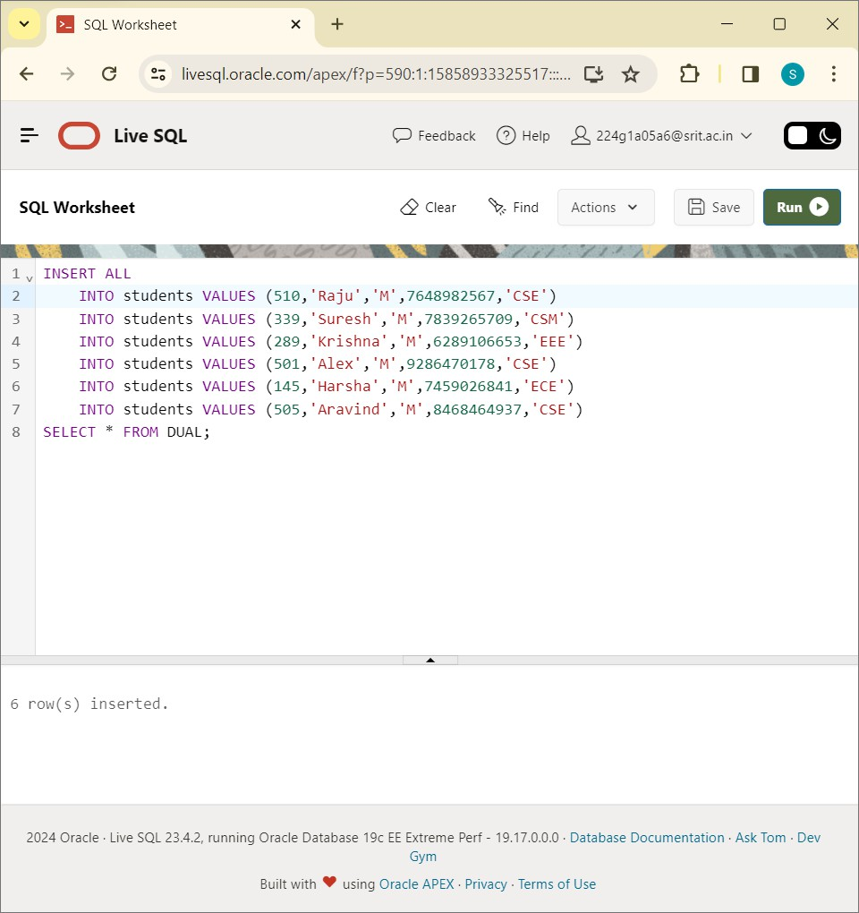

SELECT * FROM students:

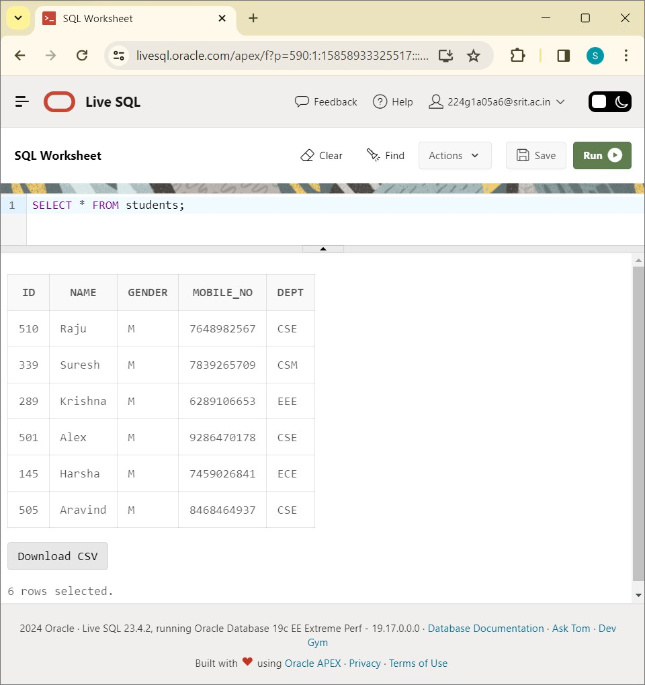

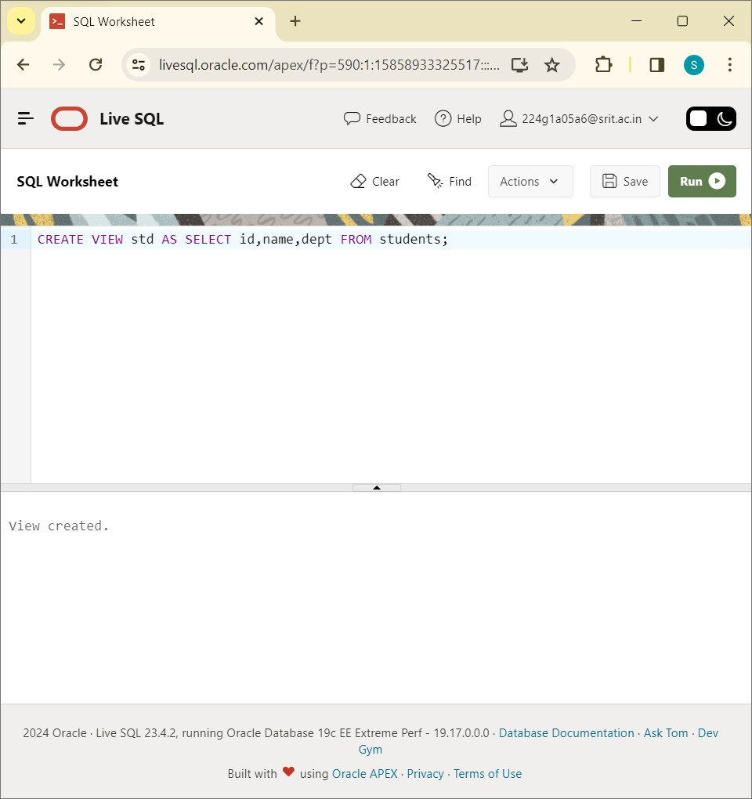

CREATE VIEW cse_std AS SELECT id,name,gender,dept FROM students WHERE dept='CSE':

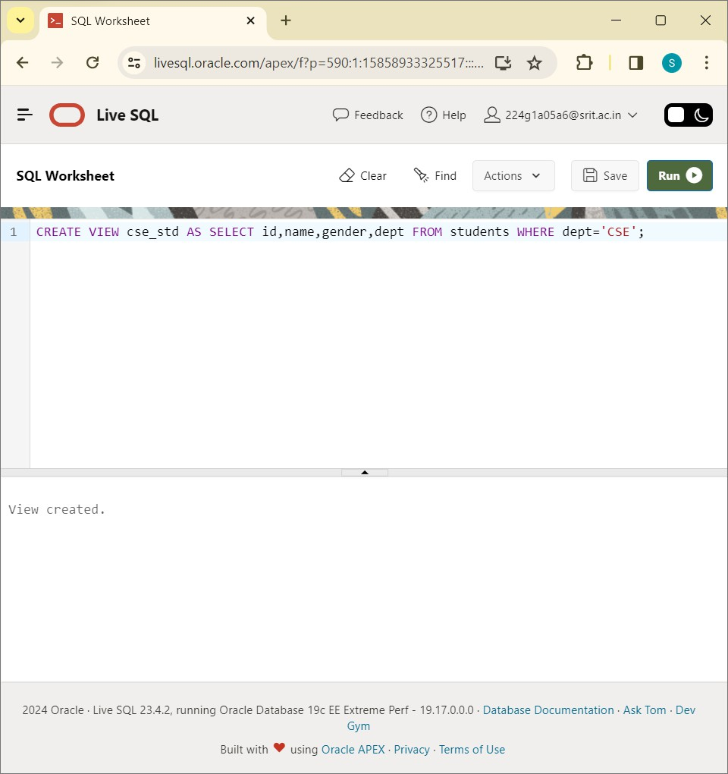

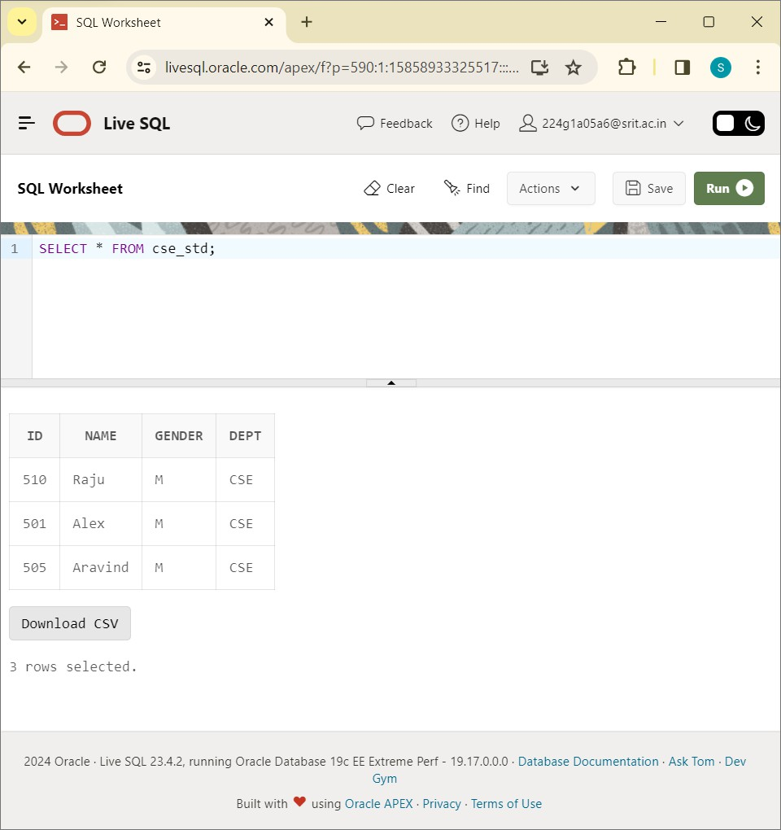

SELECT * FROM std:

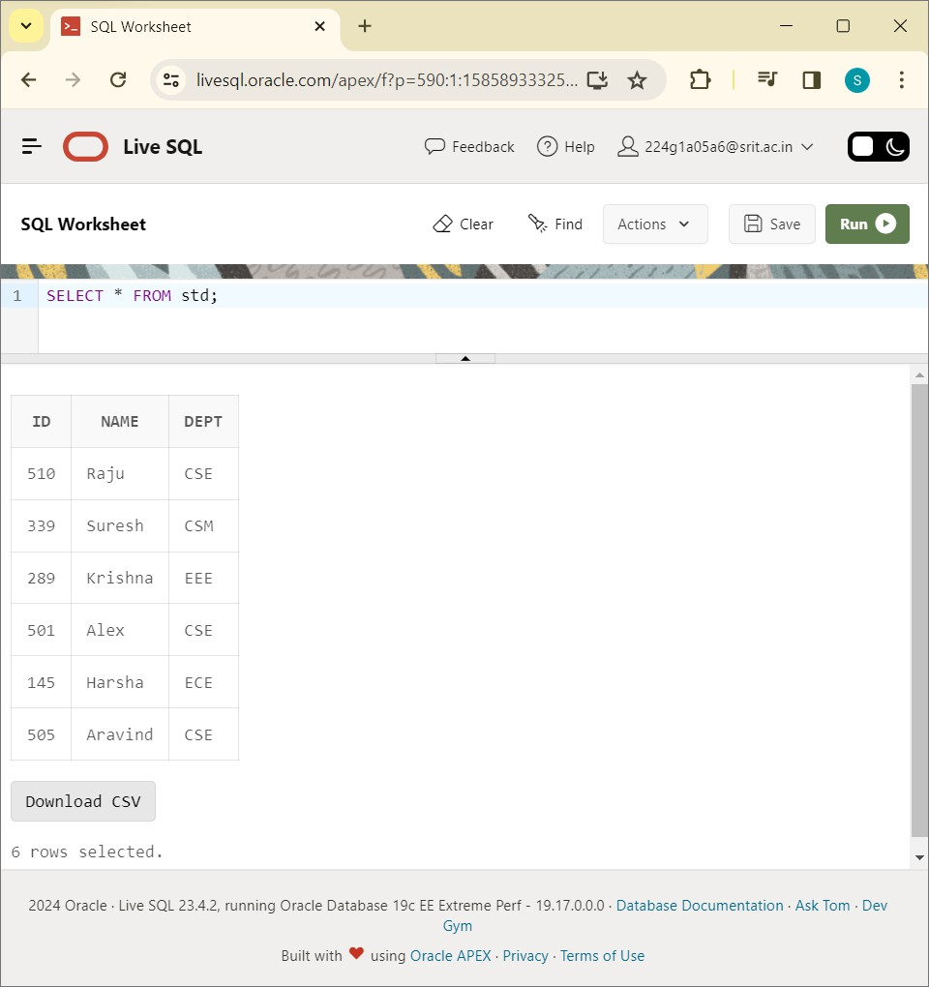

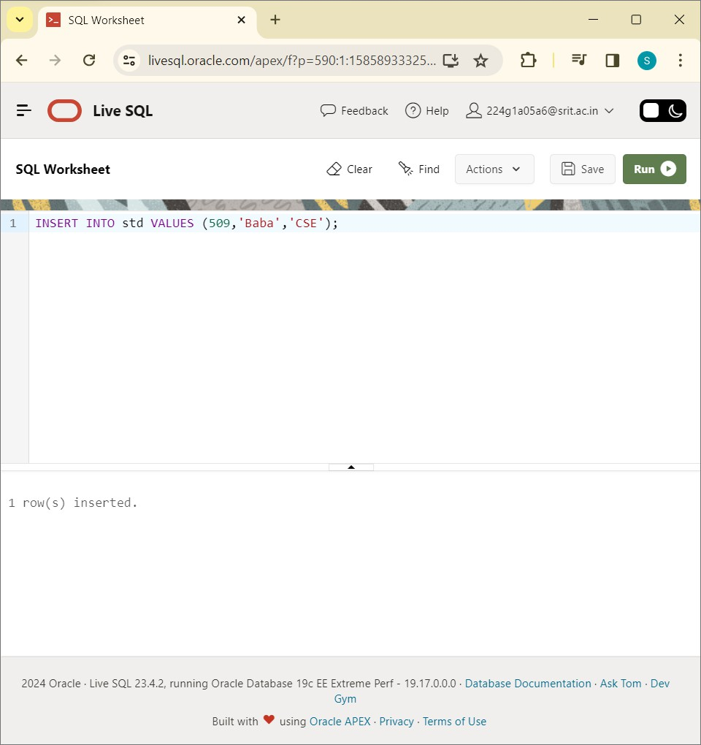

SELECT * FROM cse_std:

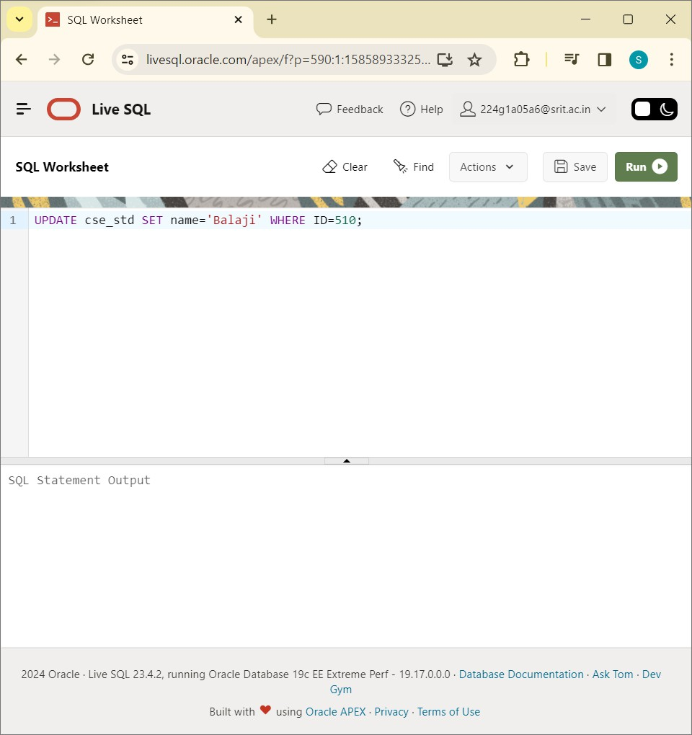

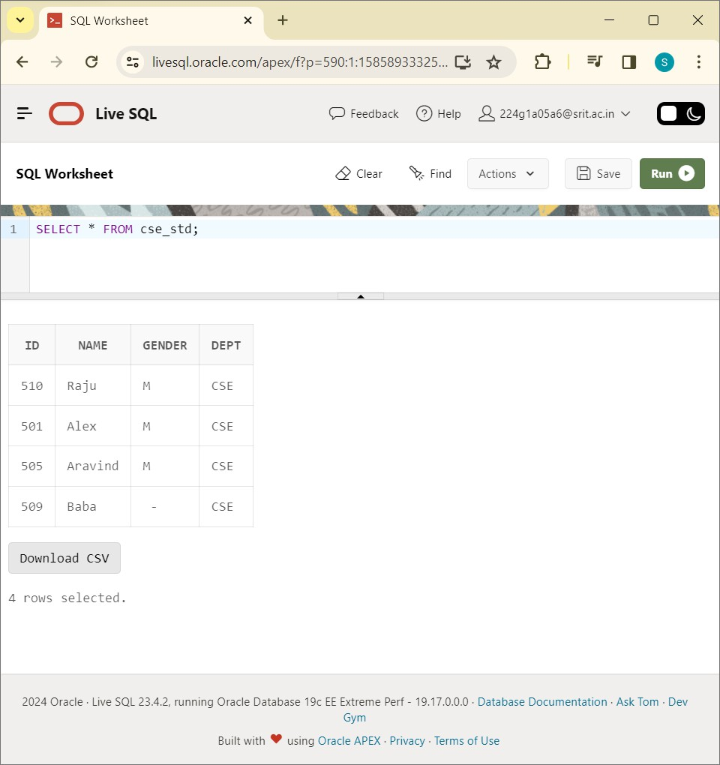

SELECT * FROM cse_std:

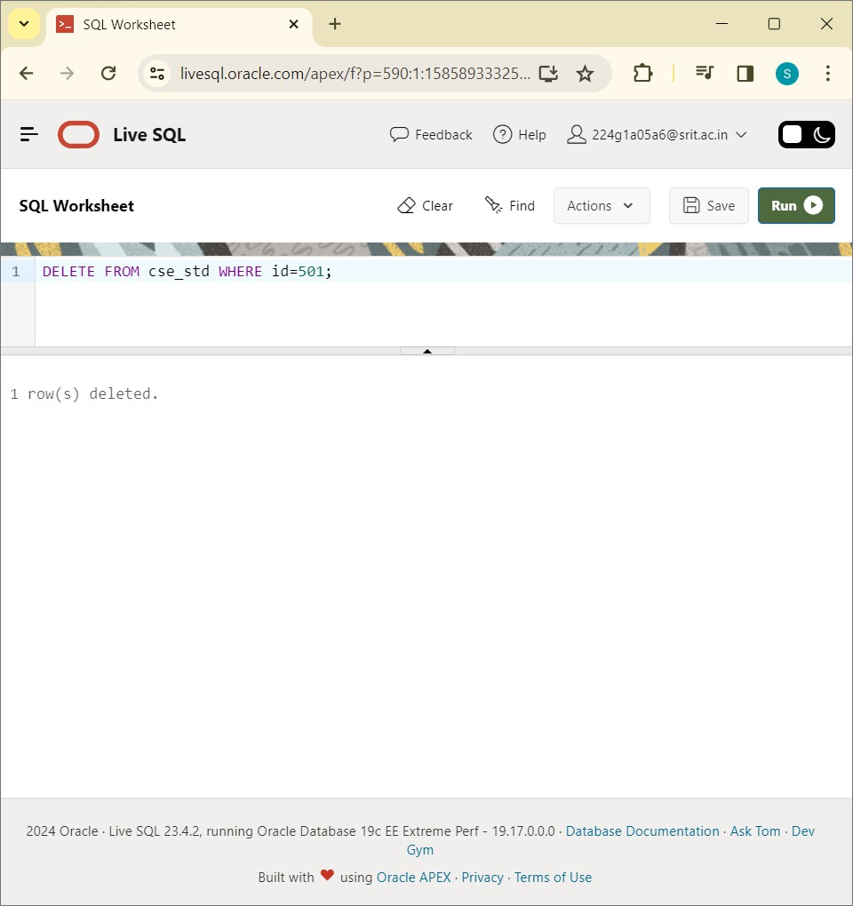

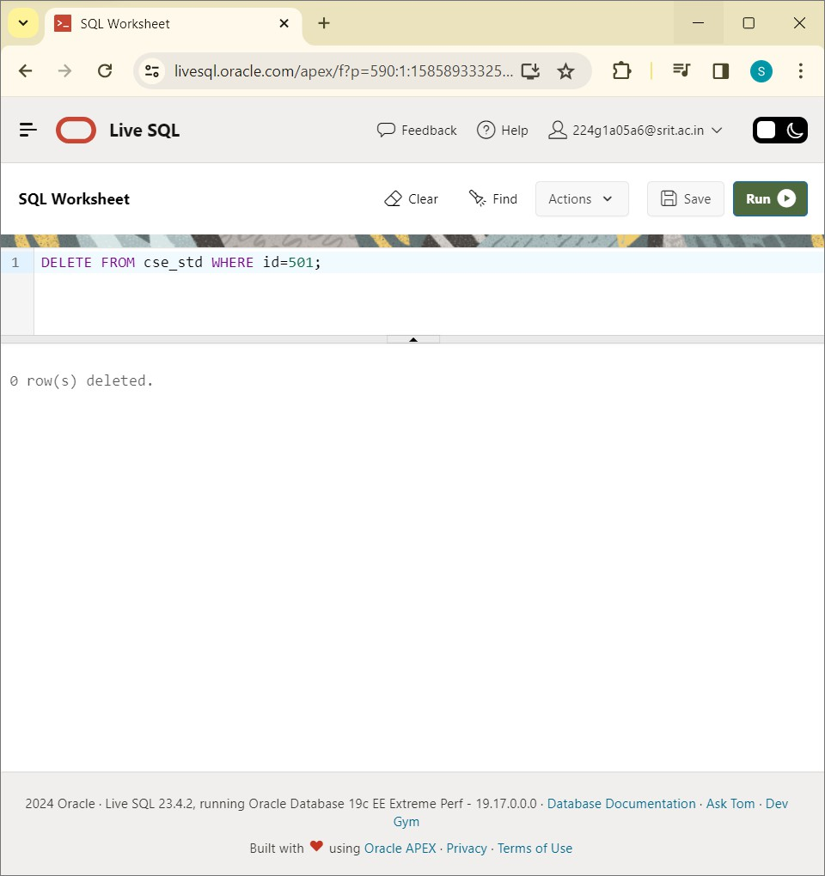

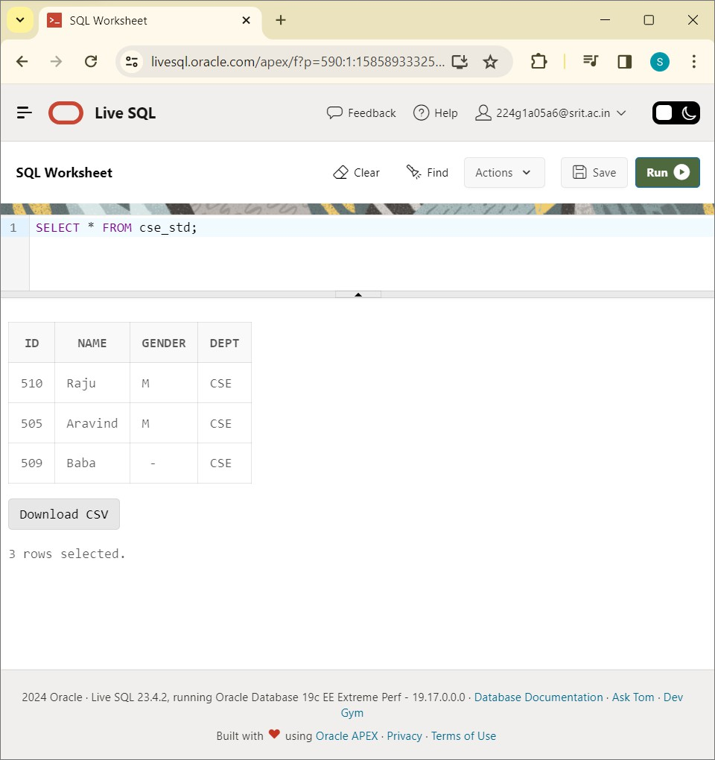DELETE FROM cse_std WHERE id=501;

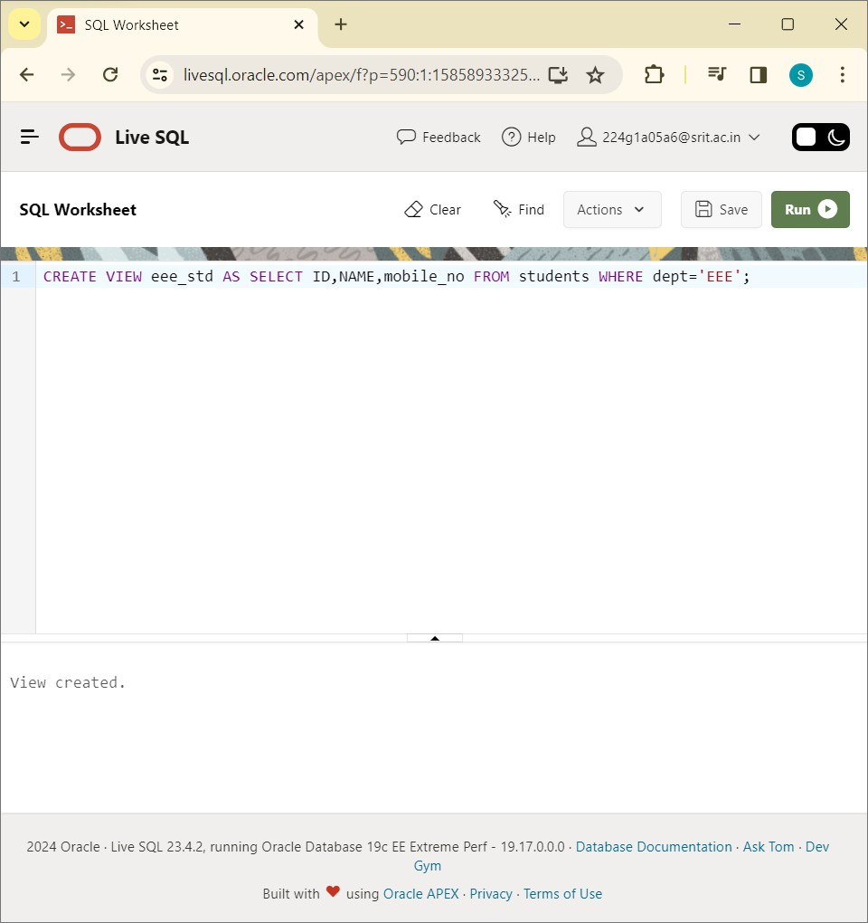

CREATE VIEW eee_std AS SELECT ID,NAME,mobile_no FROM students WHERE dept='EEE':

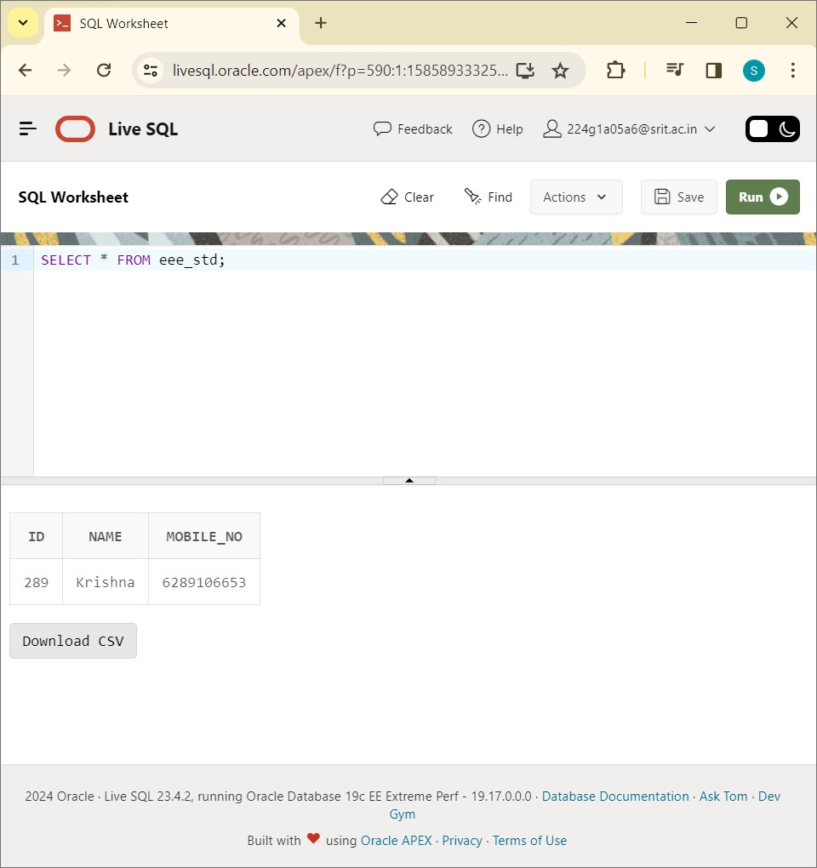

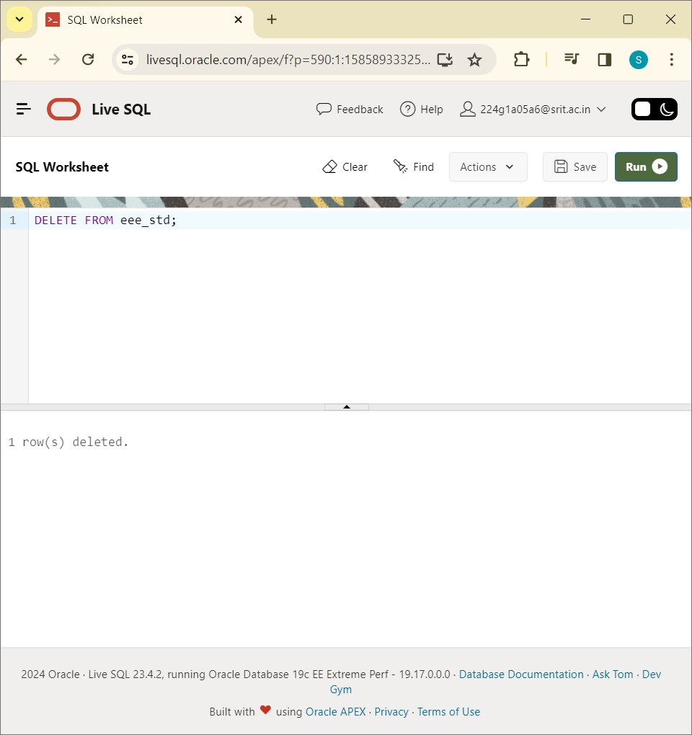

DELETE FROM eee_std:

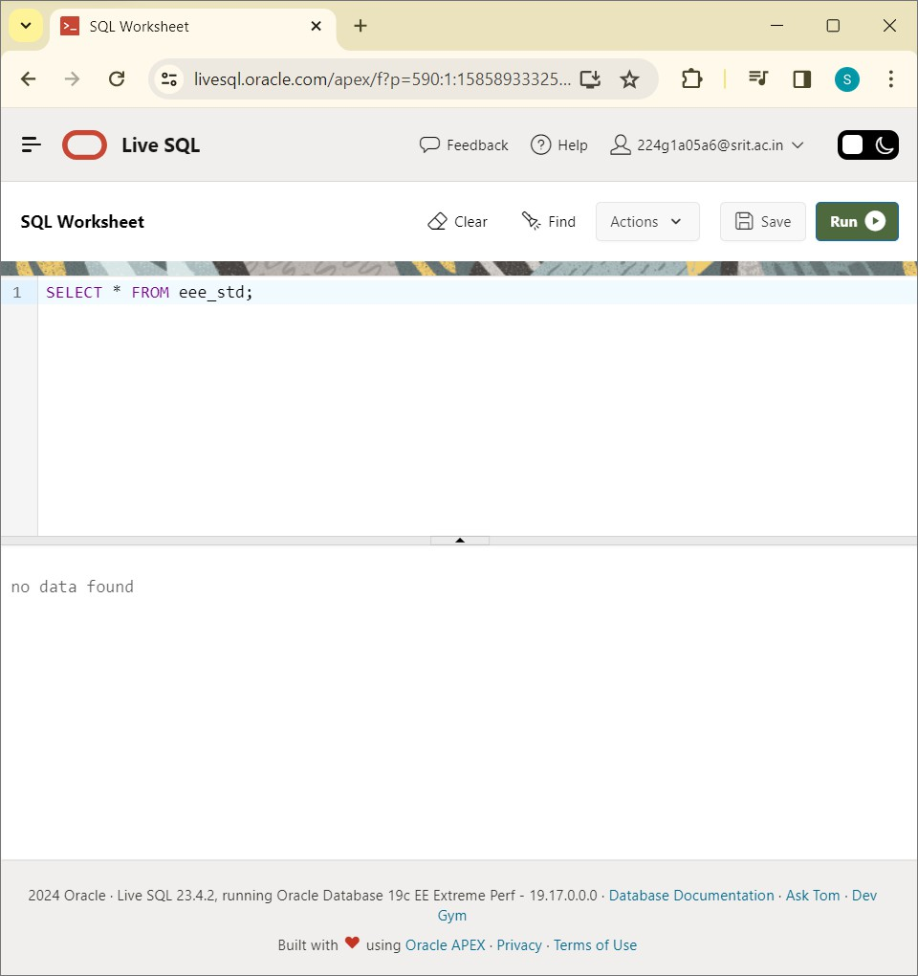

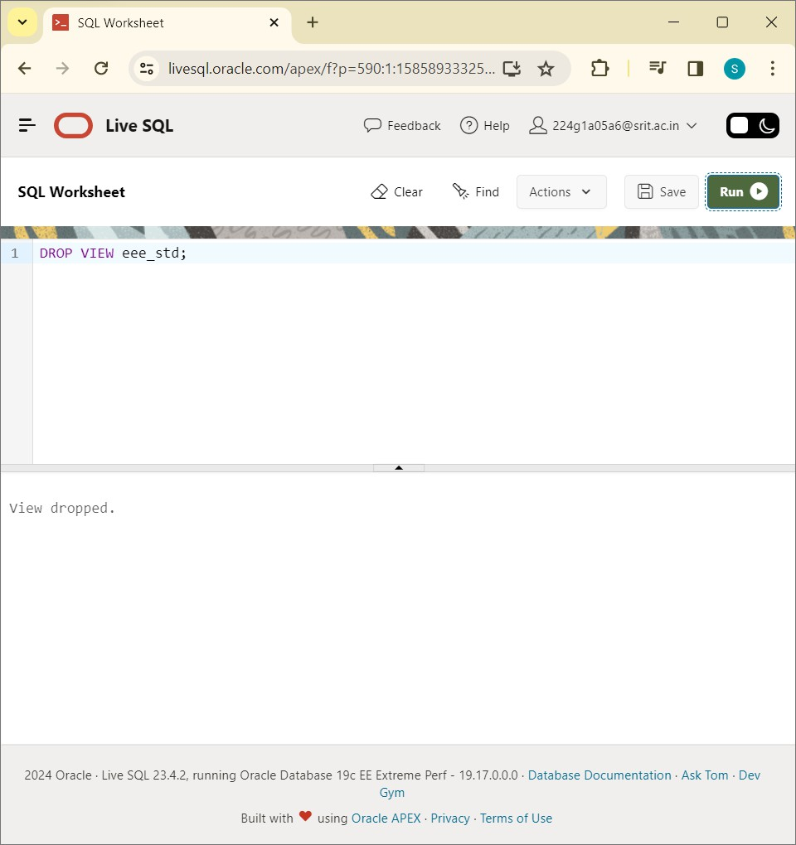

DROP VIEW eee_std:

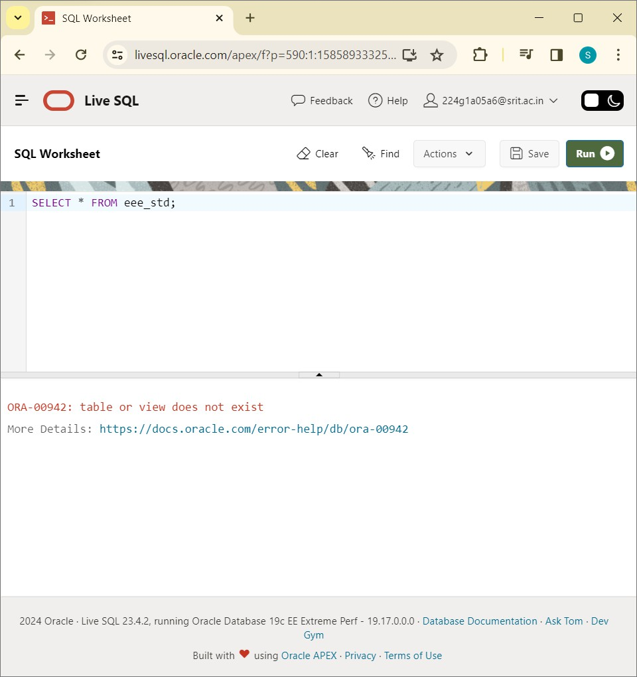

Write SQL Queries to perform RELATIONAL SET OPERATIONS ( i.e. UNION,UNION ALL, INTERSECT, MINUS, CROSS JOIN, NATURAL JOIN)?

CREATE TABLE instructor:

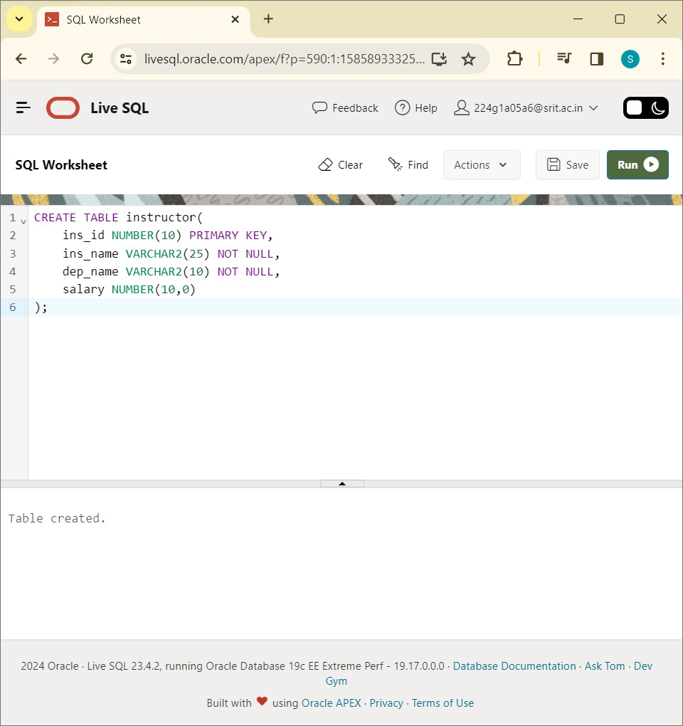

CREATE TABLE department:

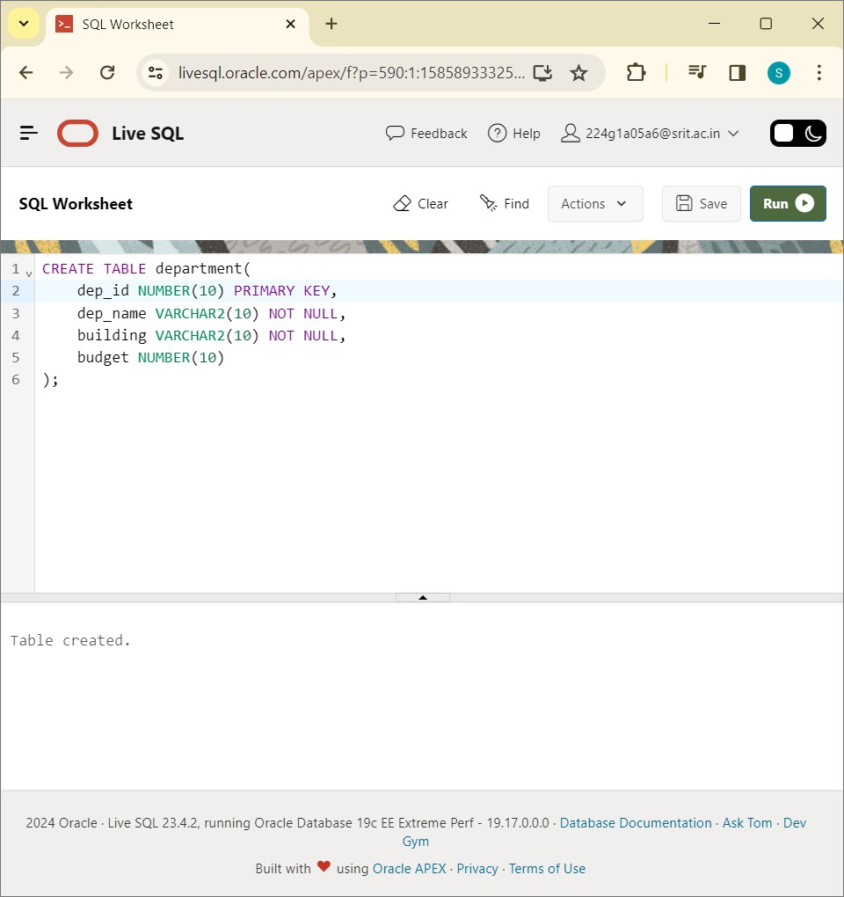

Write SQL Queries to perform SPECIAL OPERATIONS ( i.e. ISNULL, BETWEEN, LIKE, IN, EXISTS)?

CREATE TABLE insructors:

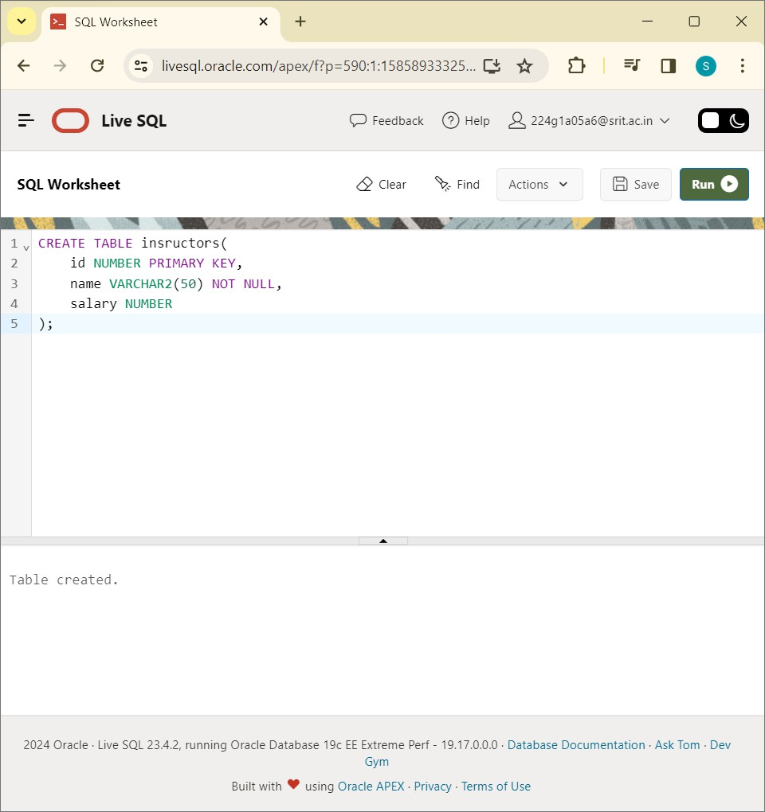

CREATE TABLE departments:

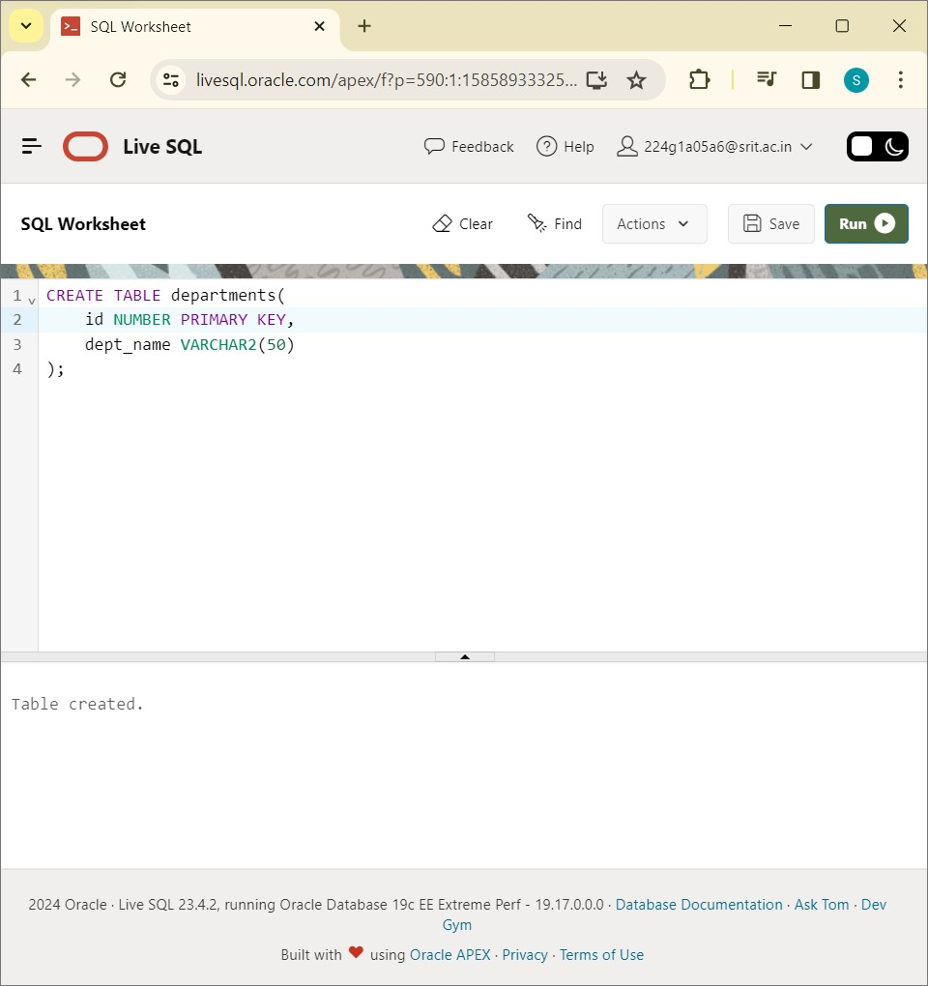

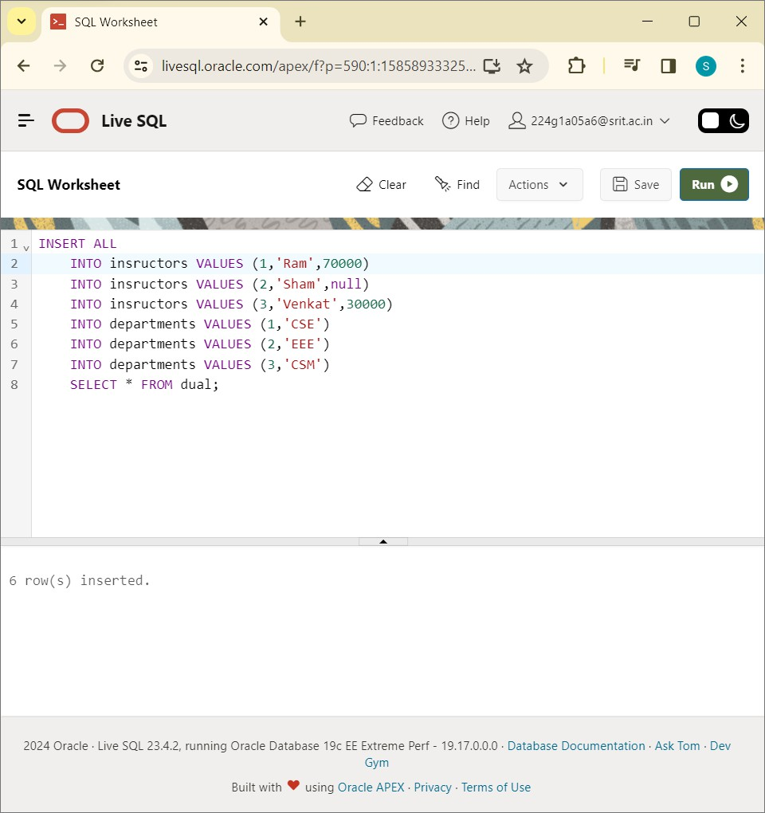

SELECT * FROM insructors:

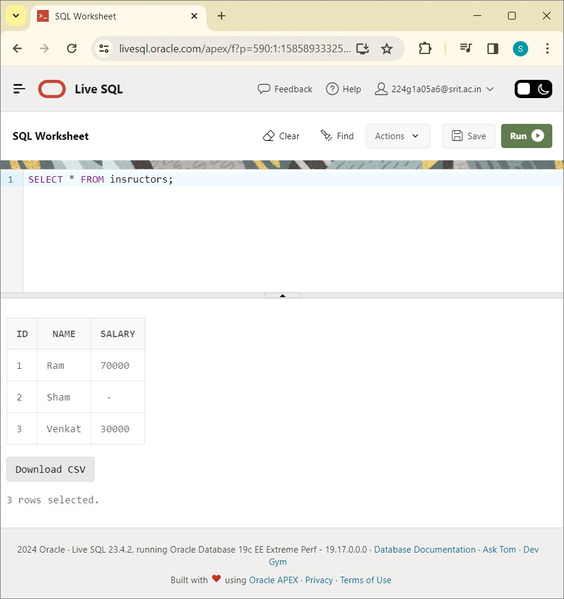

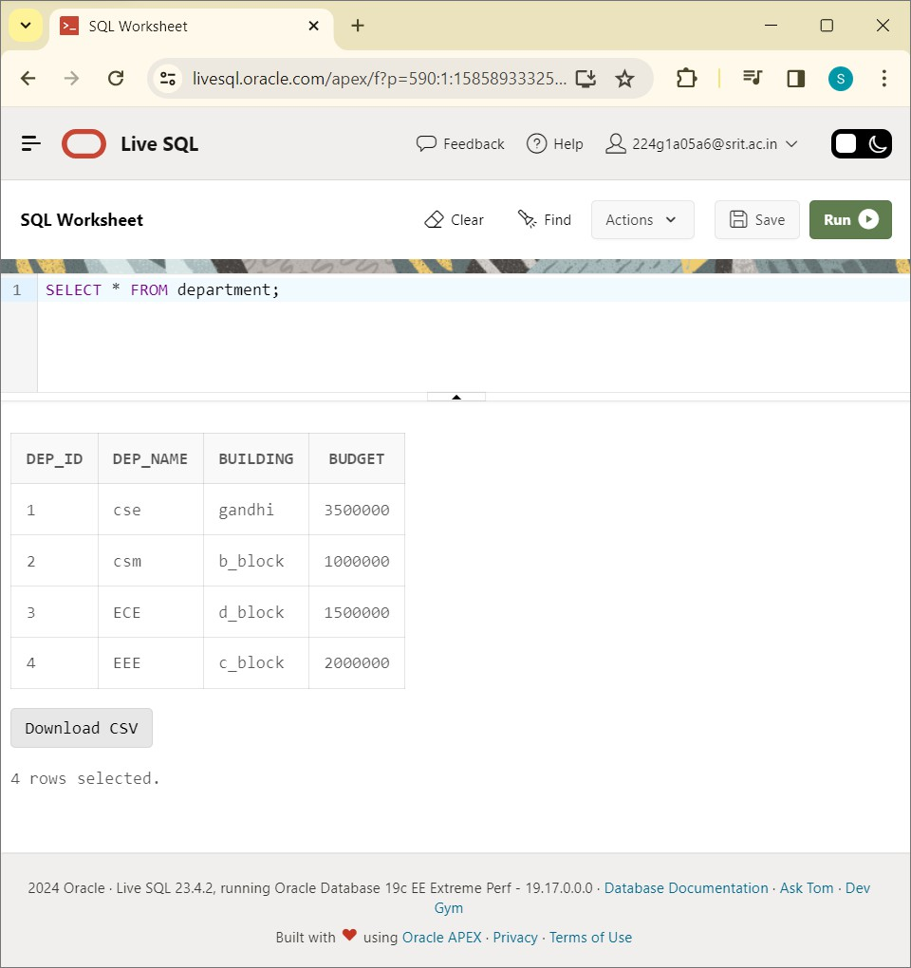

SELECT * FROM insructors WHERE salary IS NULL;

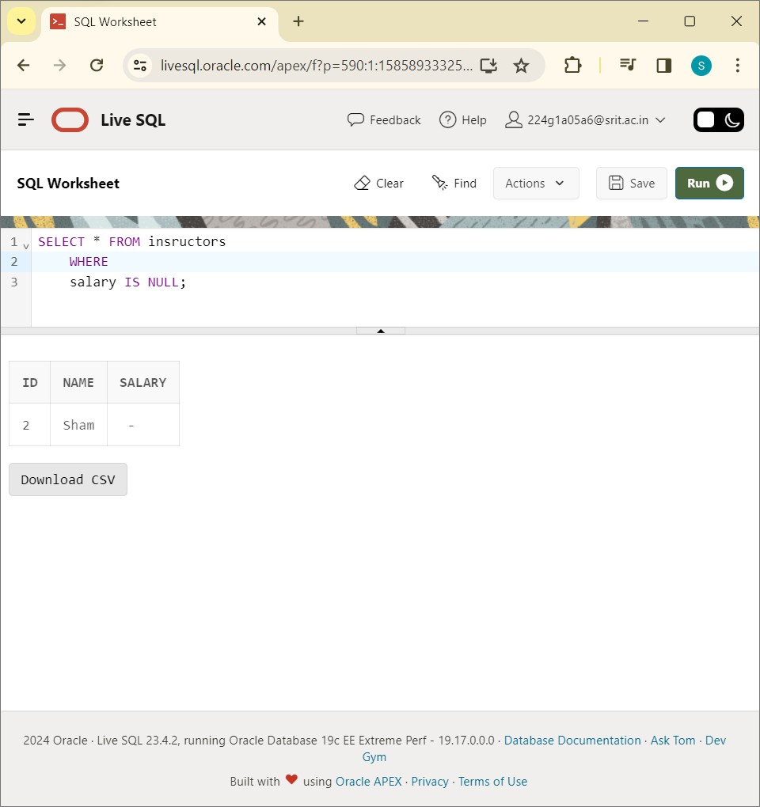

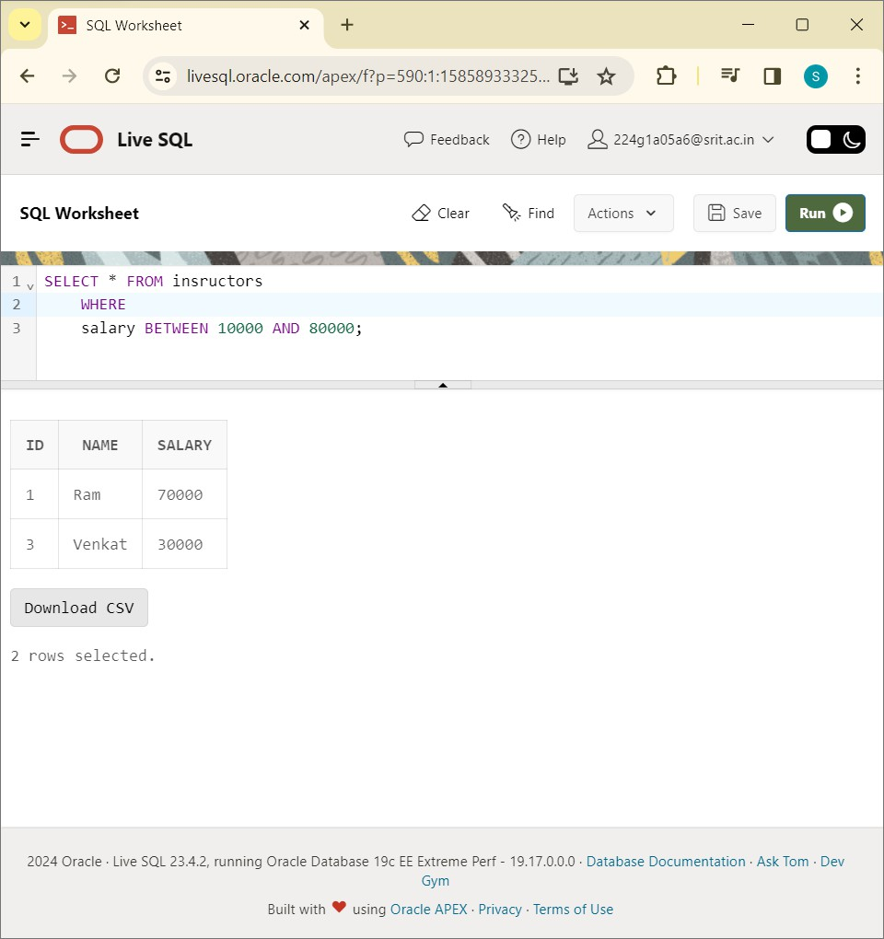

SELECT * FROM insructors WHERE name LIKE 'R%':

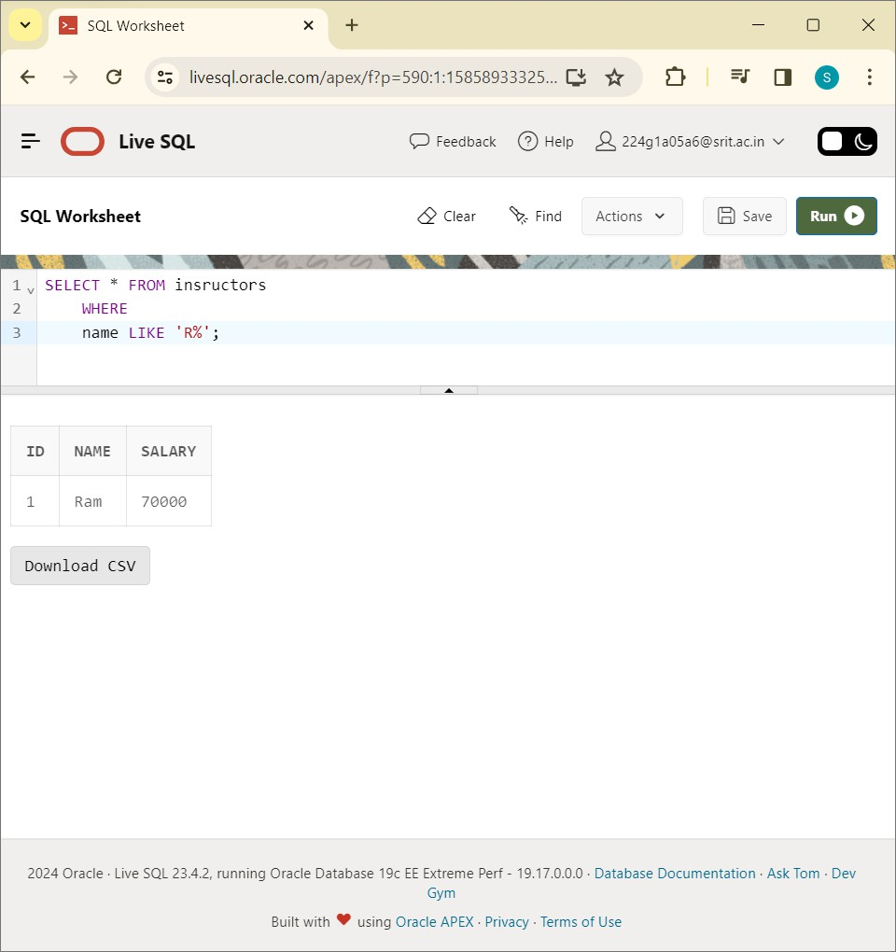

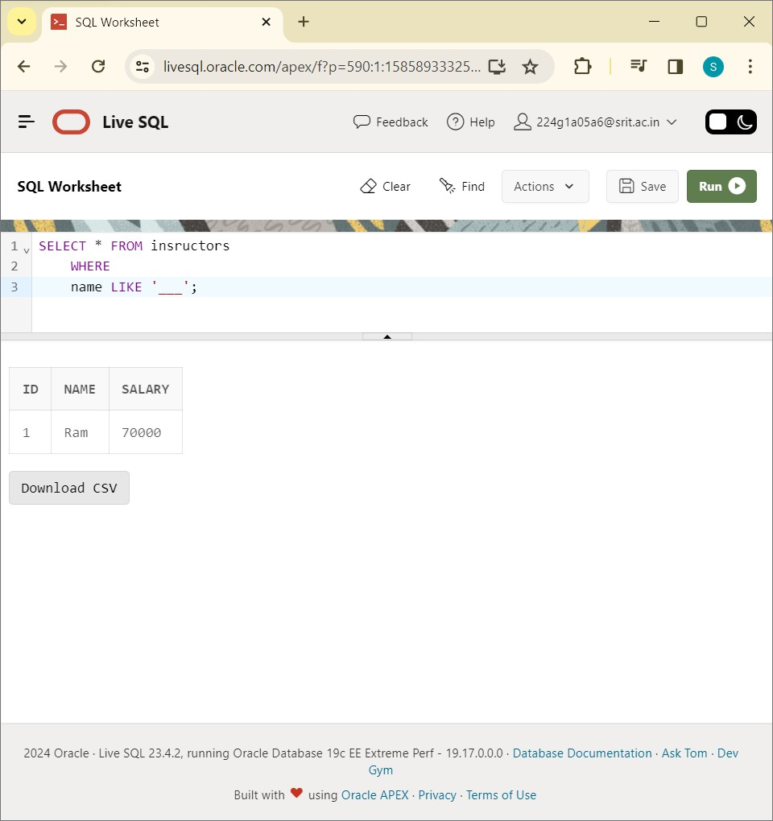

SELECT * FROM insructors WHERE Salary IN(10000,30000,20000):

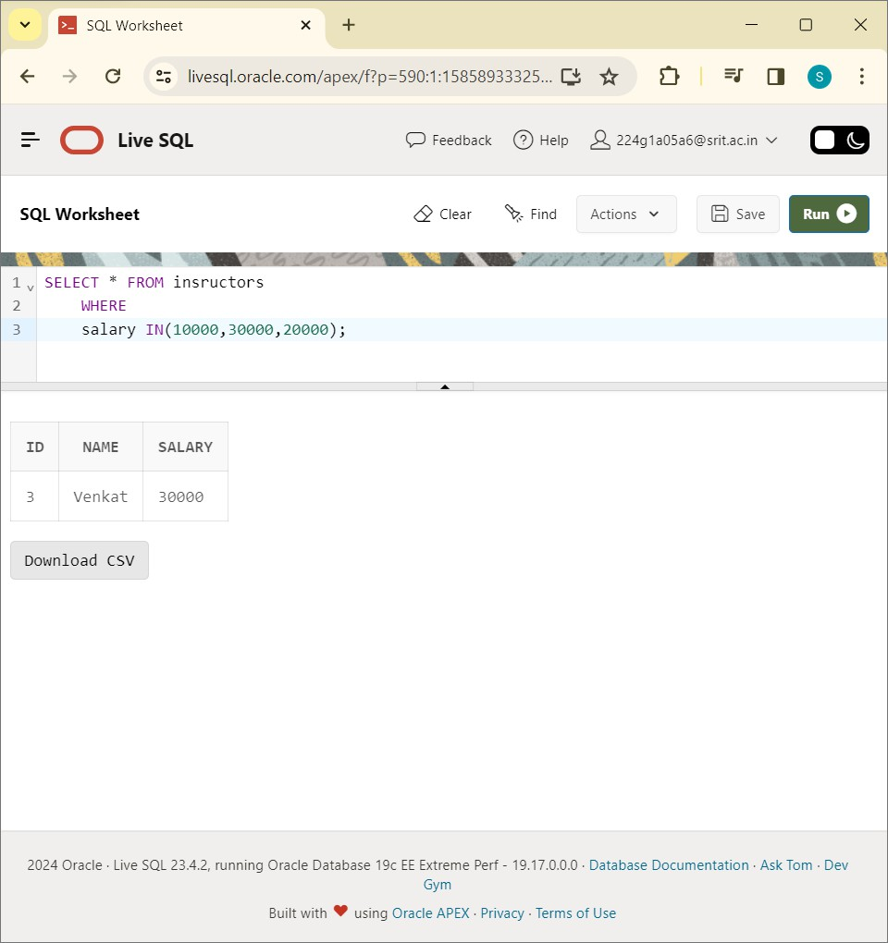

insructors.id=departments.id):

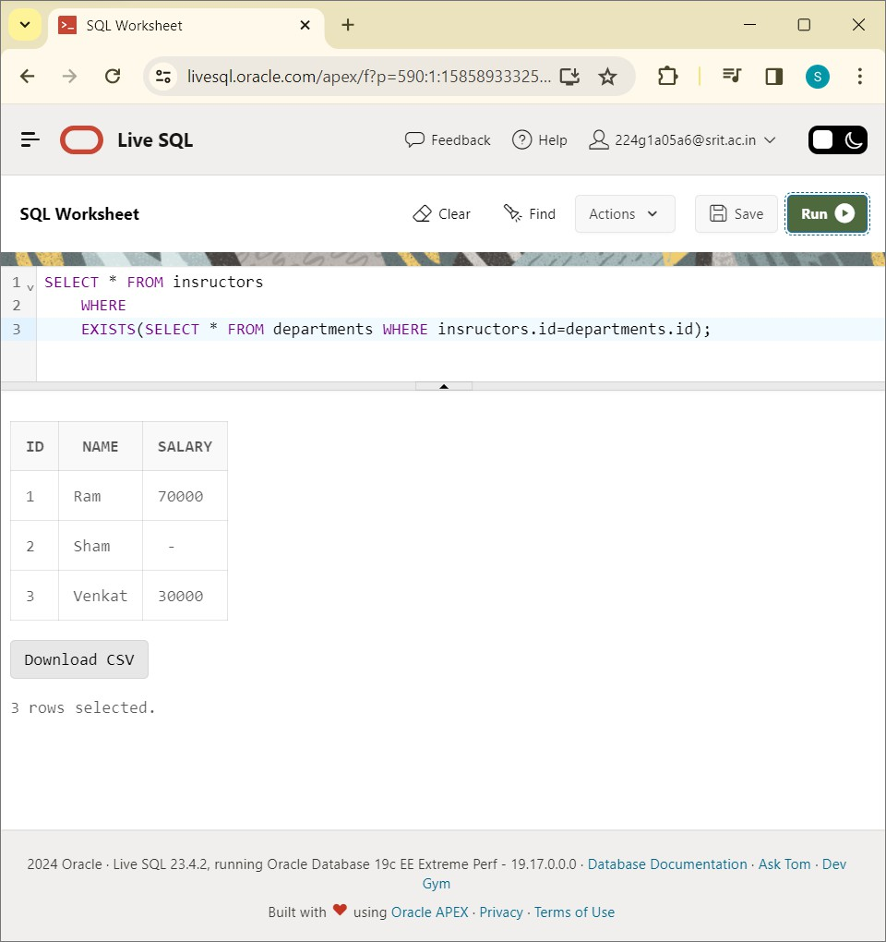

CONCLUSION : SQL Queries to perform RELATIONAL SET Operations ( I.e. ISNULL, BETWEEN, LIKE, IN, EXISTS)

# EXPERIMENT-6

Write SQL Queries to perform JOIN OPERATIONS ( i.e. CONDITIONAL JOIN, EQUI JOIN, LEFT OUTER JOIN, RIGHT OUTER JOIN, FULL OUTER JOIN)?

CREATE TABLE student:

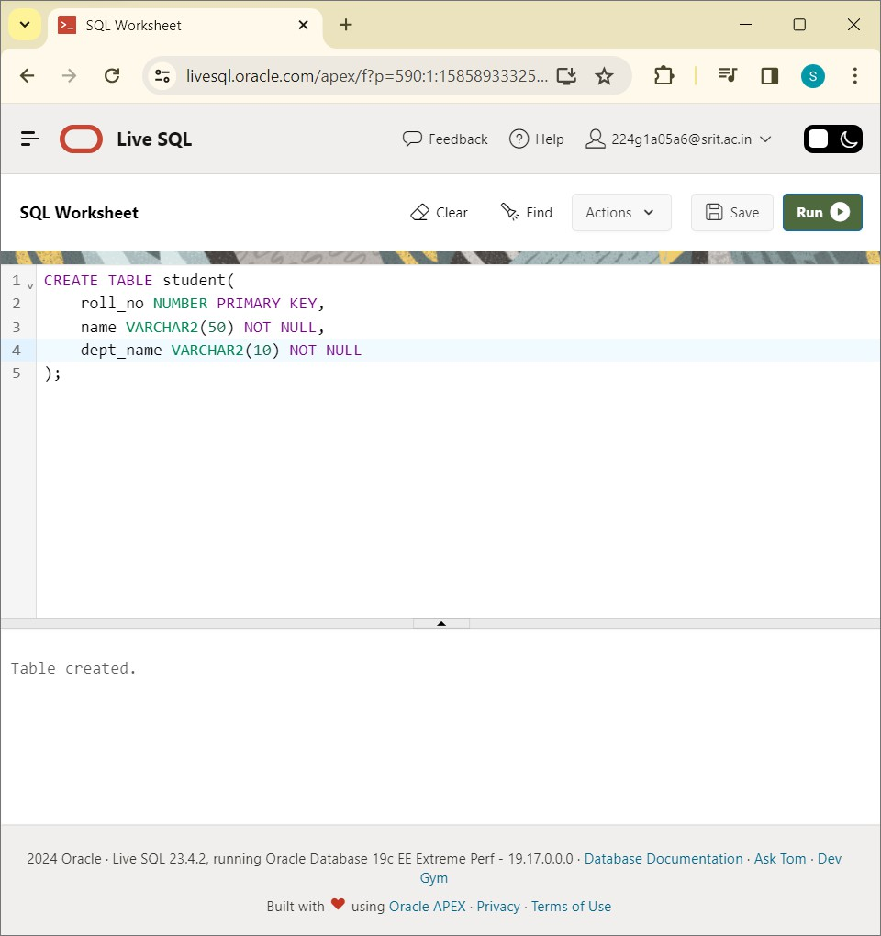

CREATE TABLE blocks:

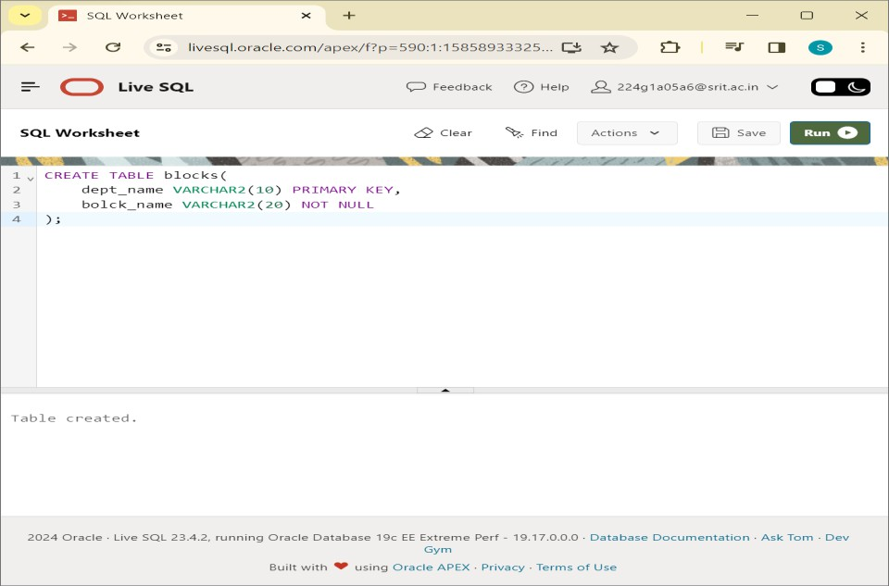

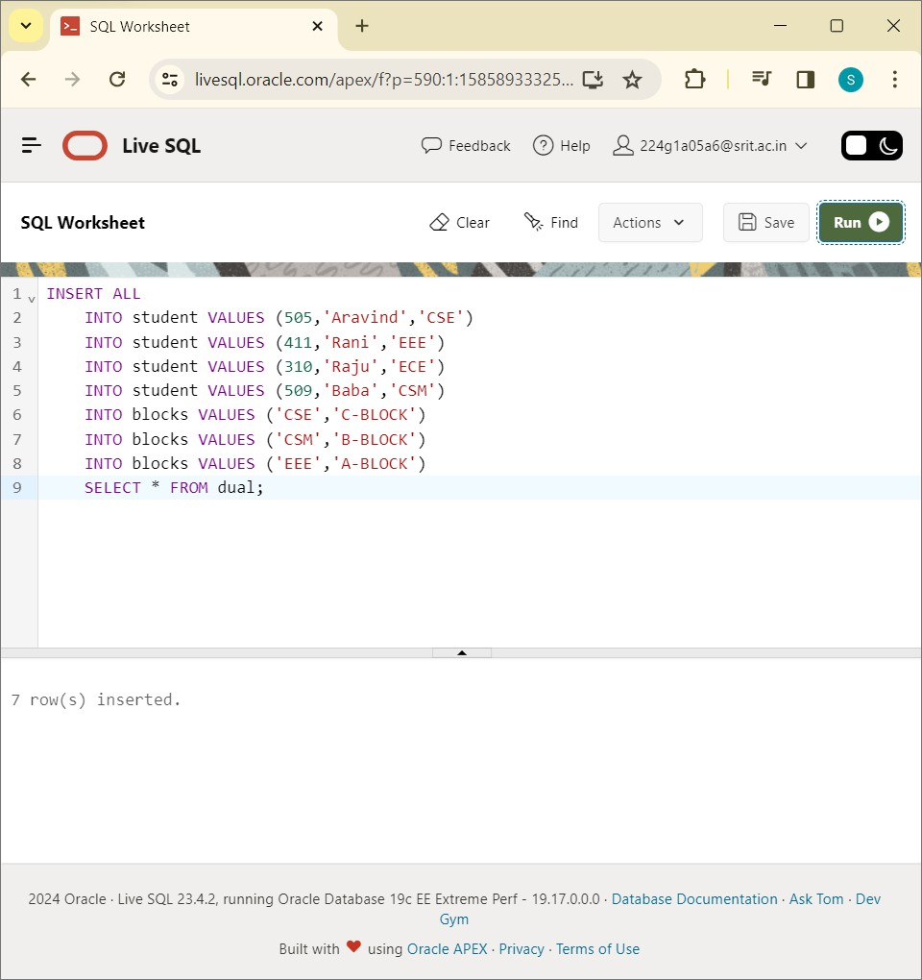

SELECT * FROM student:

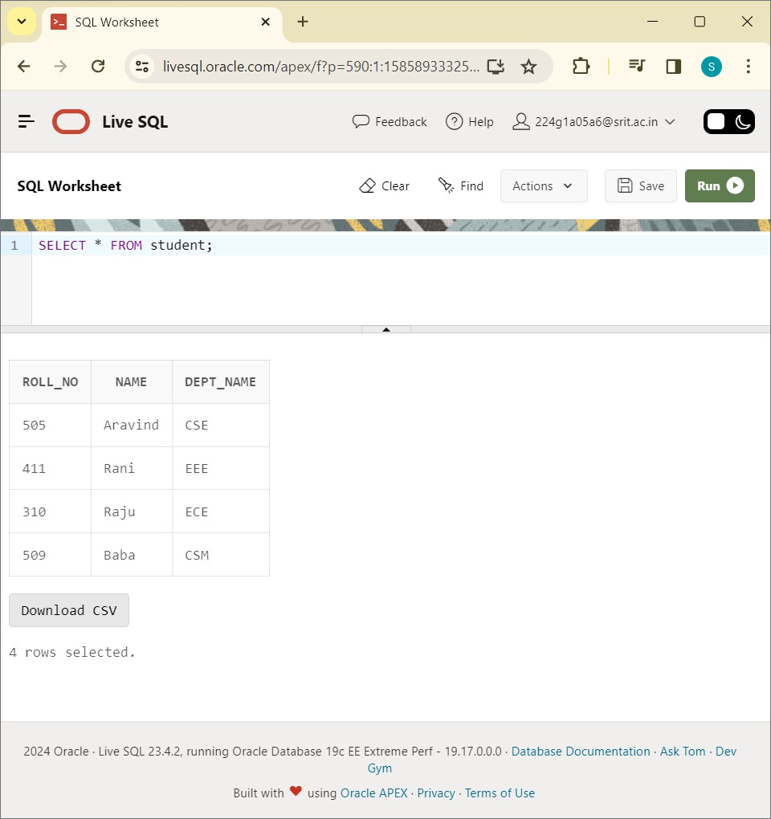

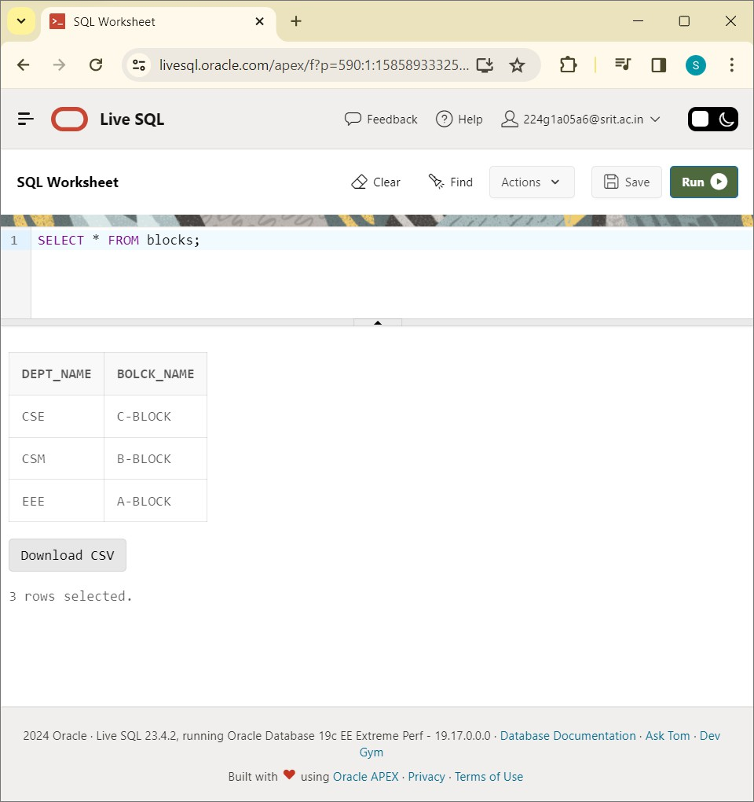

SELECT * FROM student JOIN blocks ON student.dept_name=blocks.dept_name:

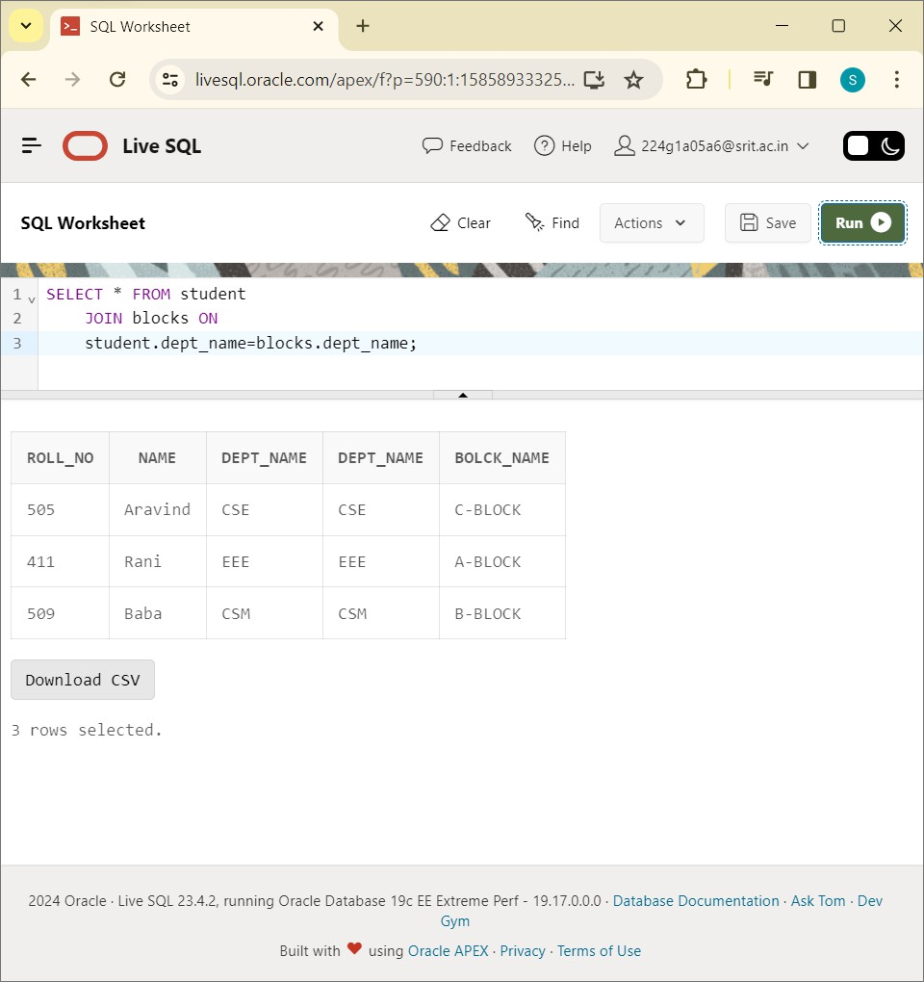

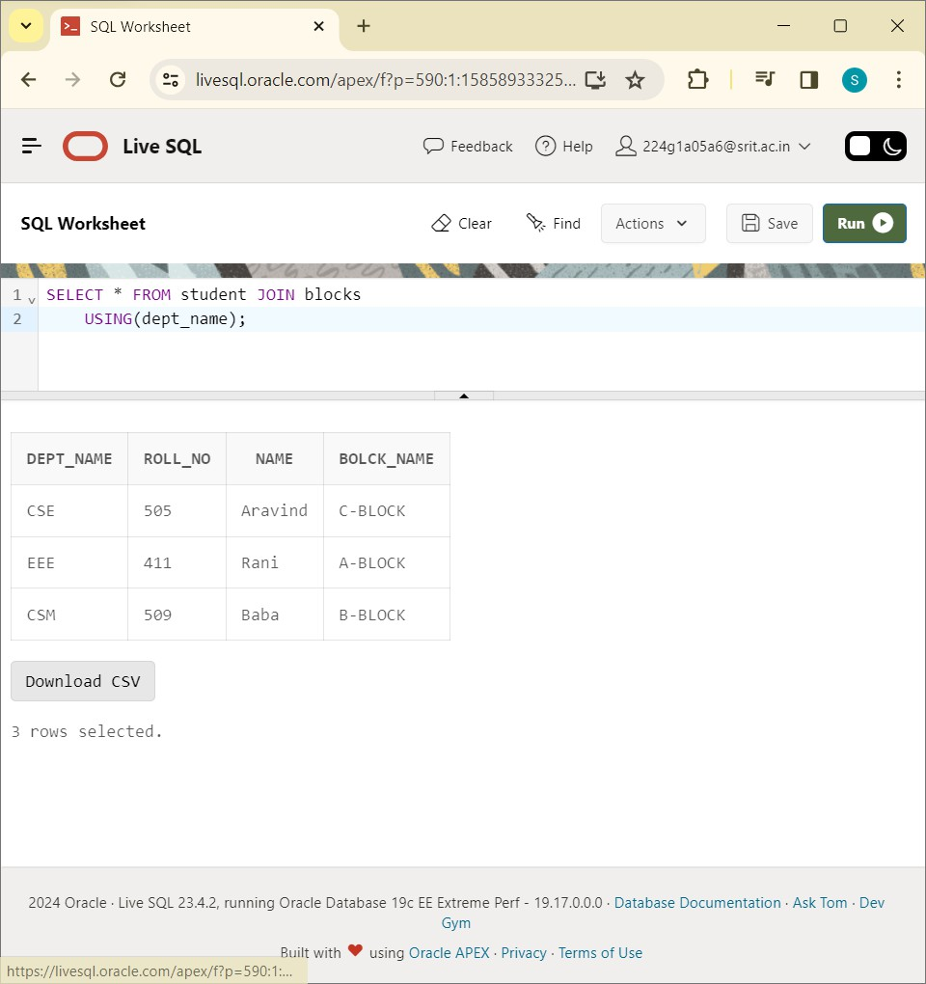

SELECT * FROM student LEFT OUTER JOIN blocks ON student.dept_name=blocks.dept_name:

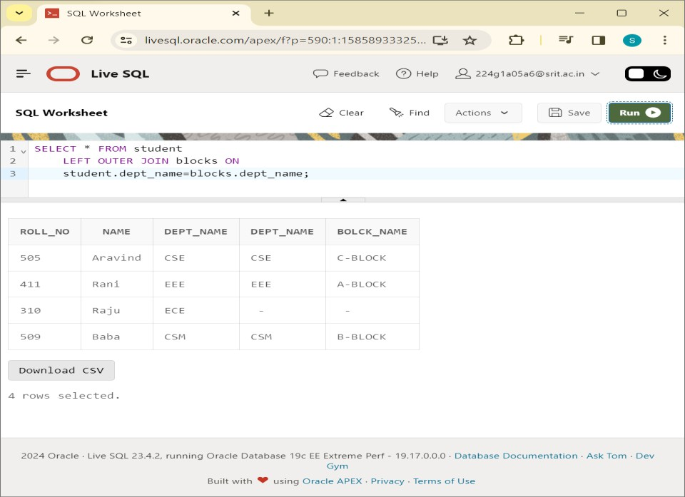

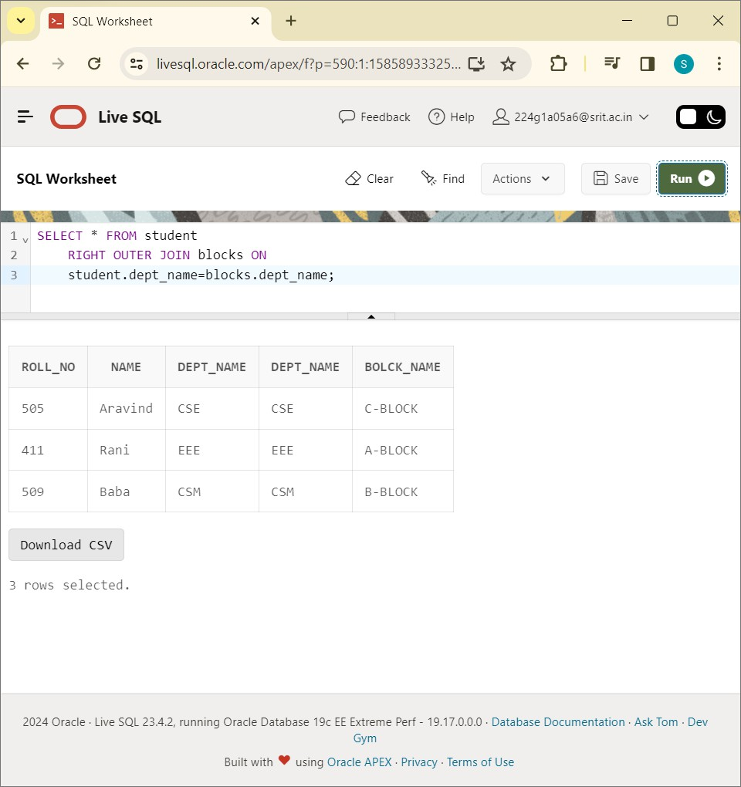

SELECT * FROM student FULL OUTER JOIN blocks ON student.dept_name=blocks.dept_name:

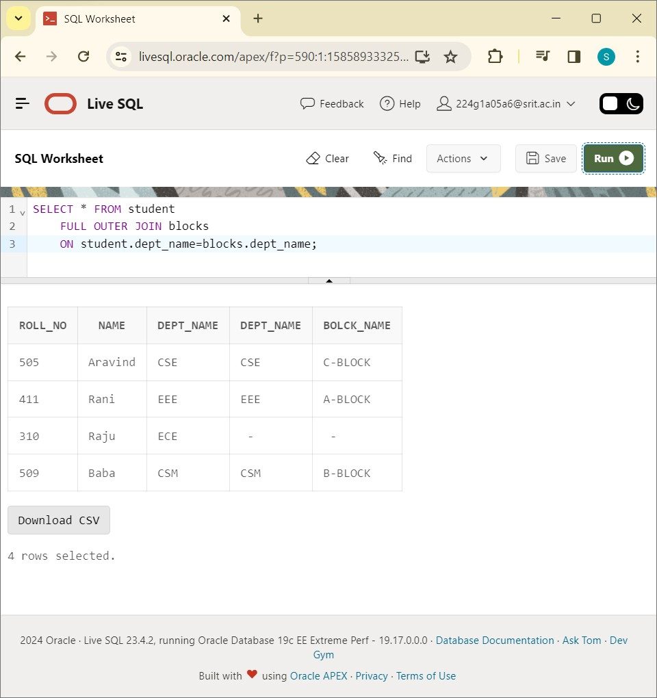

RIGHT OUTER, FULL OUTER JOIN) is successfully executed in SQL plus.

# EXPERIMENT-7

Write SQL Queries to perform AGGREGRATE OPERATIONS (i.e. SUM, COUNT, AVG, MIN, MAX)?

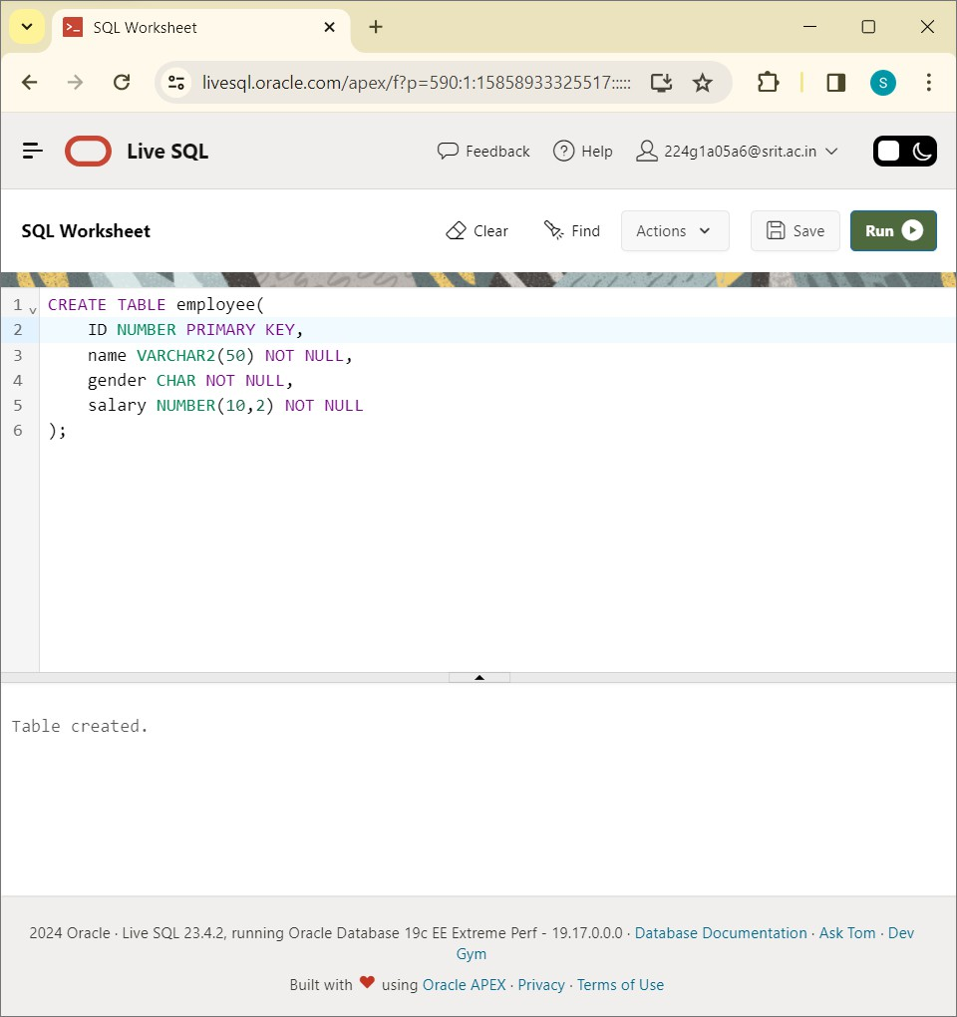

INSERT ALL VALUES INTO EMPLOYEE VALUES:

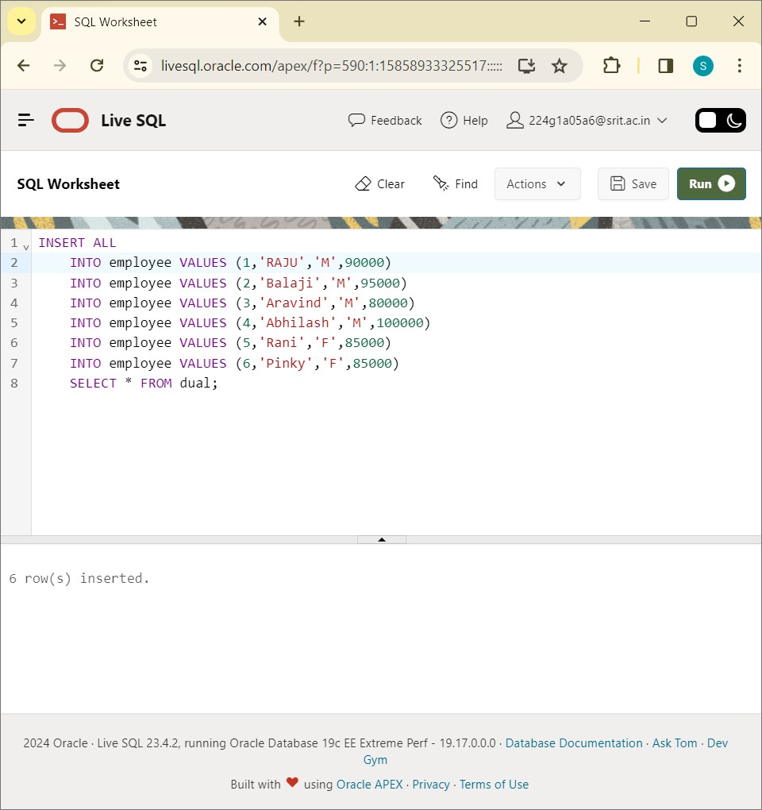

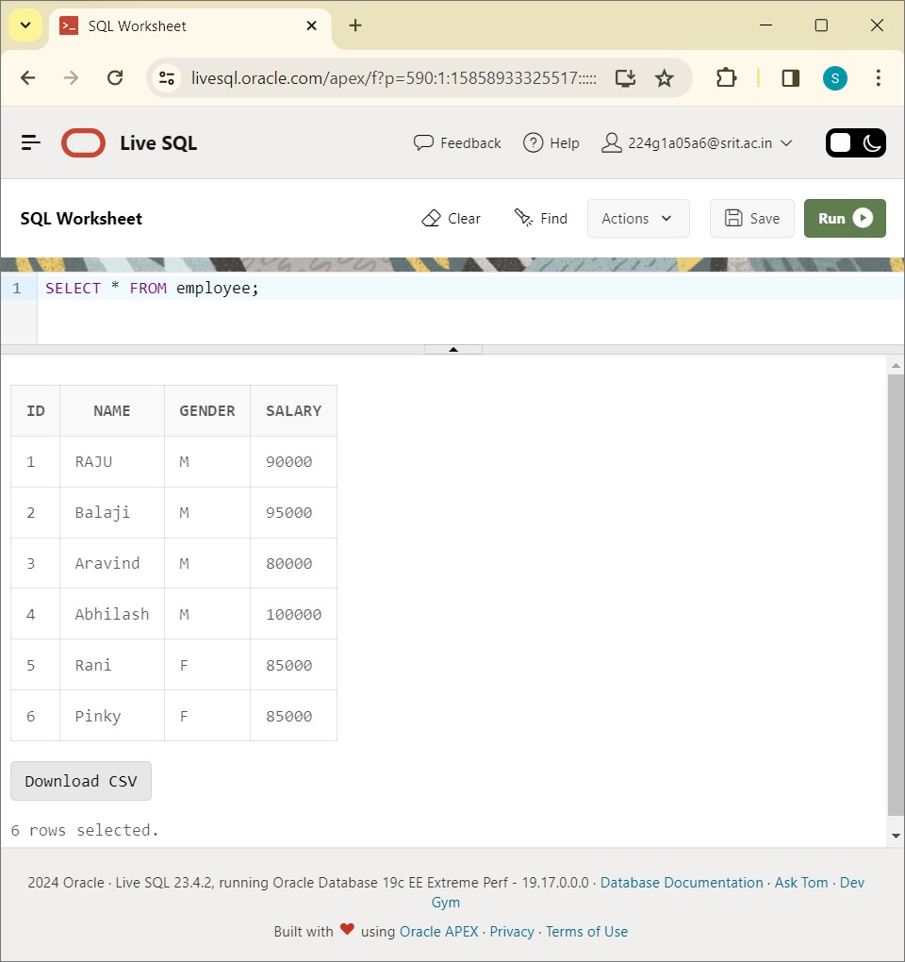

SELECT SUM(salary) FROM employee:

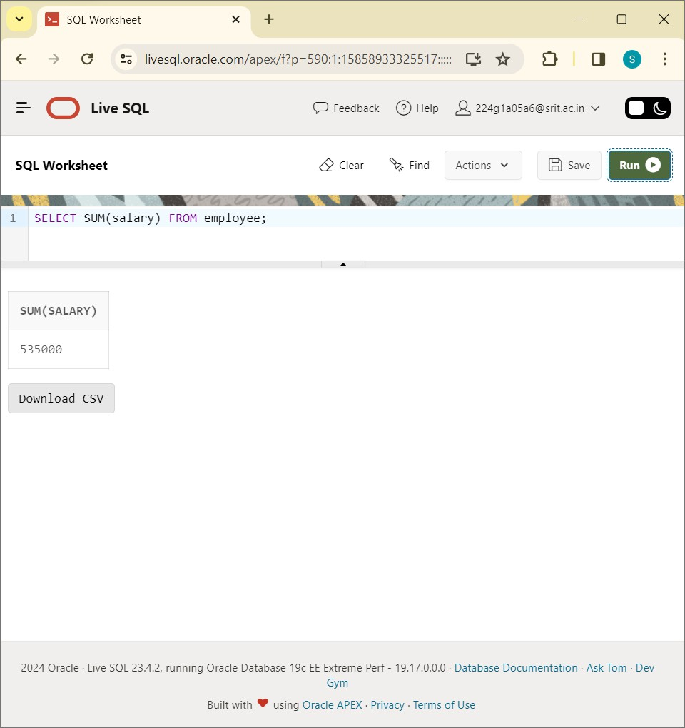

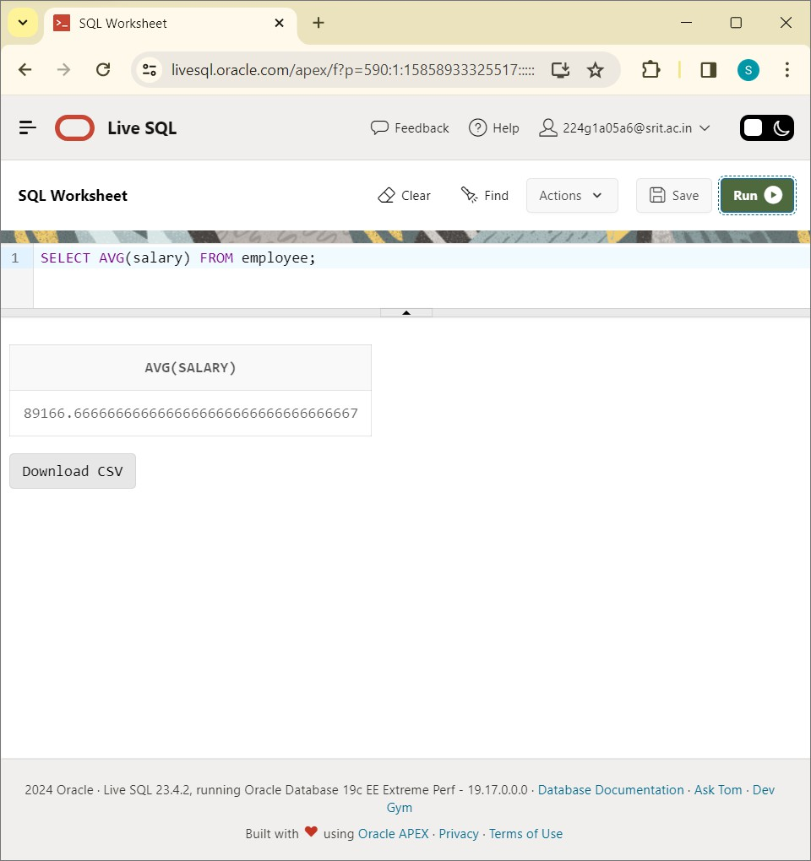

SELECT COUNT(salary) FROM employee:

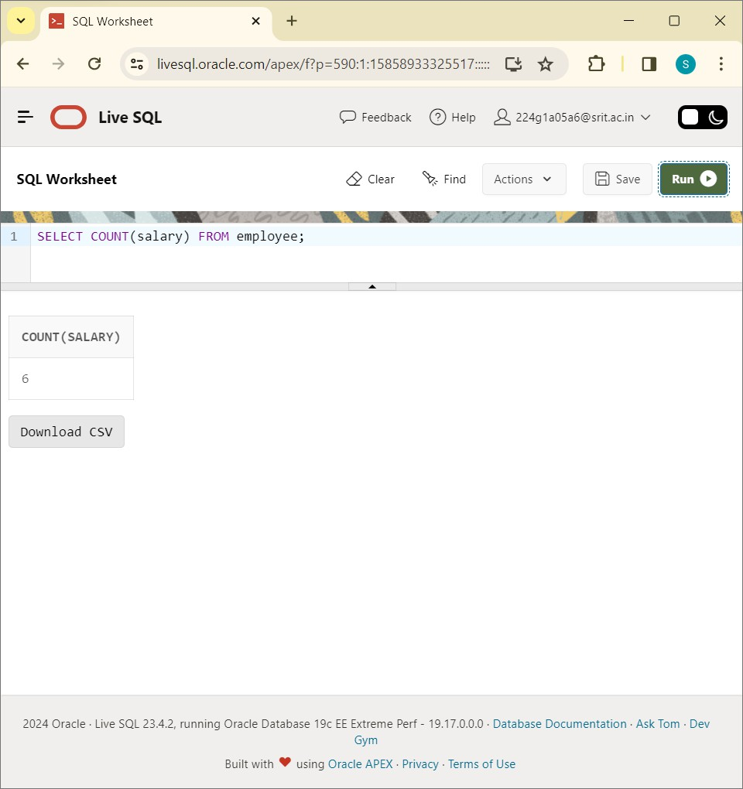

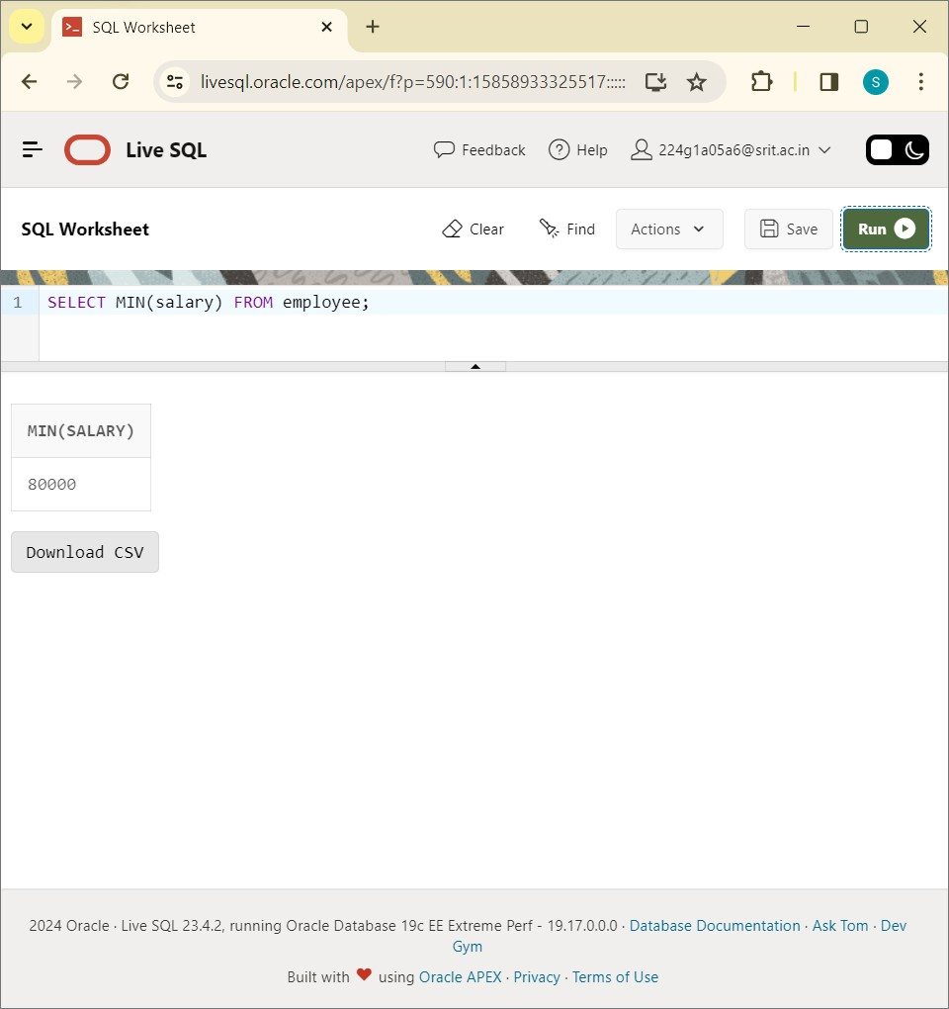

SELECT MAX(salary) FROM employee:

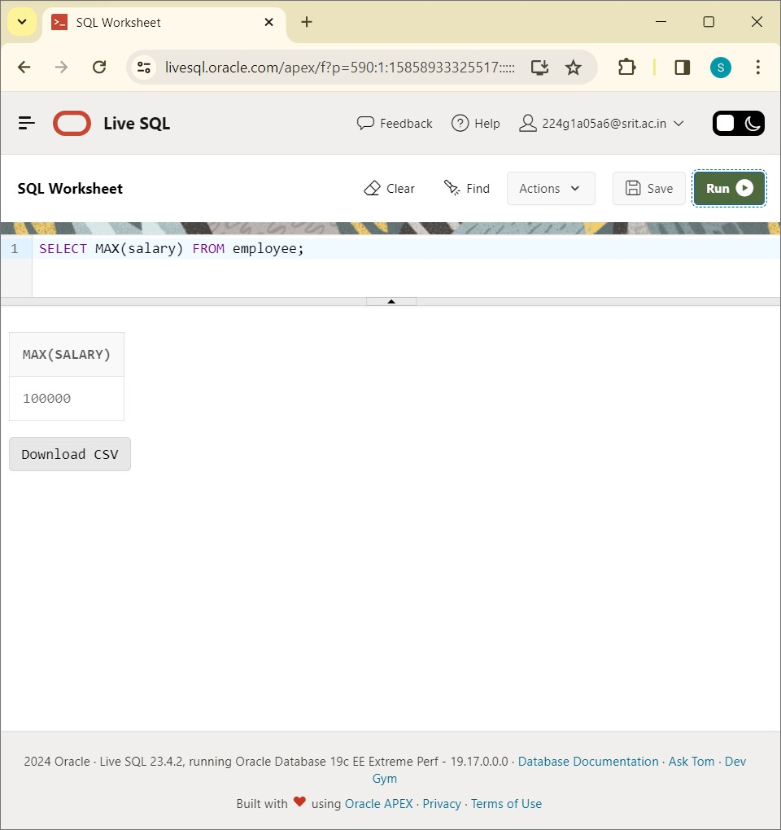

CONCLUSION: SQL Queries to perform AGGREGRATE OPERATIONS is successfully executed in sql plus.

# EXPERIMENT-8

Write SQL Queries to perform ORACLE BUILT IN FUNCTIONS (i.e. DATE,TIME)? CREATE NAMES TABLES:

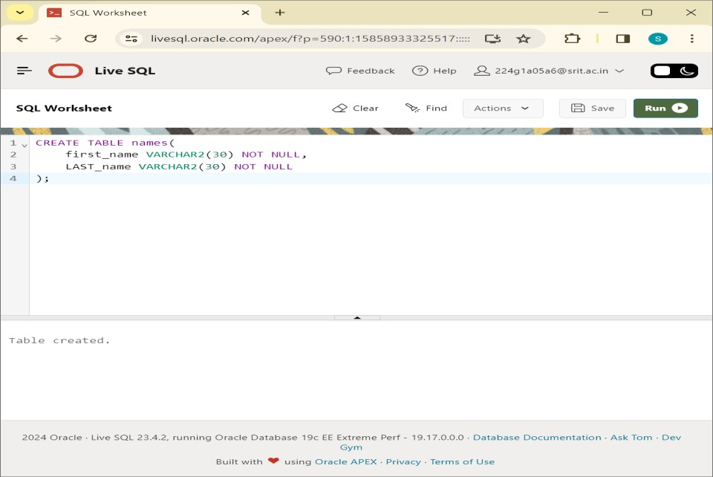

INSERT VALUES INTO NAMES:

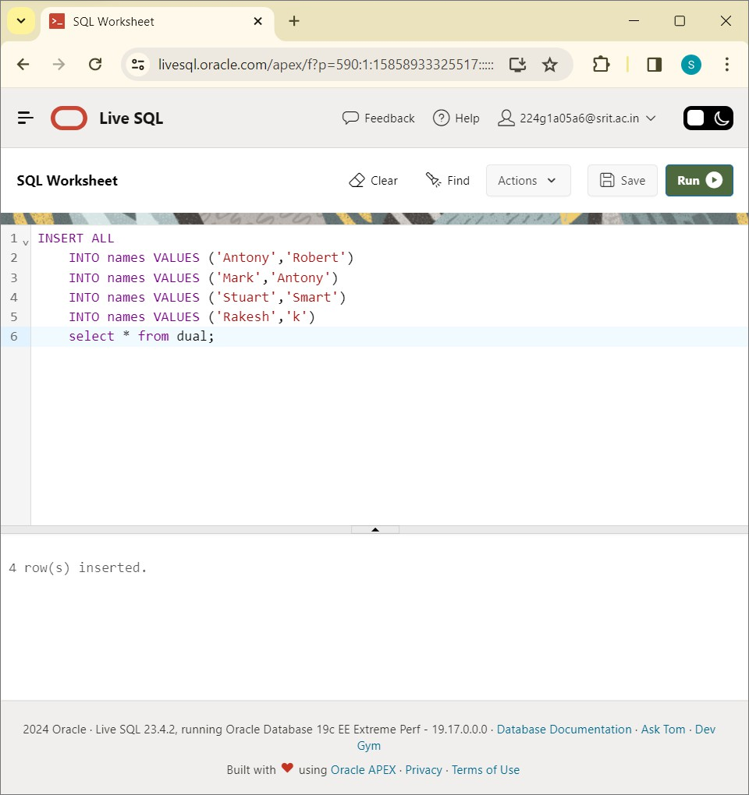

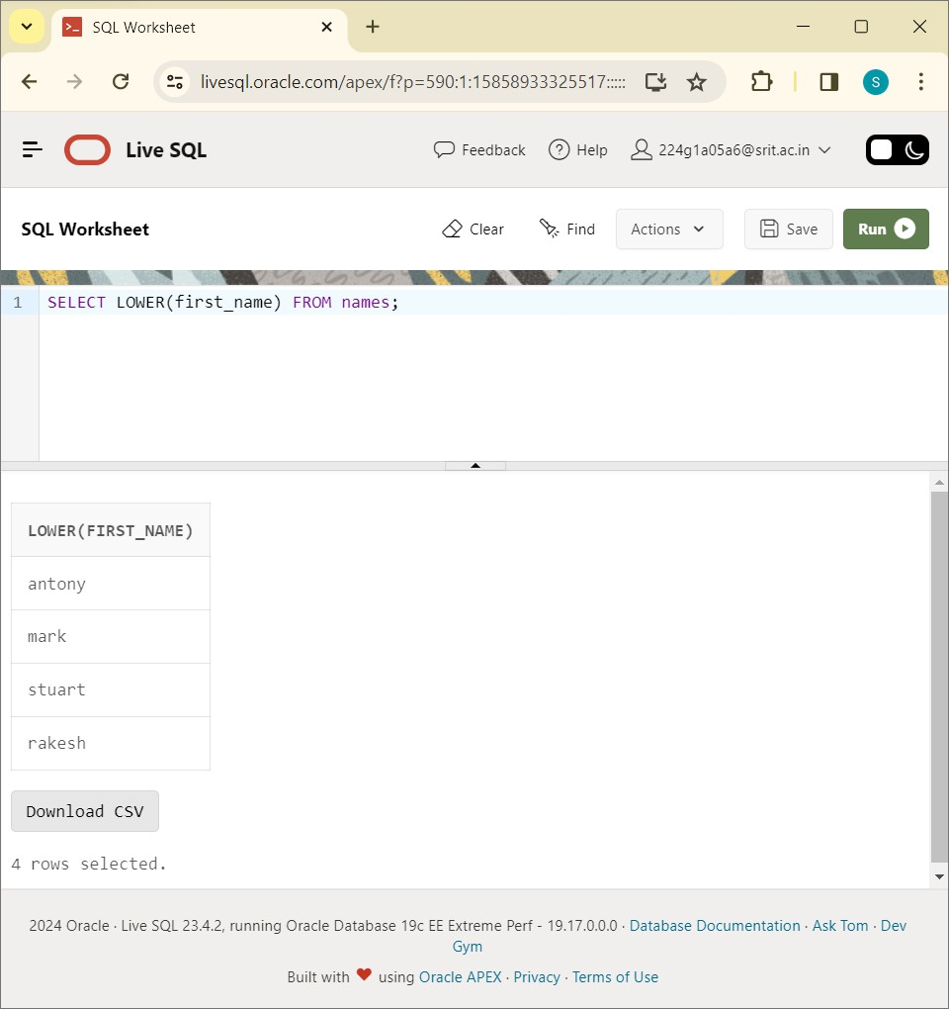

SELECT UPPER(first_name) FROM names:

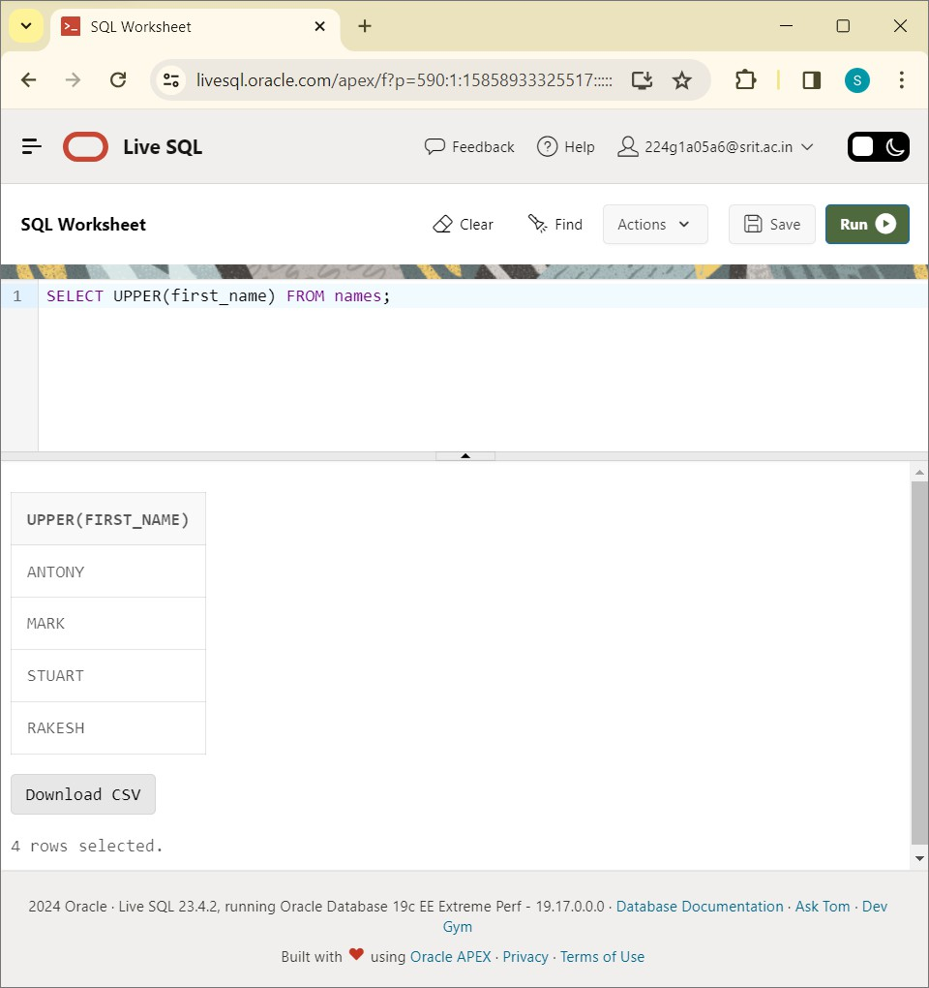

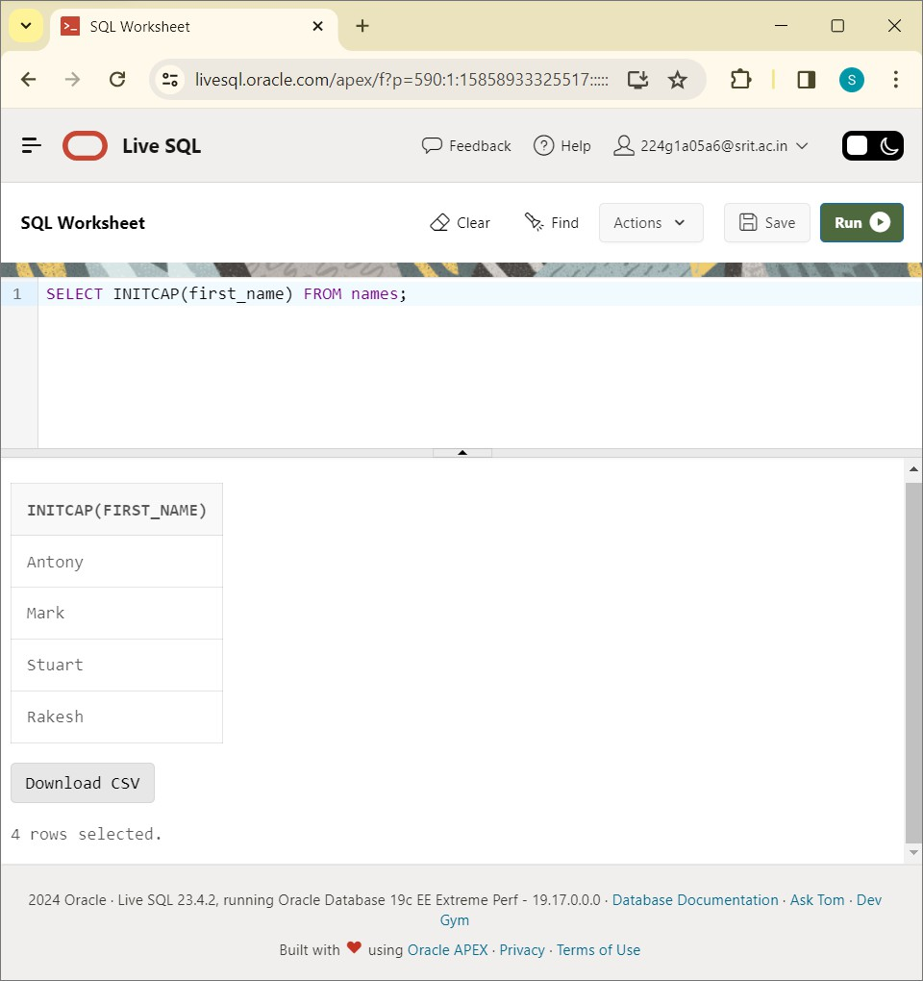

SELECT CONCAT(first_name,last_name) FROM names:

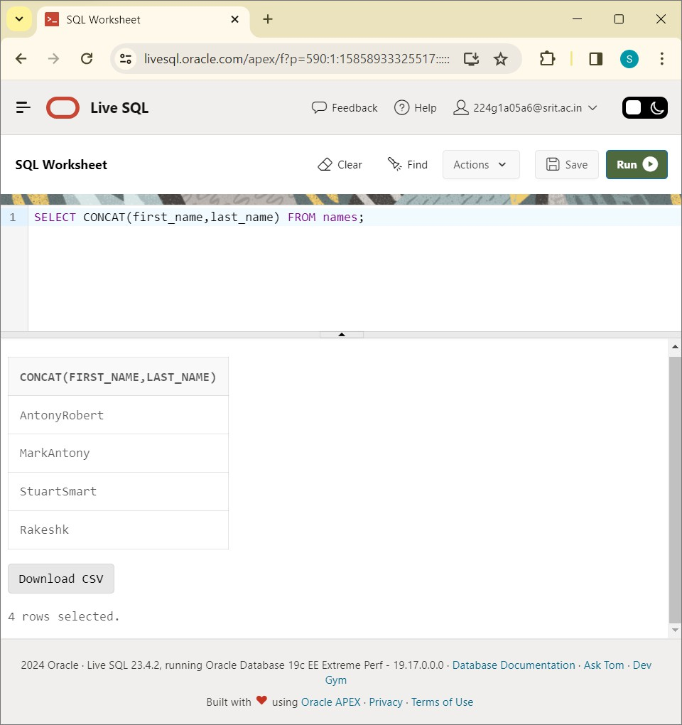

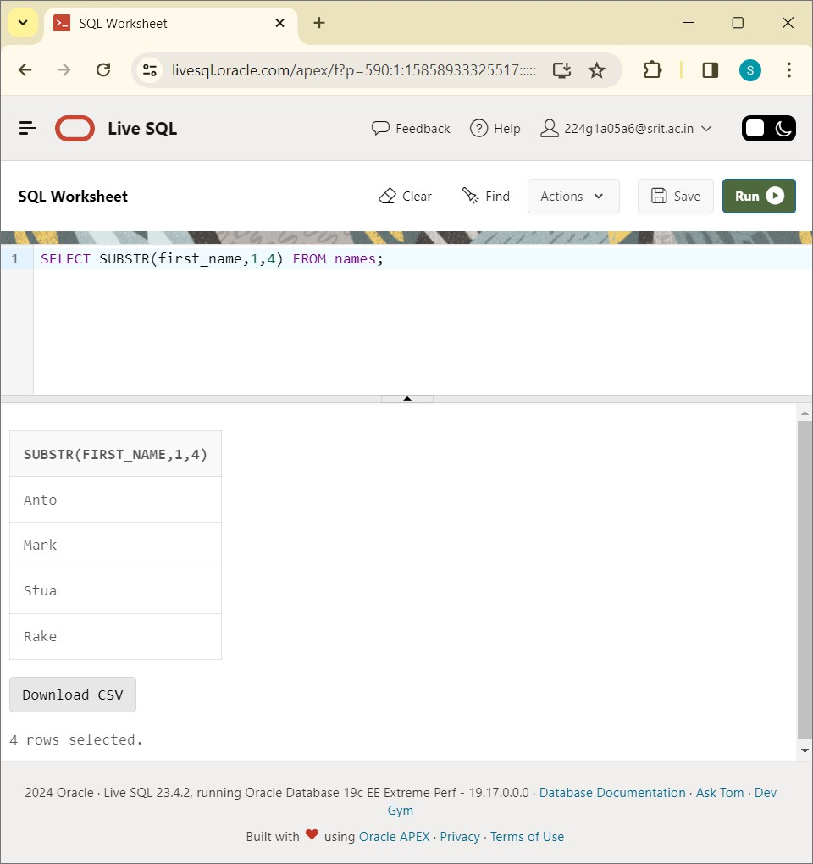

SELECT LENGTH(first_name) FROM names:

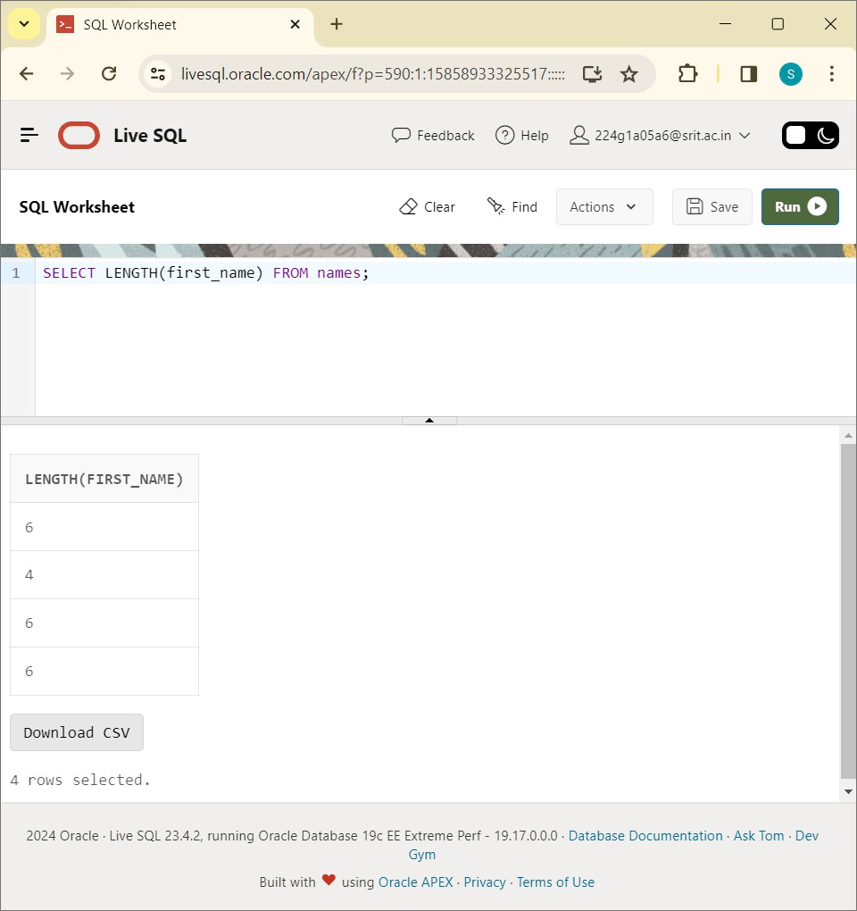

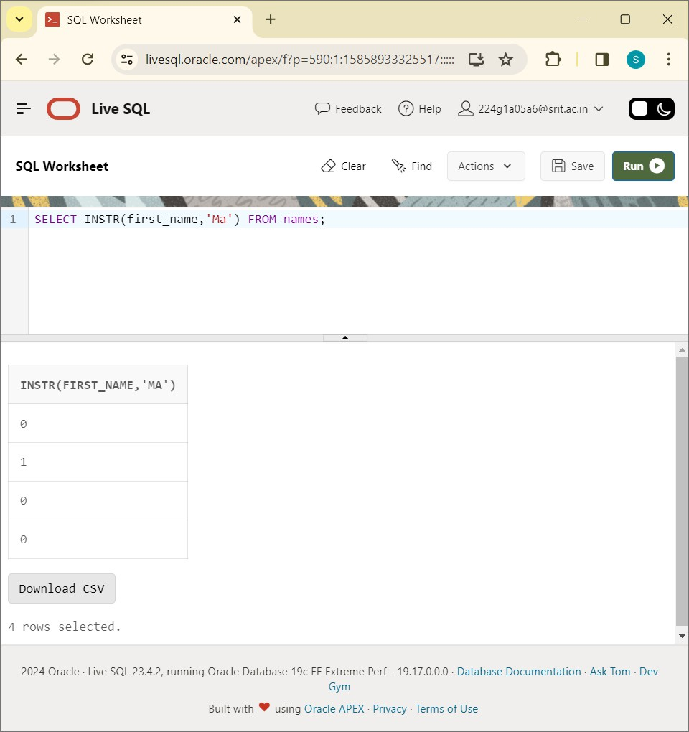

SELECT TRIM(' ' FROM first_name) FROM names:

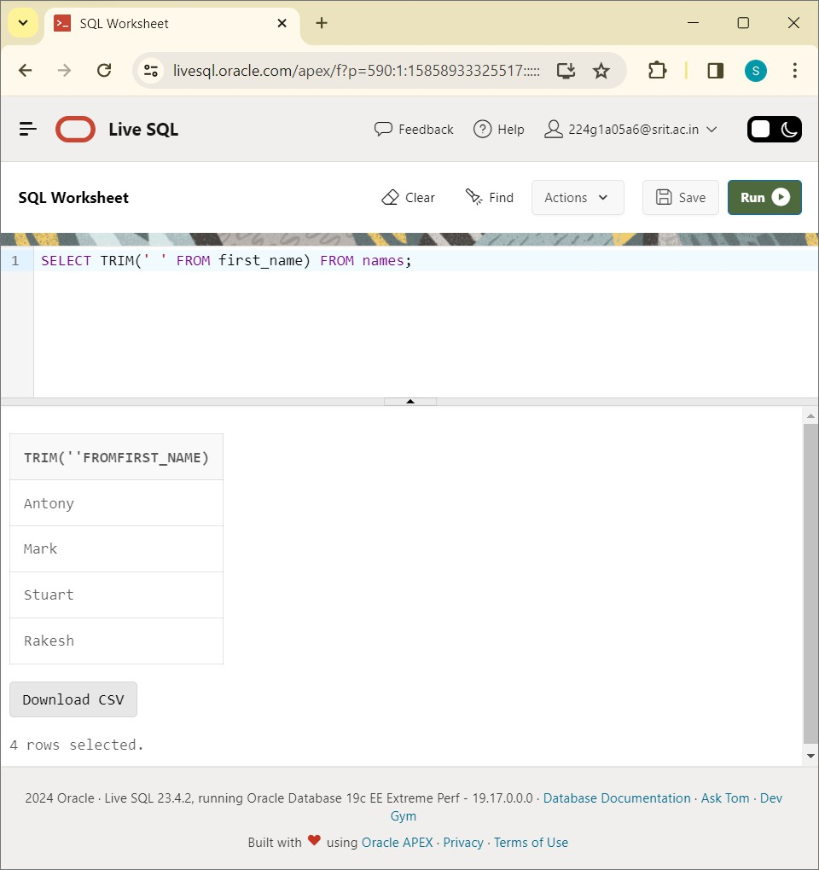

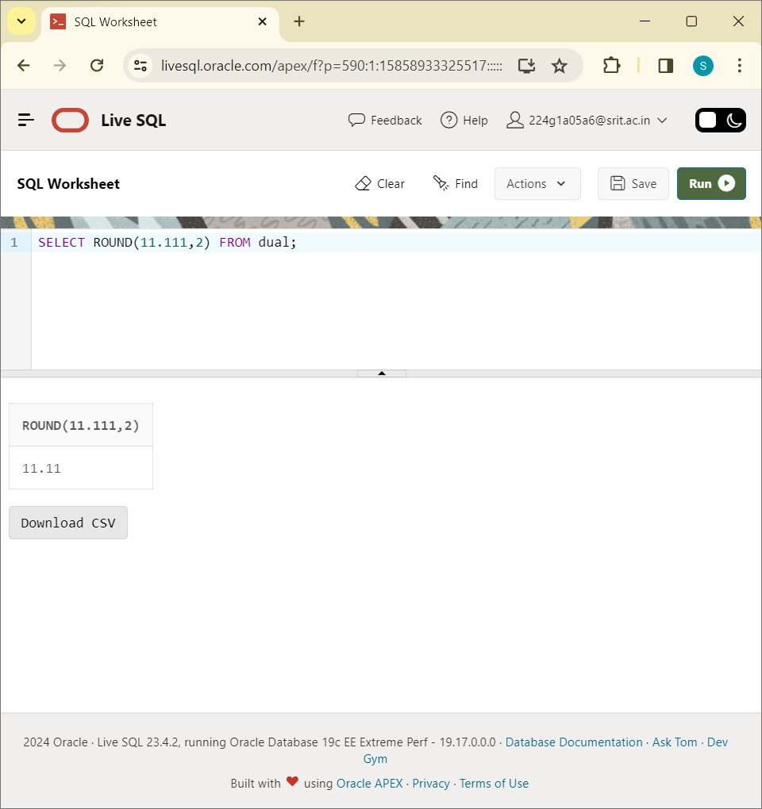

SELECT MOD(11,2) FROM dual:

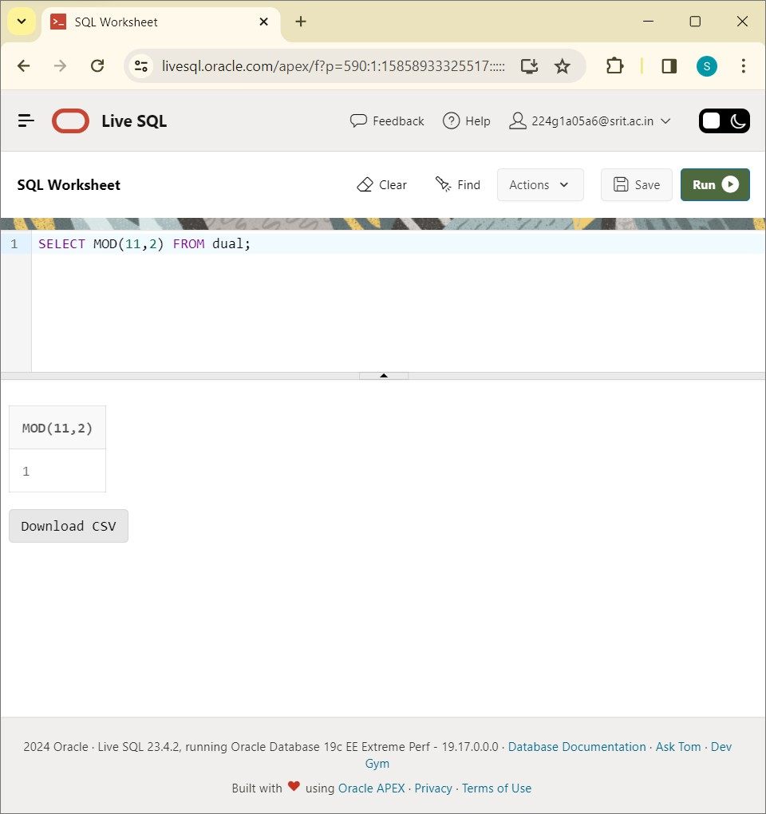

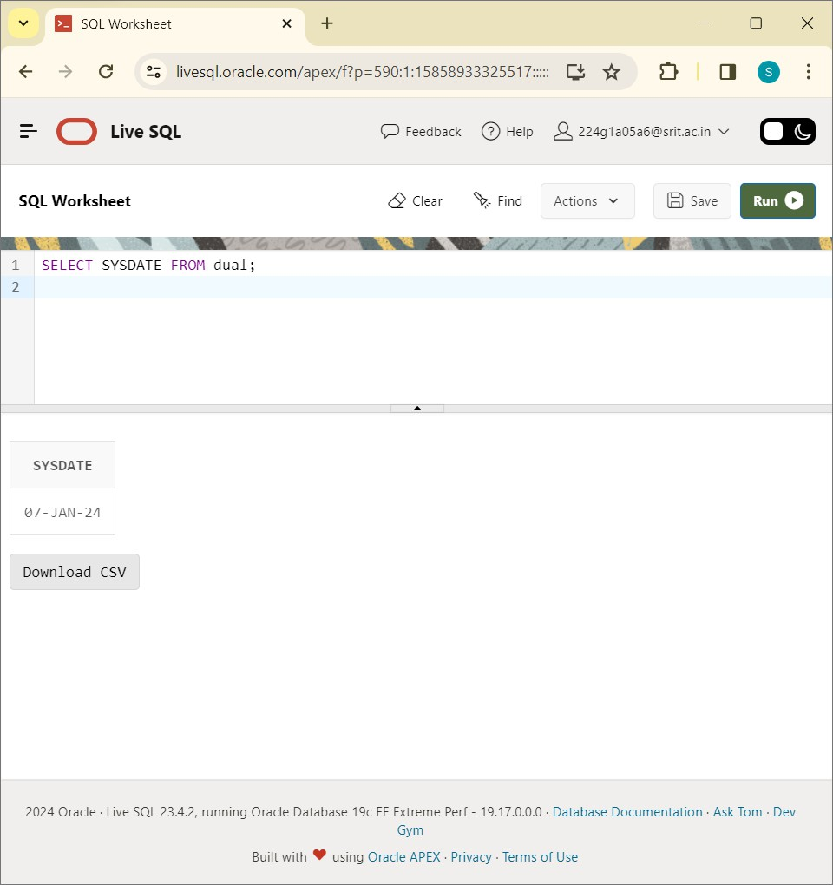

SELECT MONTHS_BETWEEN(SYSDATE,'08-DEC-2024') FROM dual:

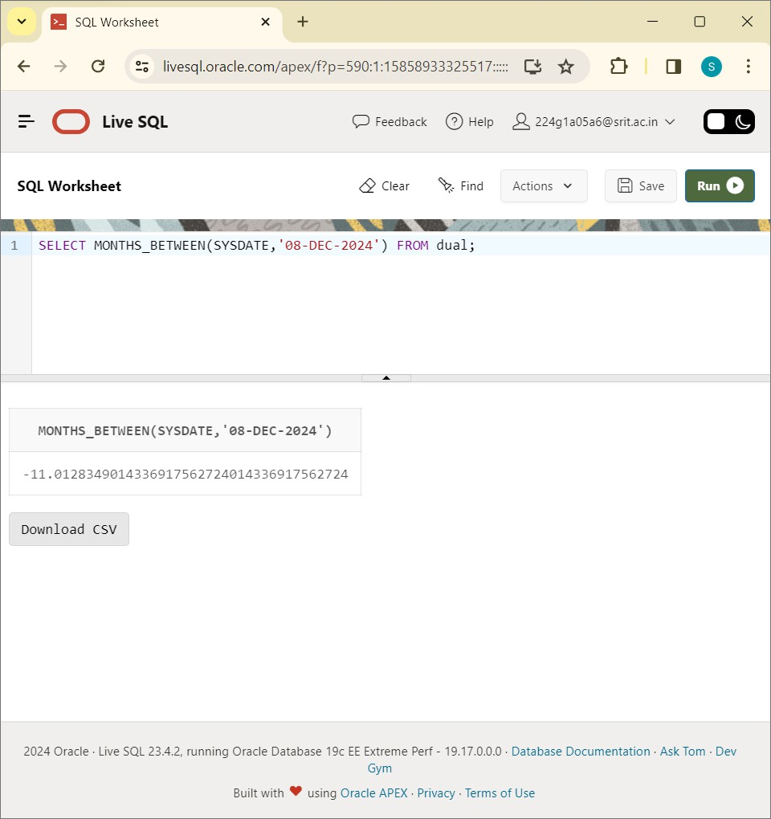

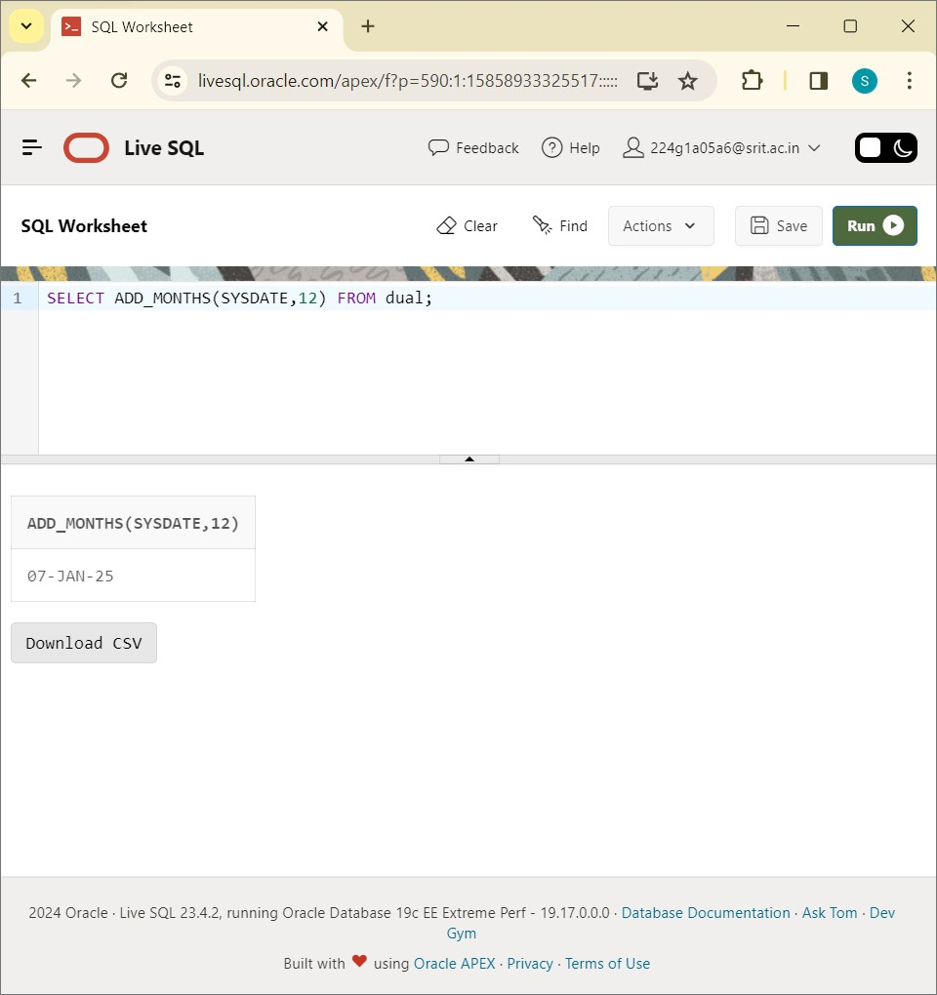

SELECT NEXT_DAY(SYSDATE,'MONDAY') FROM dual:

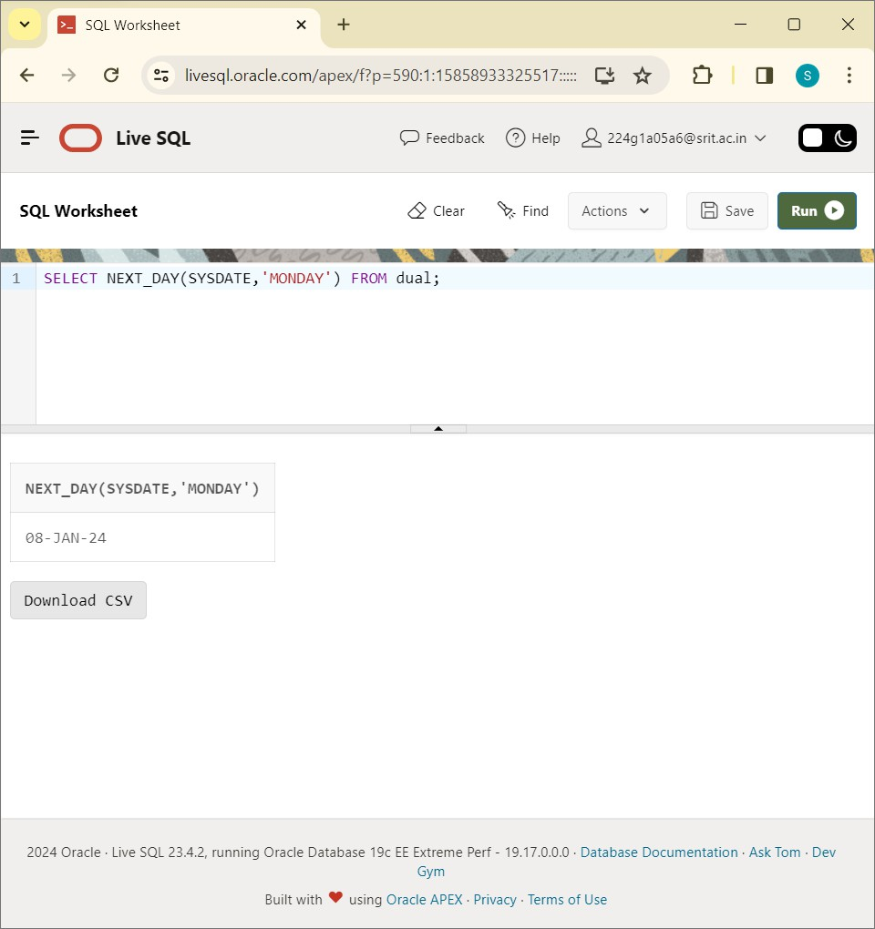

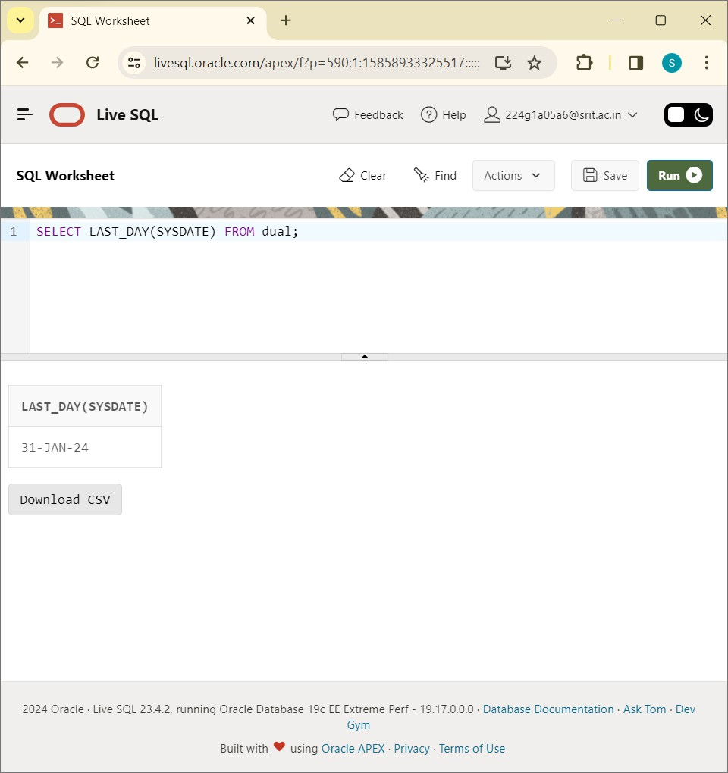

SELECT CURRENT_TIMESTAMP(3) FROM dual:

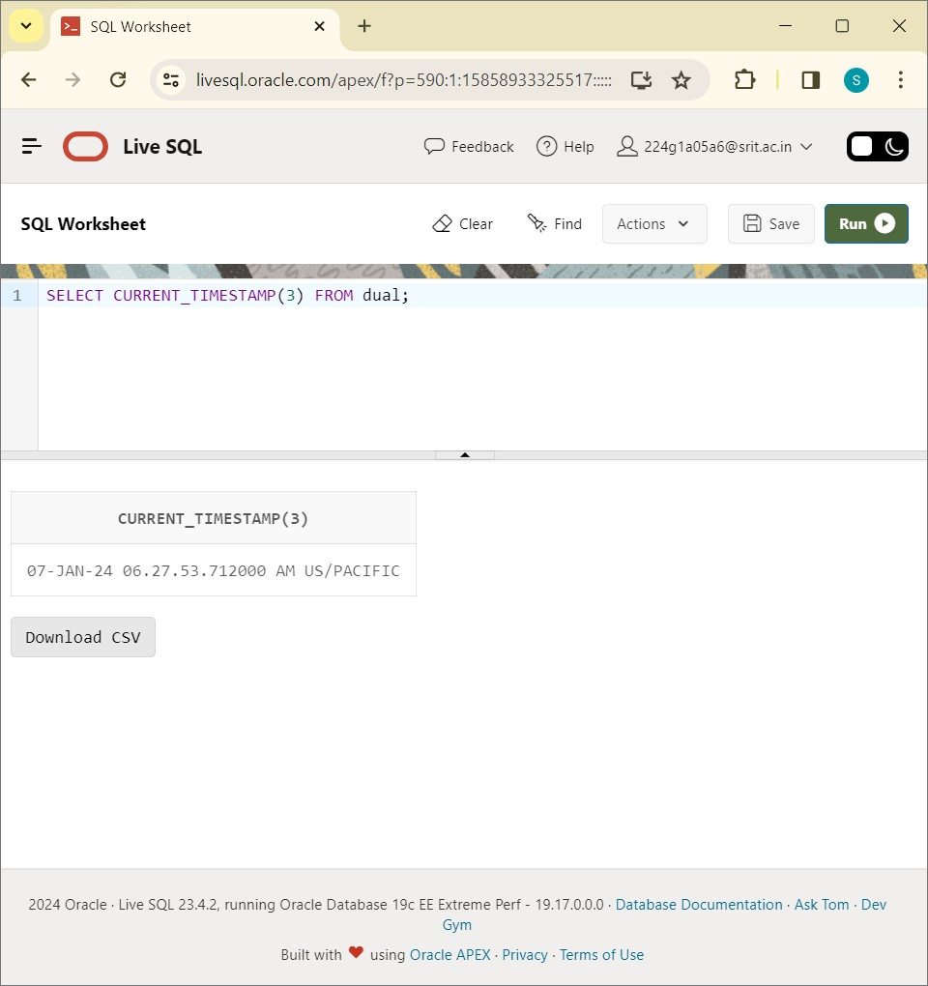

# EXPERIMENT-9

**Write SQL queries to perform KEY CONSTRAINTS (i.e. PRIMARY KEY, FOREIGN KEY, UNIQUE NOR NULL, CHECK, DEFAULT).**

CREATE TABLE stud:

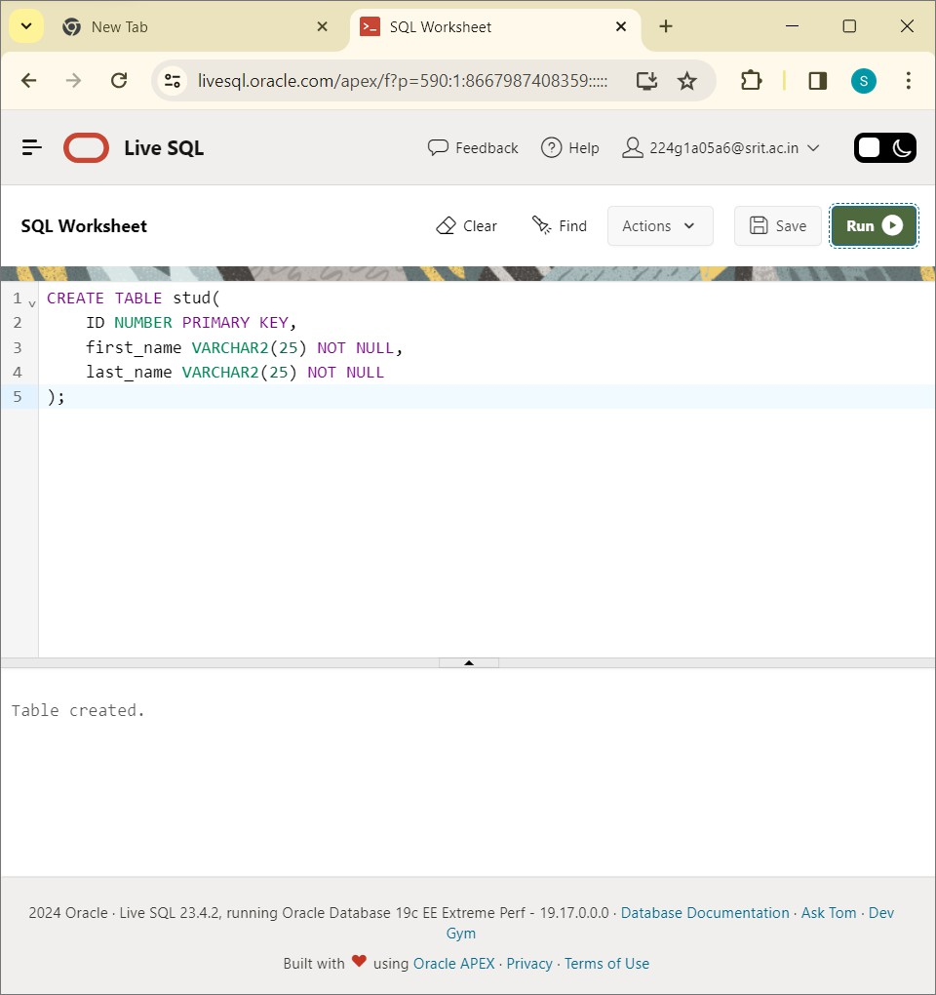

INSERT INTO stud VALUES:

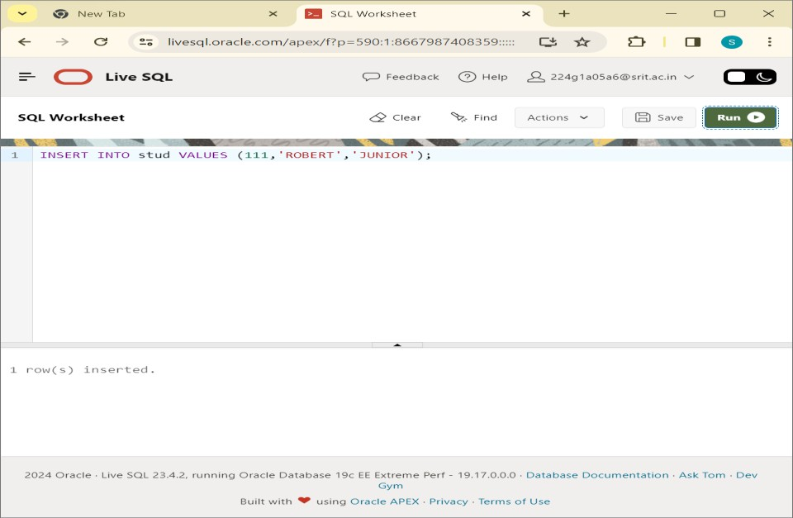

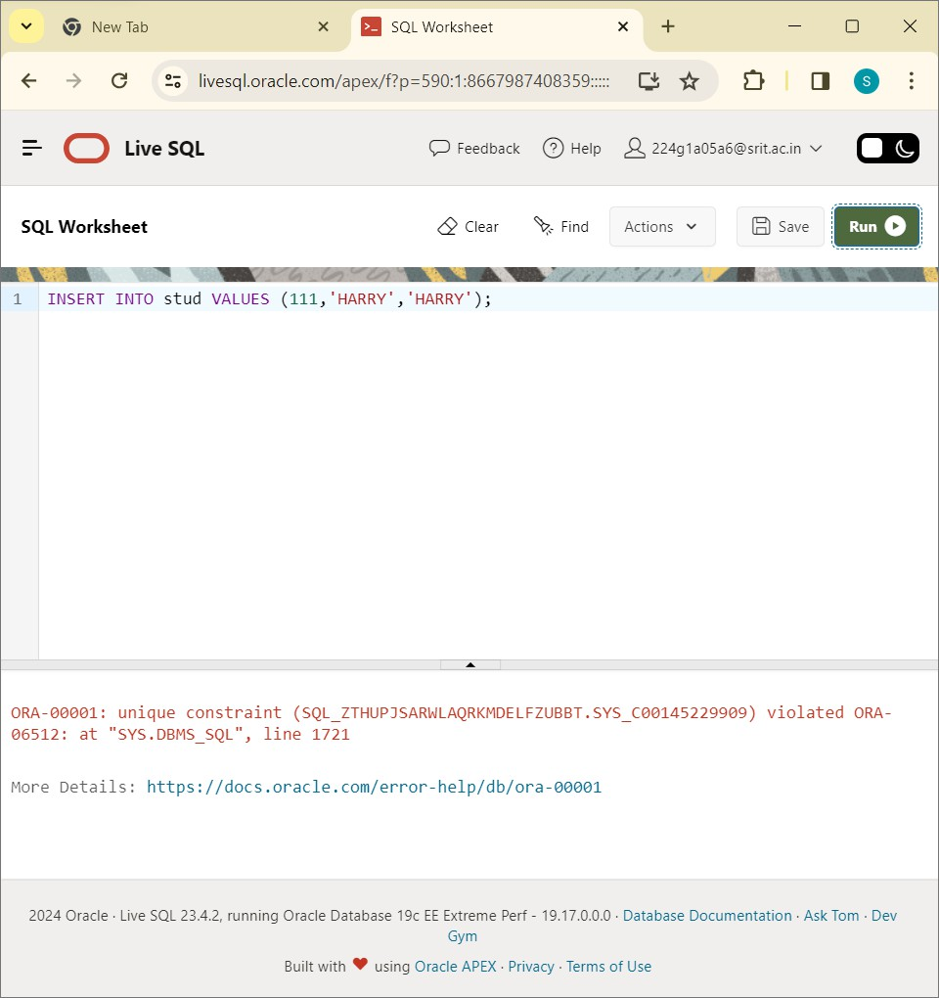

CREATE TABLE orders:

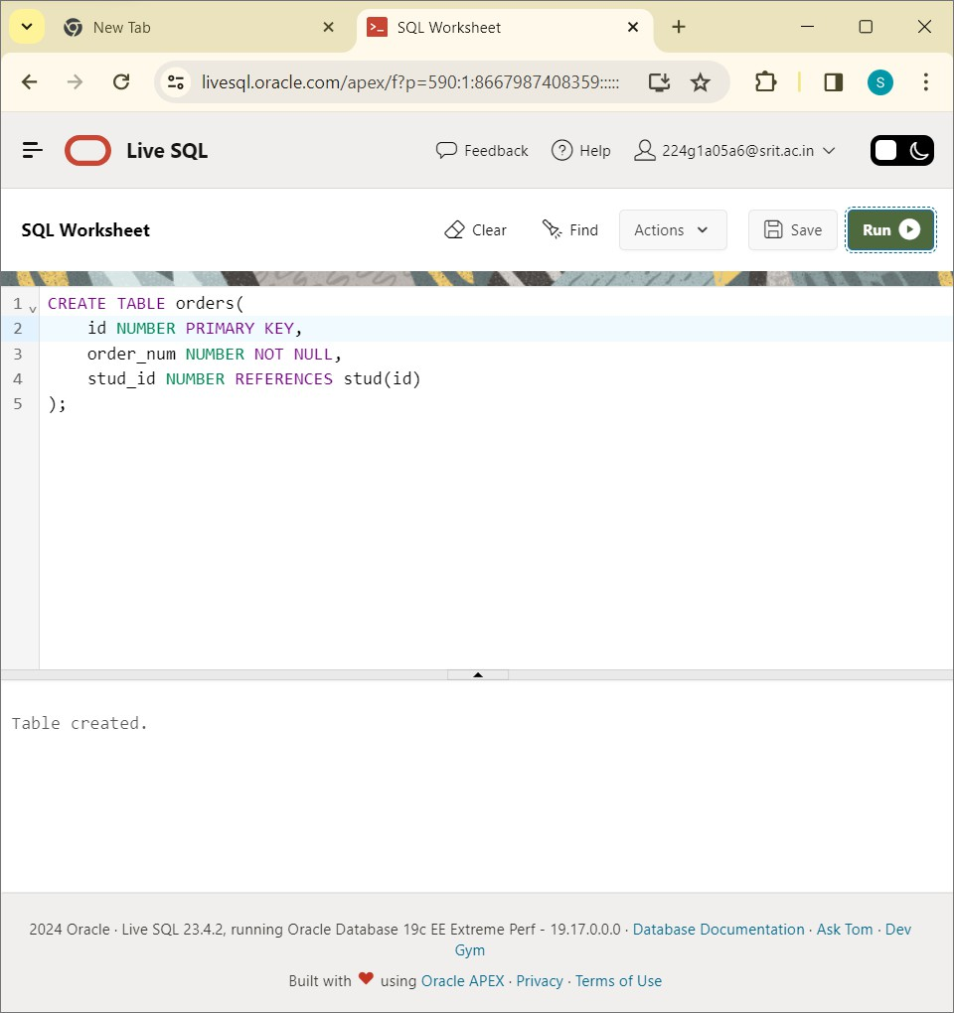

INSERT INTO orders VALUES:

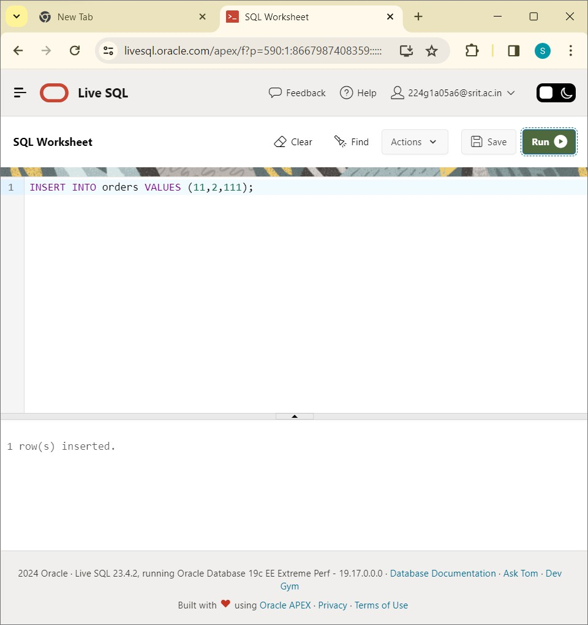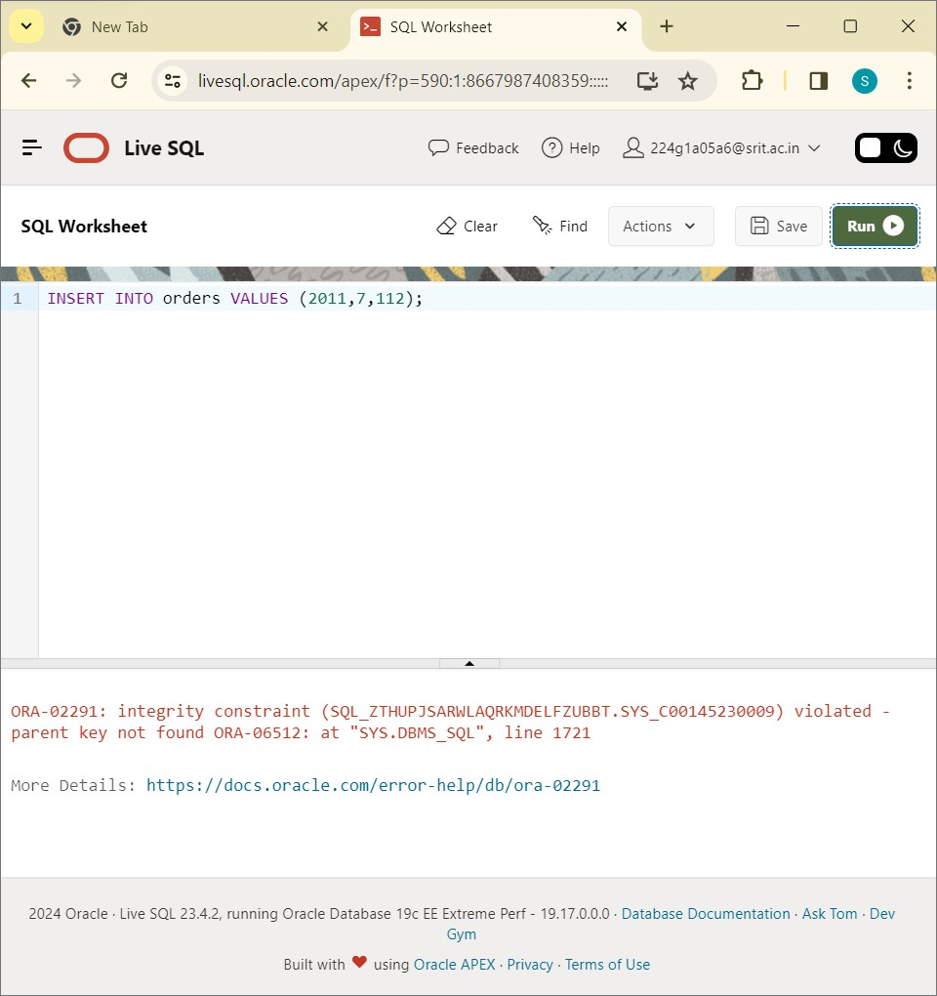

CREATE TABLE employees:

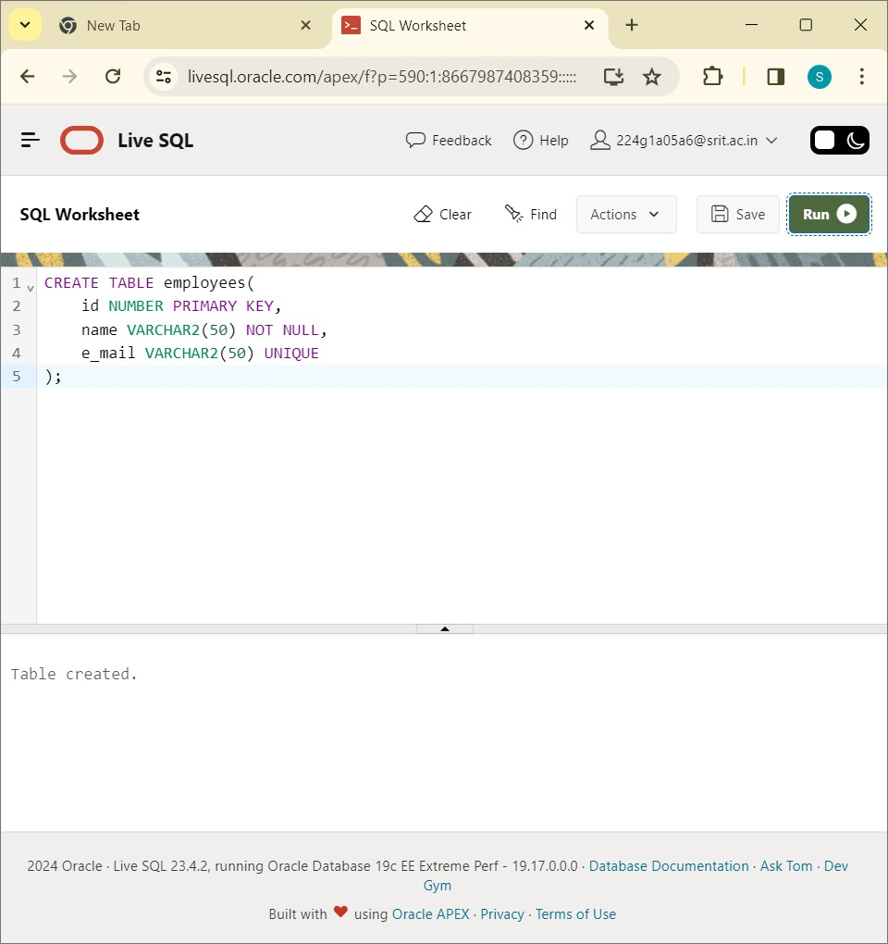

INSERT INTO employees VALUES:

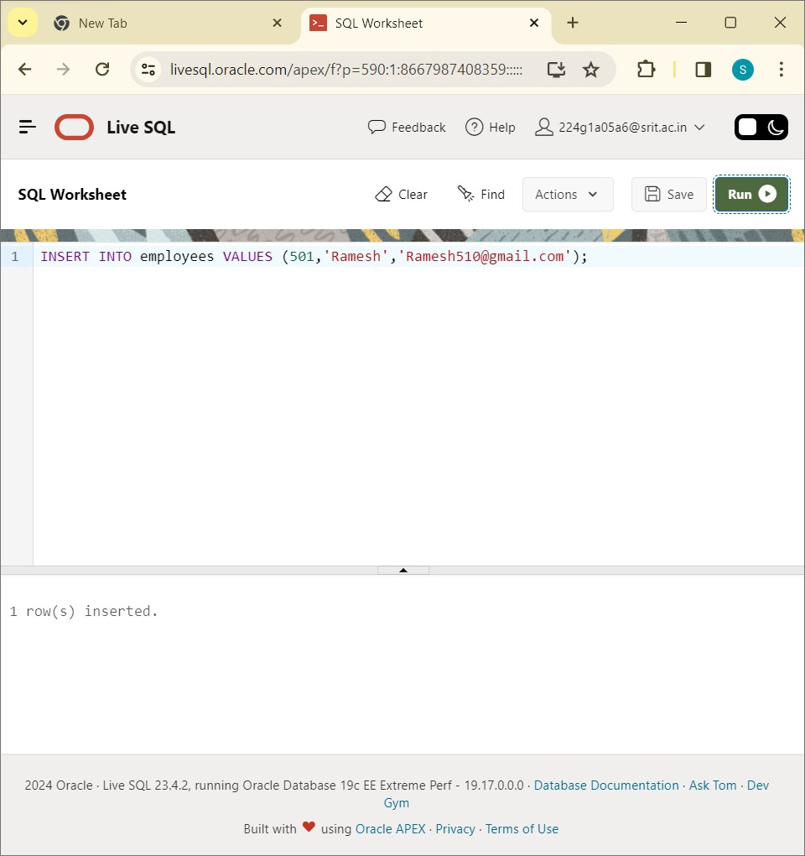

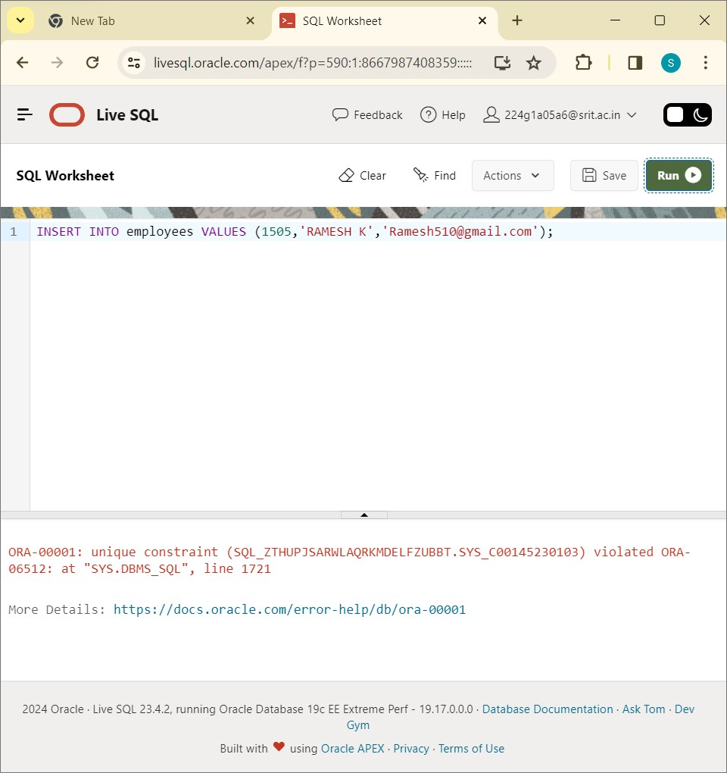

CREATE TABLE order1:

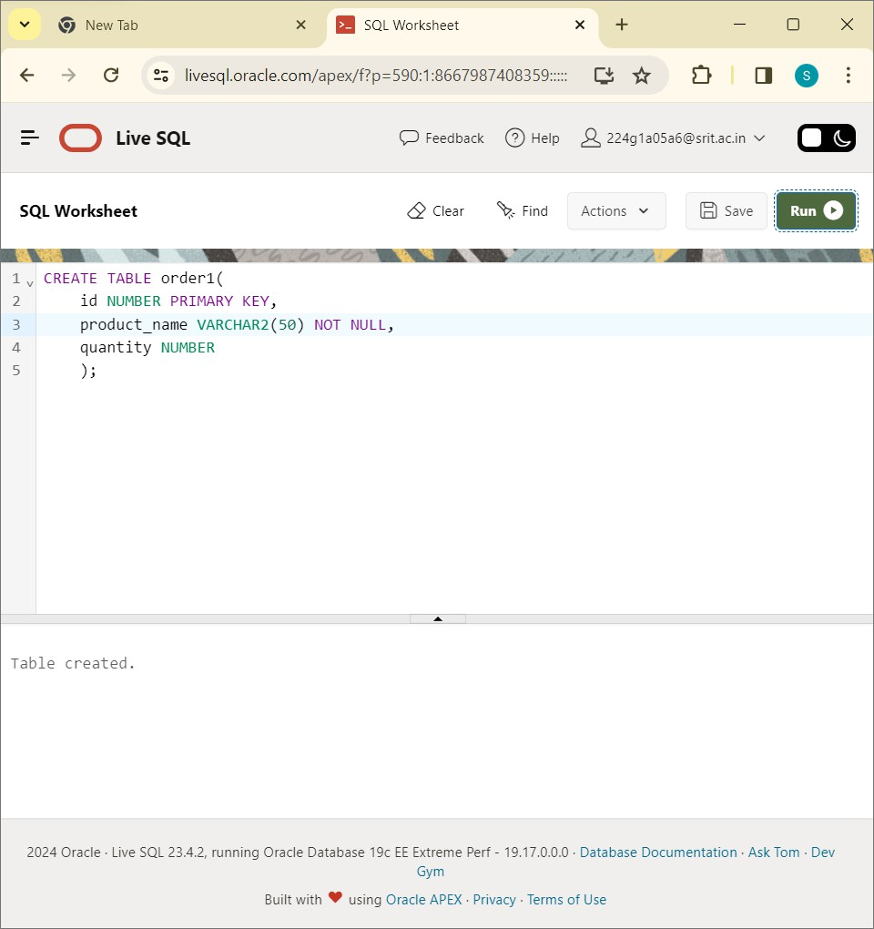

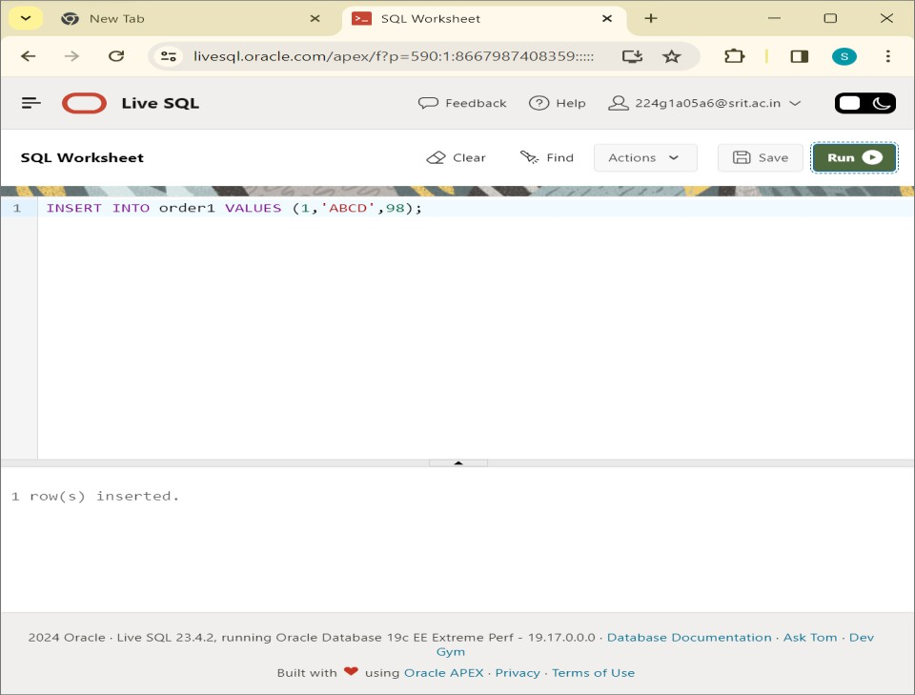

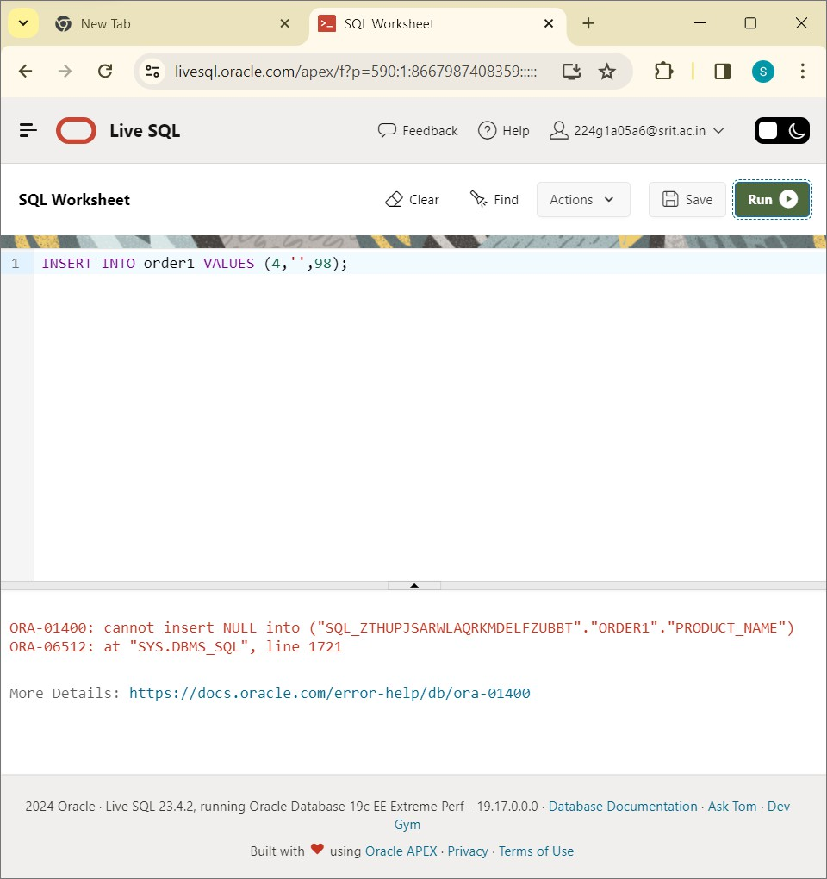

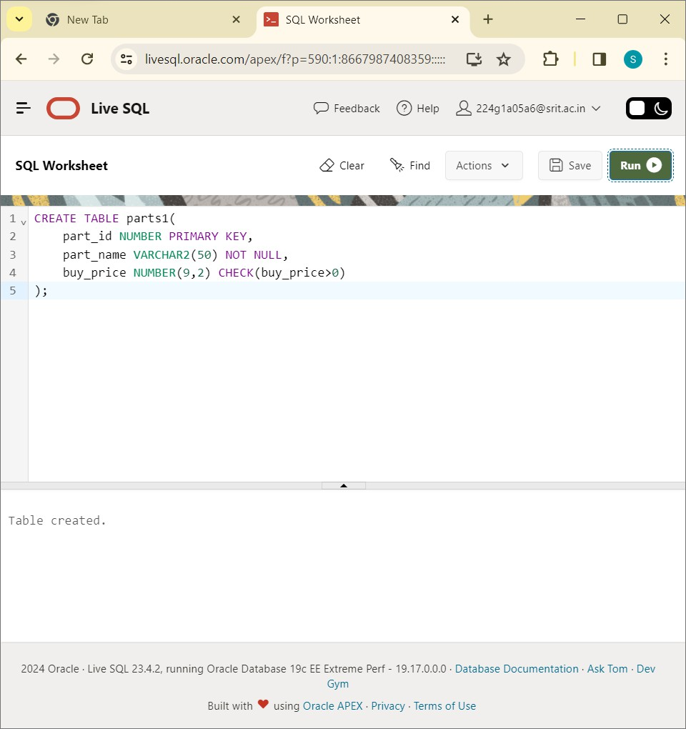

INSERT INTO parts1 VALUES:

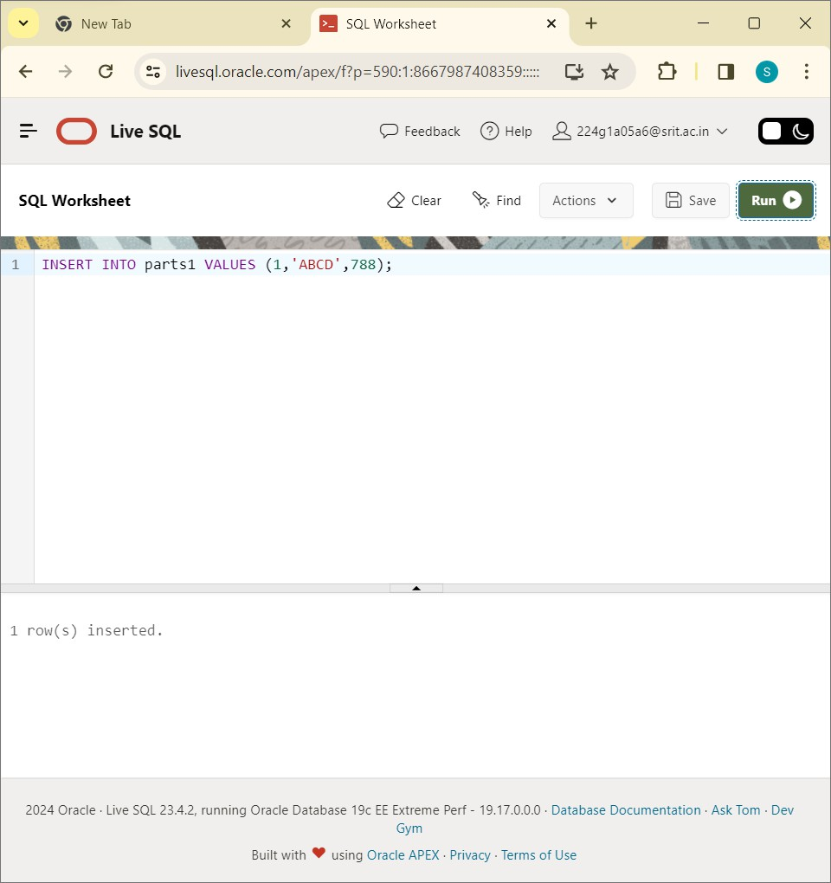

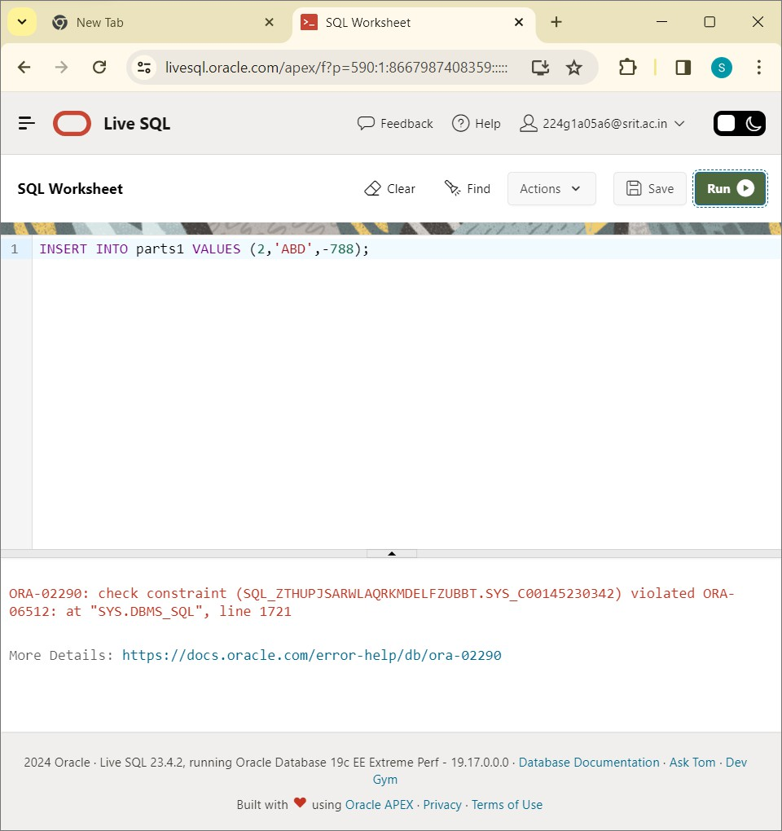

CREATE TABLE customers1:

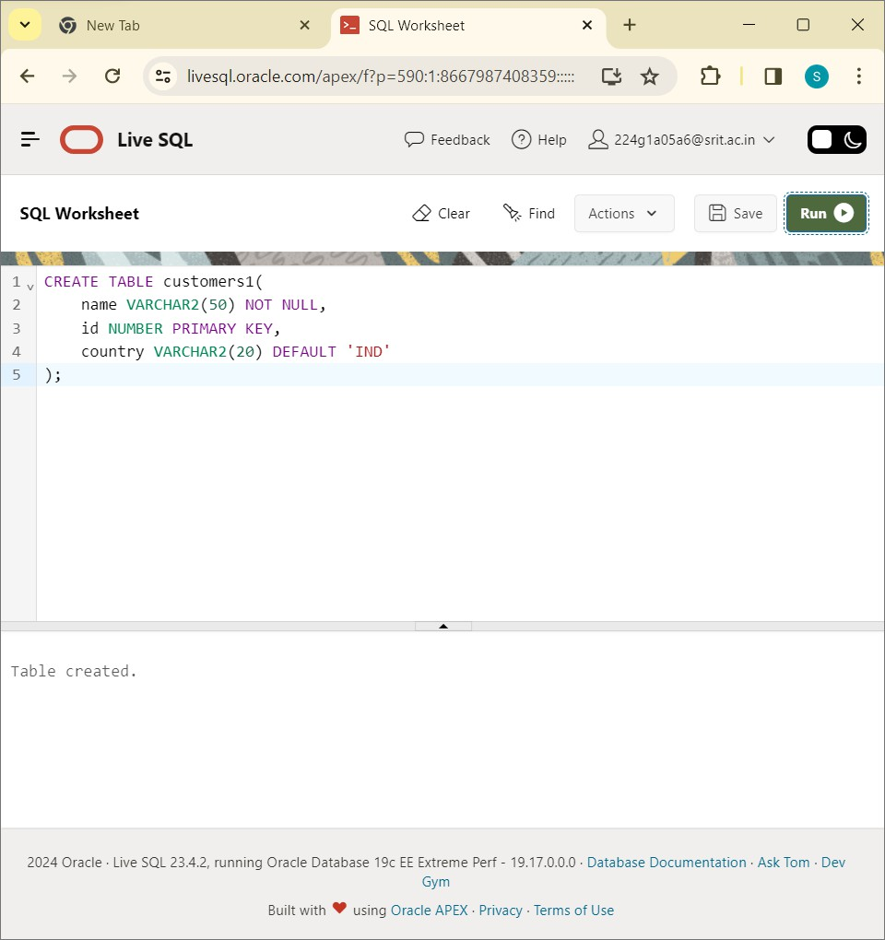

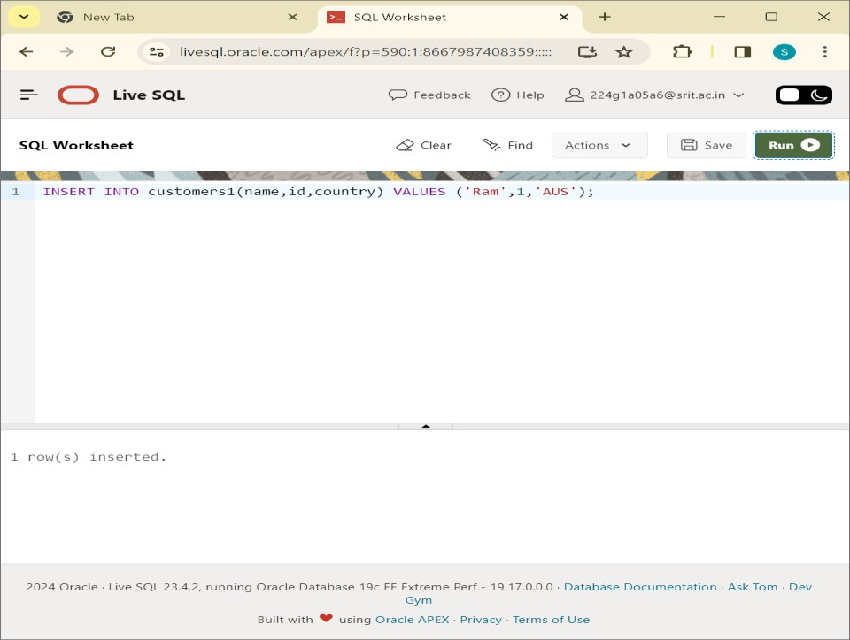

SELECT * FROM customers1:

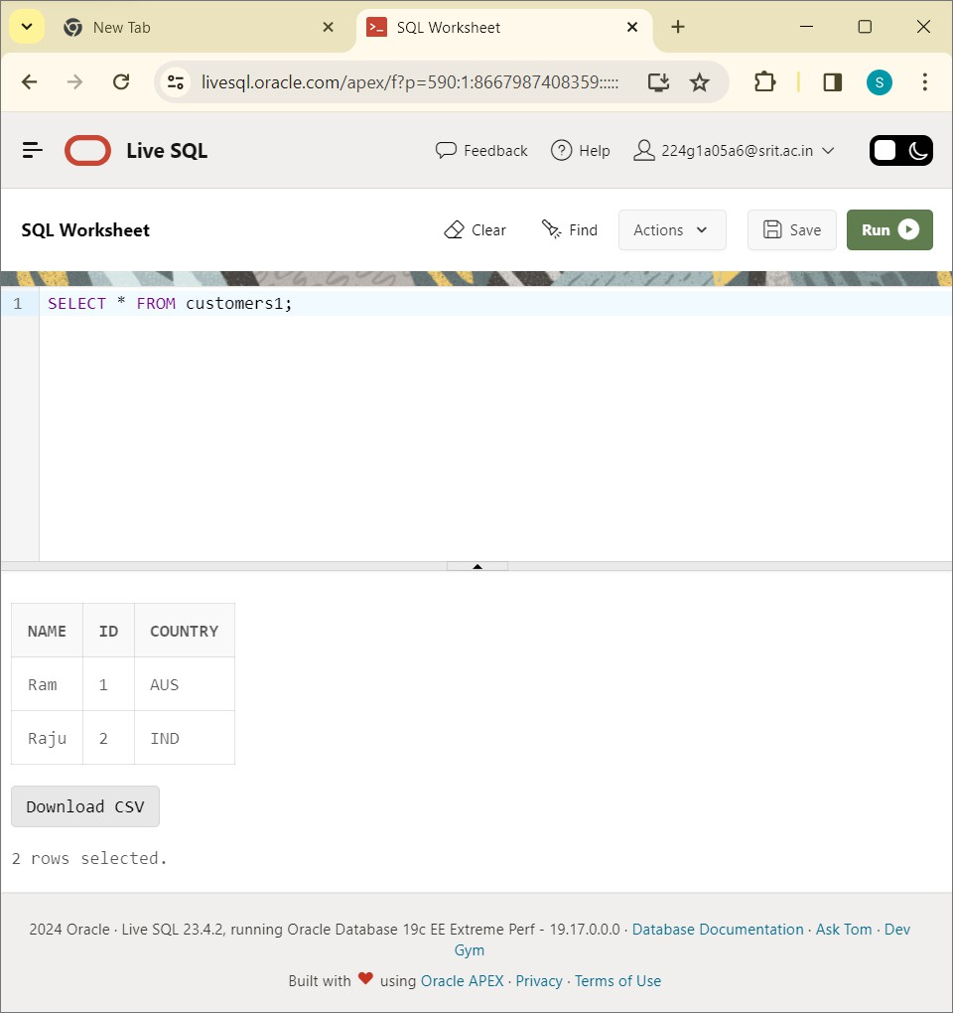

CONCLUSION: Write SQL Queries to perform Key Constraints is successfully executed.

Write PL/SQL for calculating the factorial of a given number?

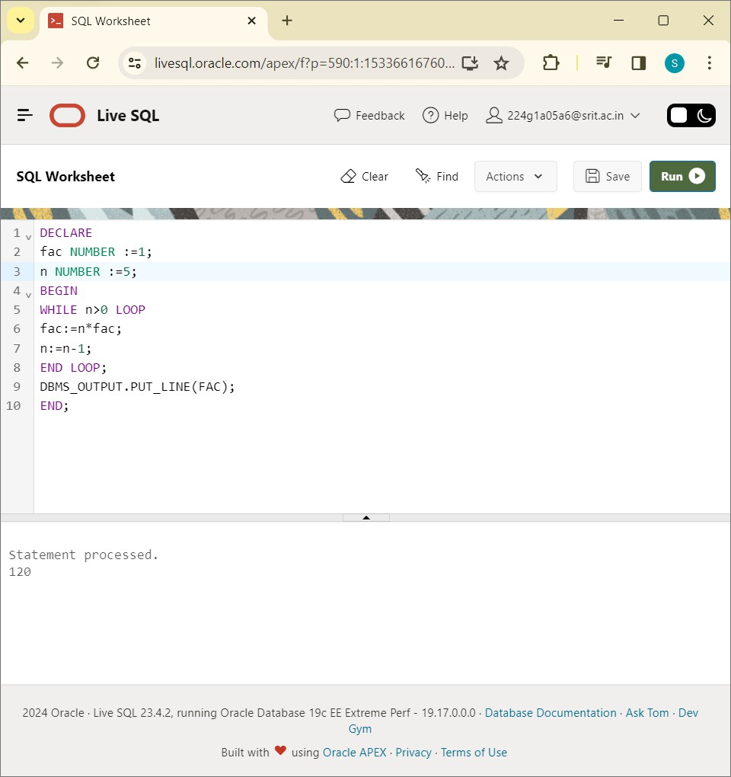

CONCLUSION: PL/SQL program for calculating the factorial of a given number is successfully executed in online live SQL plus.

Write a PL/SQL program for finding the given number is prime number or not?

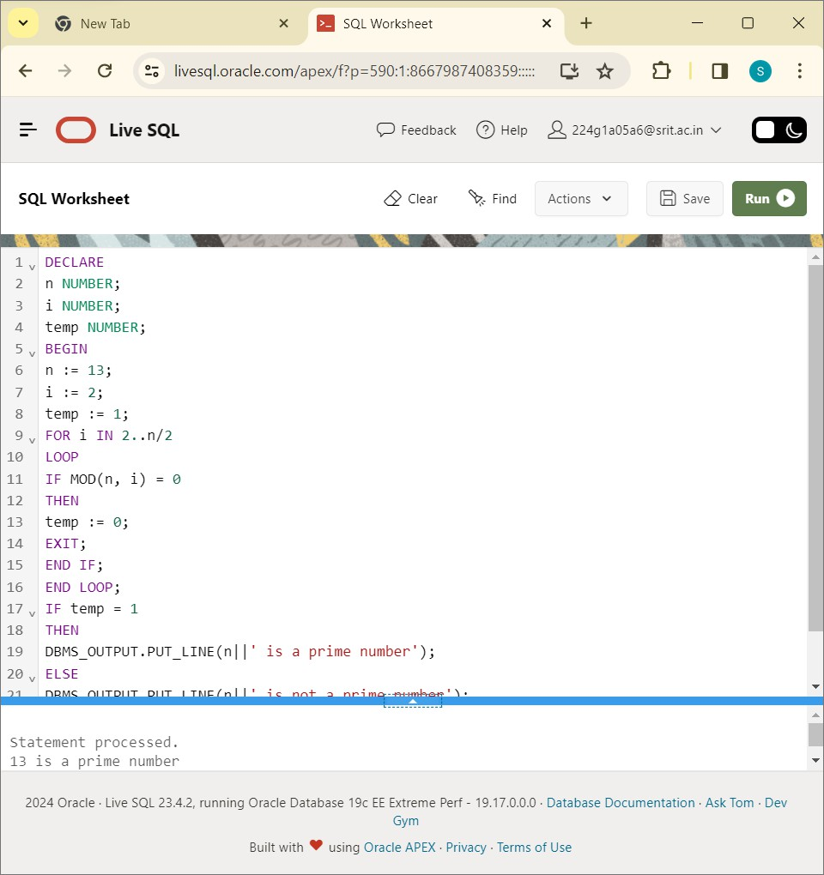

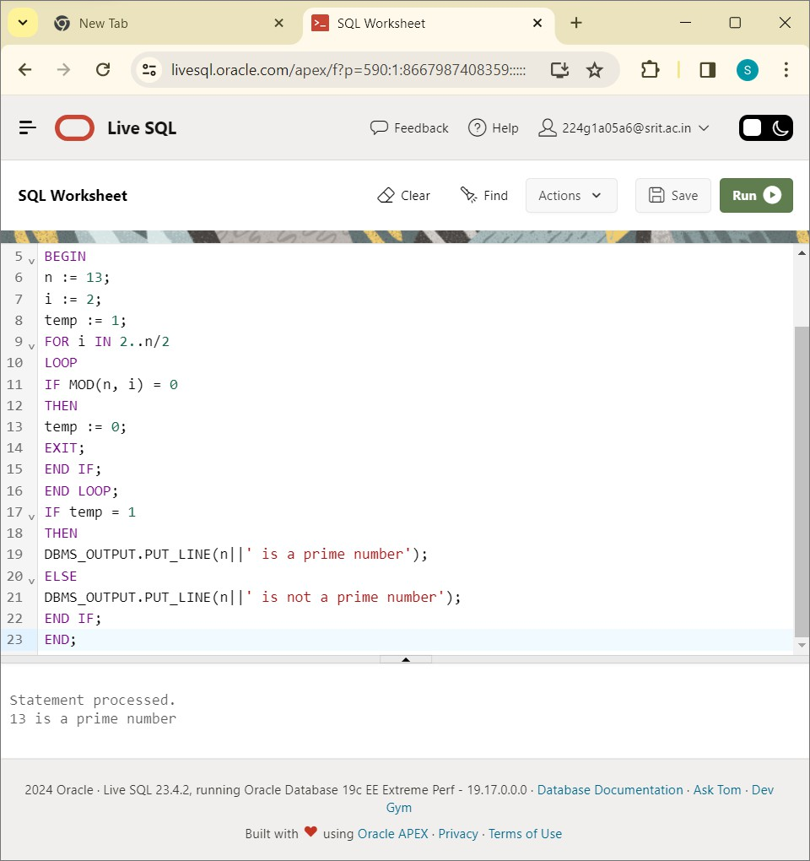

CONCLUSION: A PL/SQL Program for finding the given number is factorial number or not is successfully executed in live SQL plus.

224G1A05A6-M.SREENIVAS(CSE)

# EXPERIMENT-12

Write PL/SQL program for displaying the Fibonacci Series up to an integer.

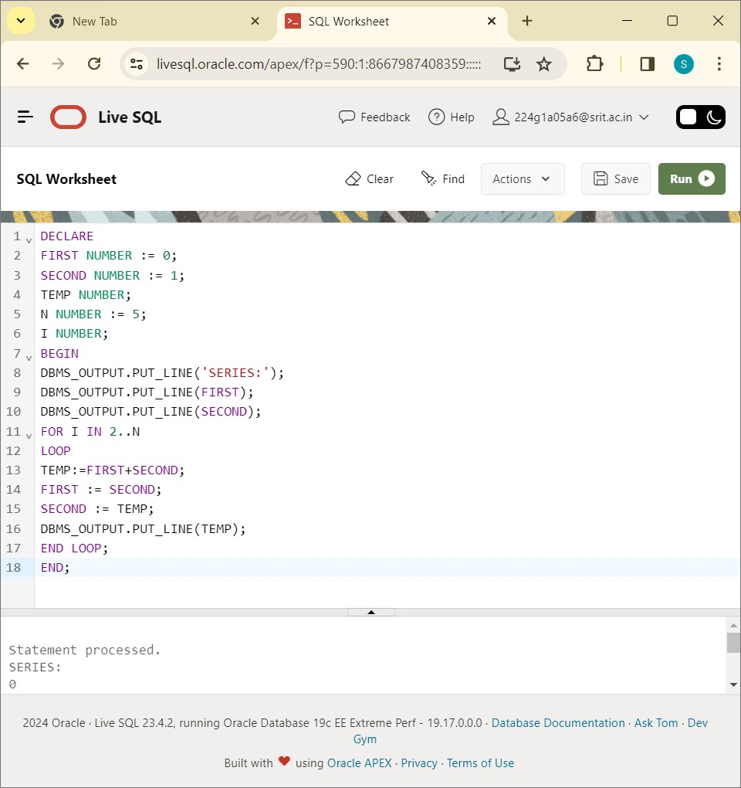

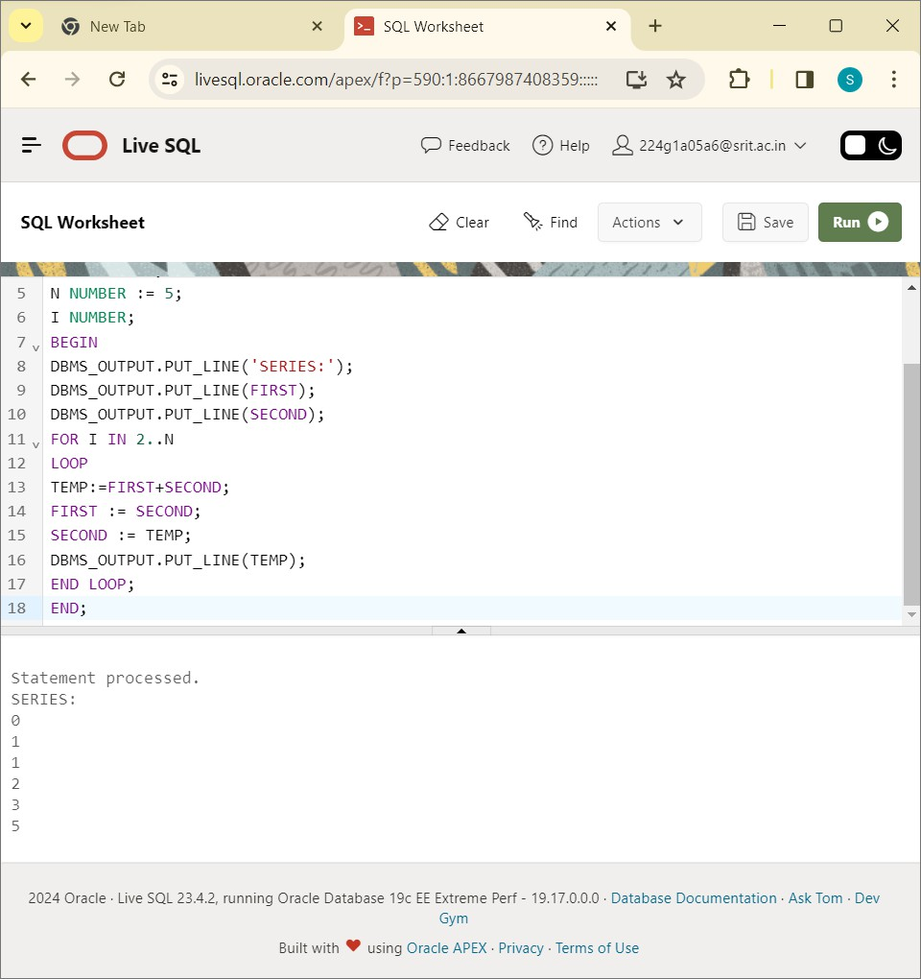

CONCLUSION: PL/SQL program for displaying the Fibonacci Series up to an integer is successfully executed in live SQL plus.

224G1A05A6-M.SREENIVAS(CSE)

# EXPERIIMENT-13

Write a PL/SQL program to implement Stored Procedure on table.

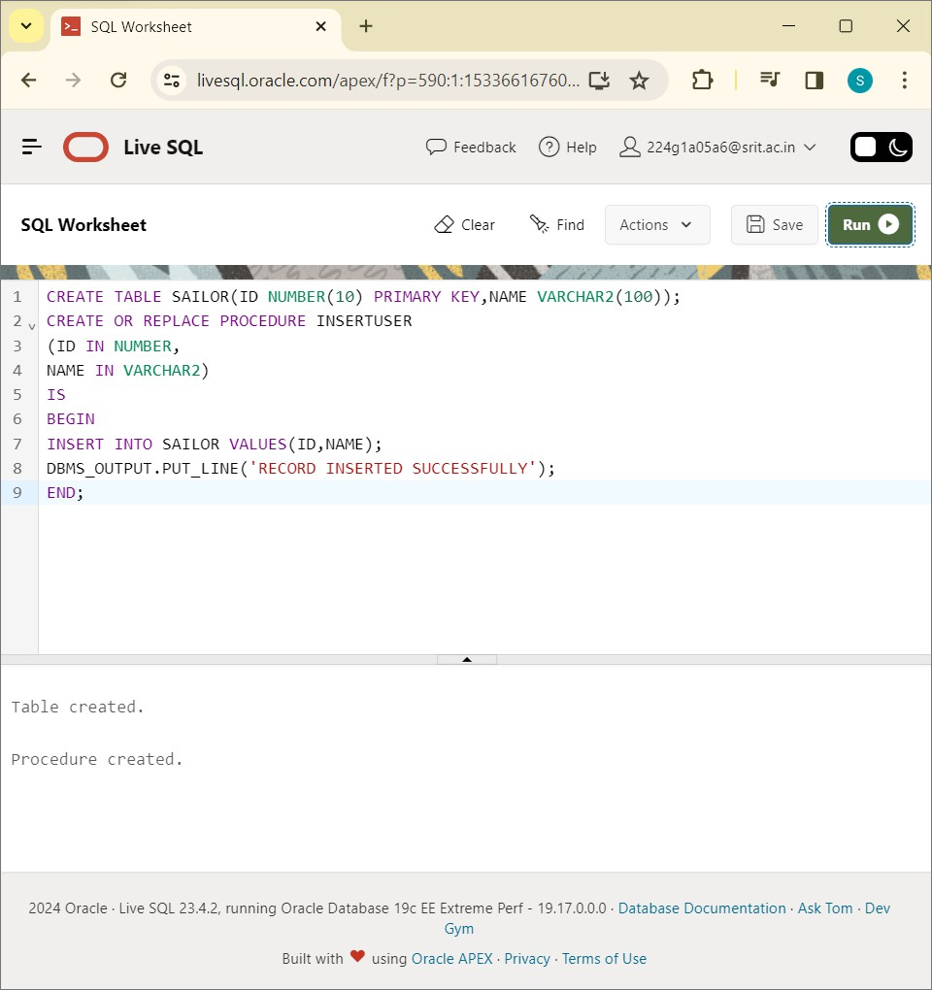

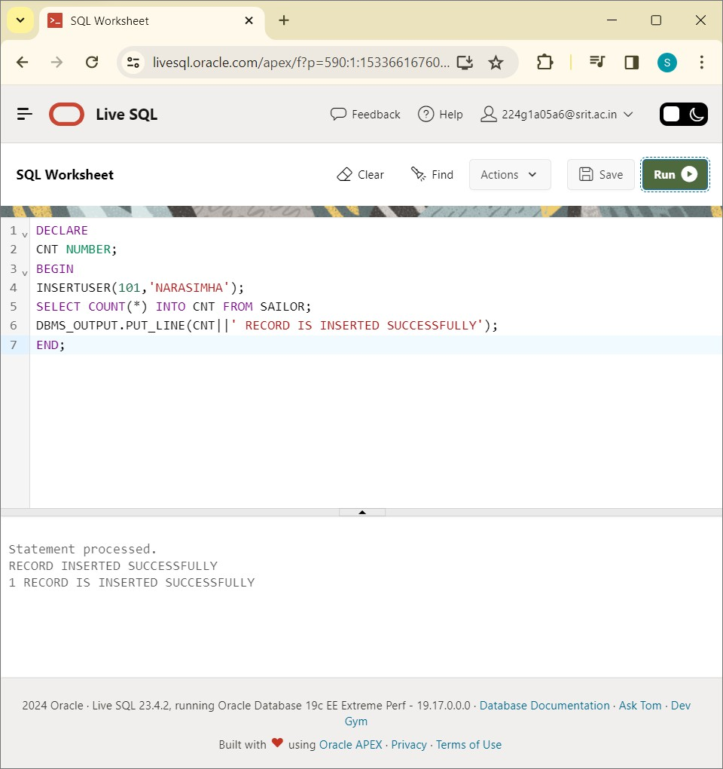

CONCLUSION: PL/SQL program to implement Stored Procedure on table is successfully executed in live SQL plus.

224G1A05A6-M.SREENIVAS(CSE)

# EXPERIMENT-14

Write PL/SQL program to implement Stored Function on table.

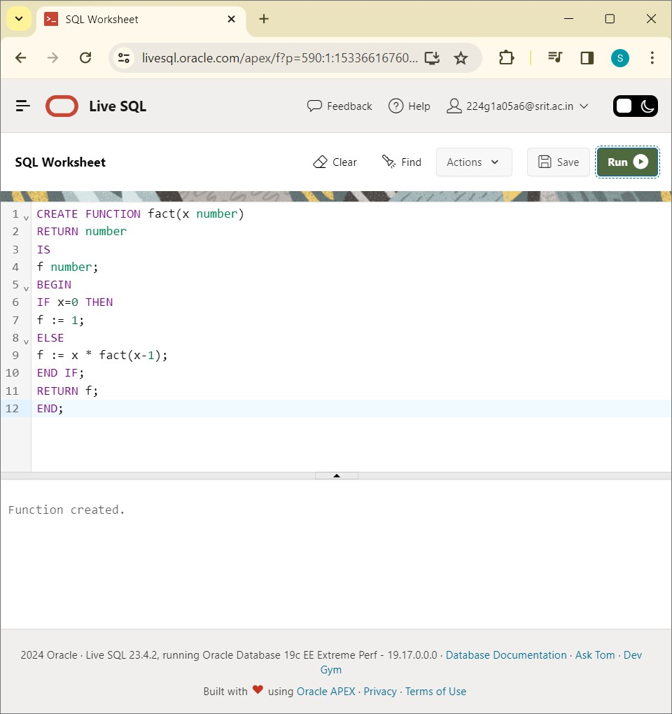

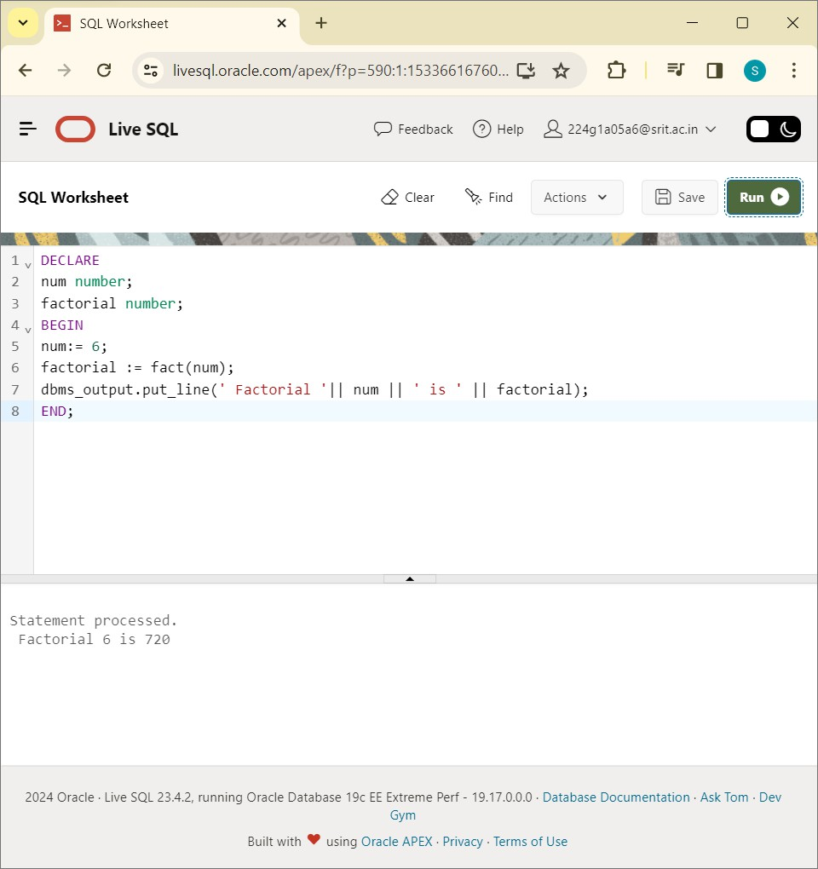

CONCLUSION: PL/SQL program to implement Stored Function on table is successfully executed in live SQL plus.

224G1A05A6- M.SREENIVAS (CSE)

# EXPERIMENT-15

Write PL/SQL program to implement Trigger on table. Create table instructor:

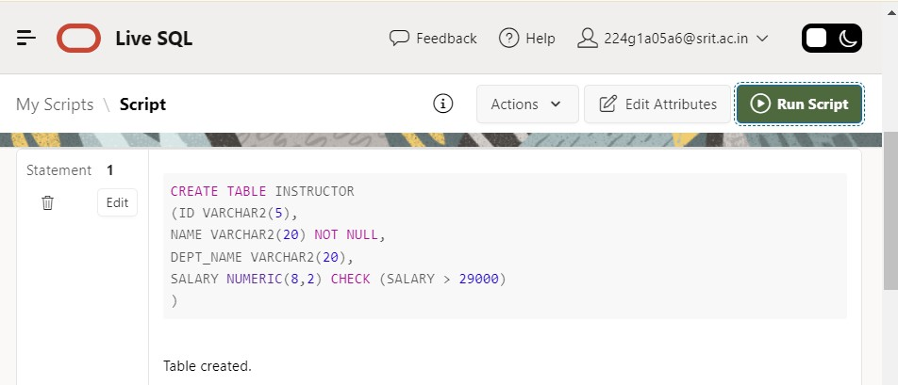

INSERT VALUES INTO TABLE INSTRUCTOR:

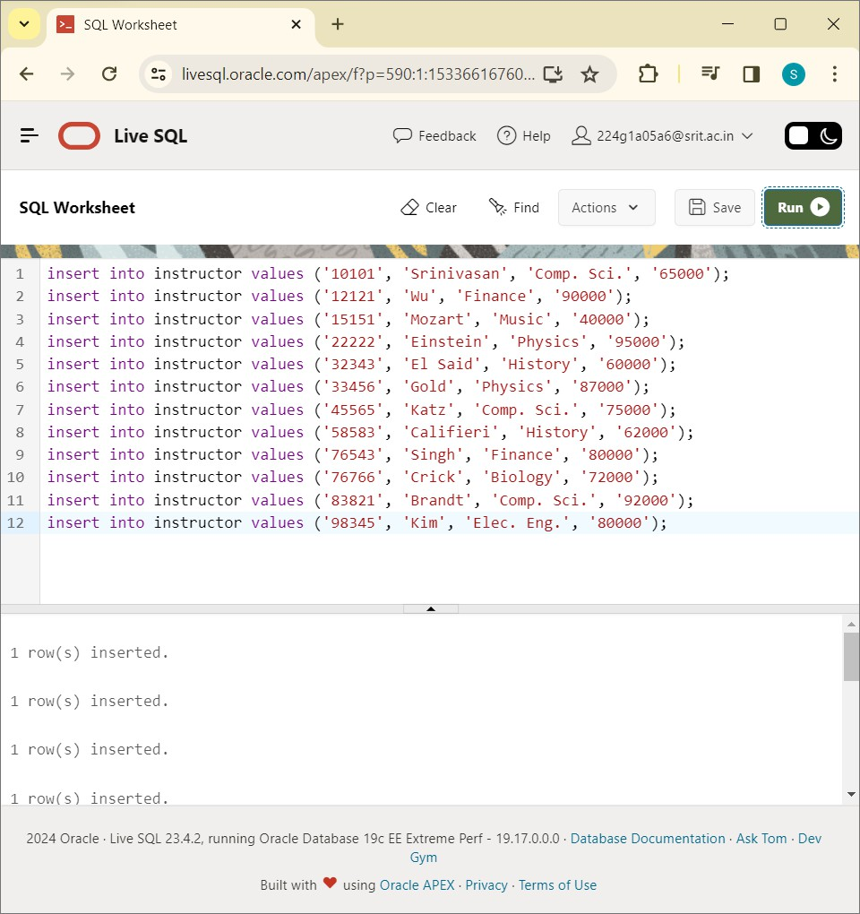

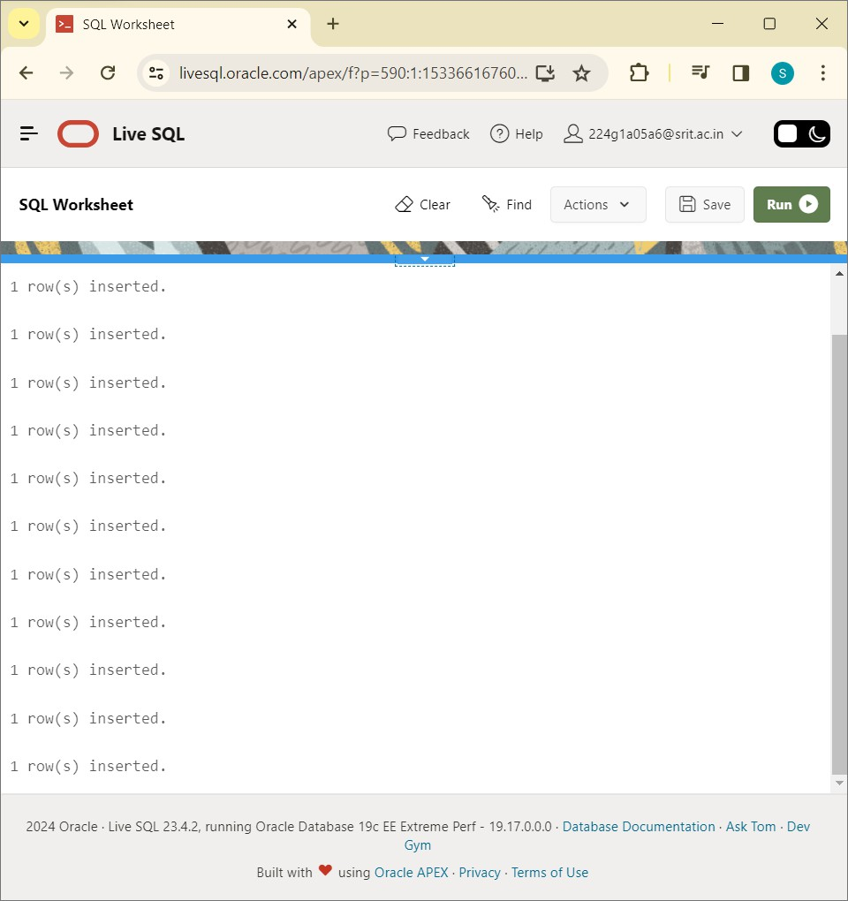

Replace trigger:

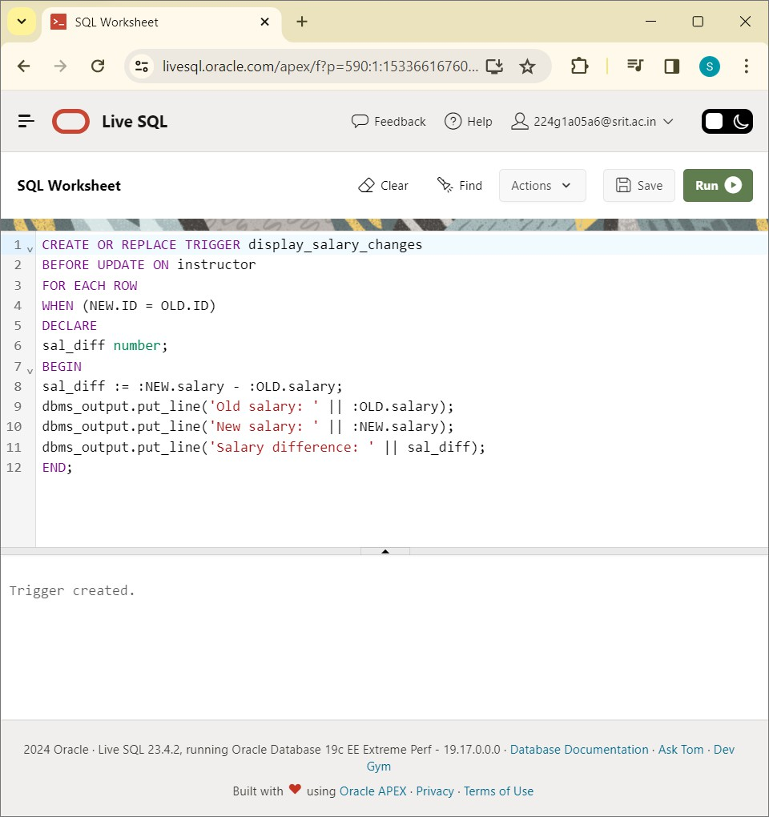

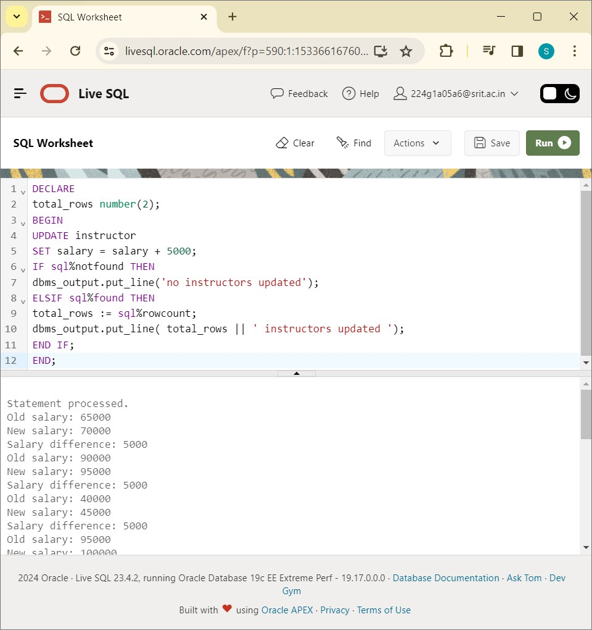

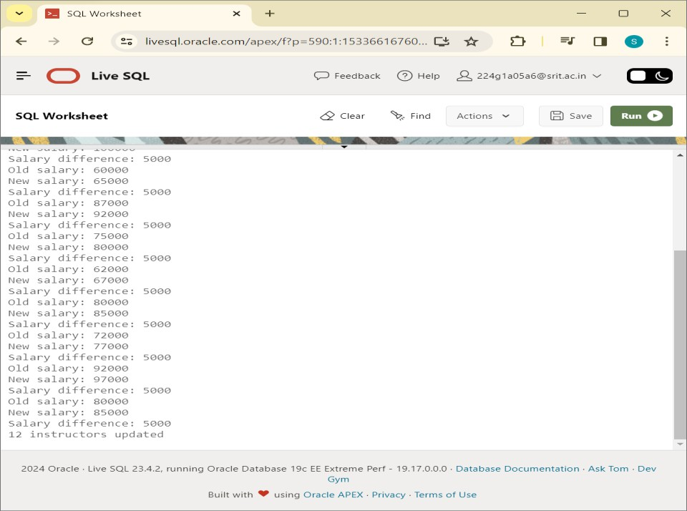

Conclusion: PL/SQL program to implement Trigger on table is successfully executed.

# EXPERIMENT-16

Write PL/SQL program to implement Cursor on table.

Create table customer:

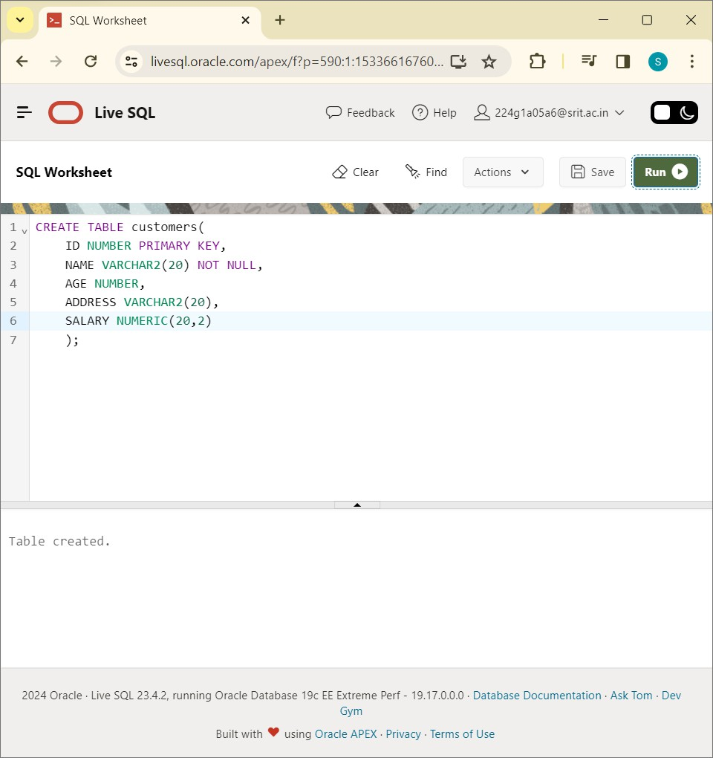

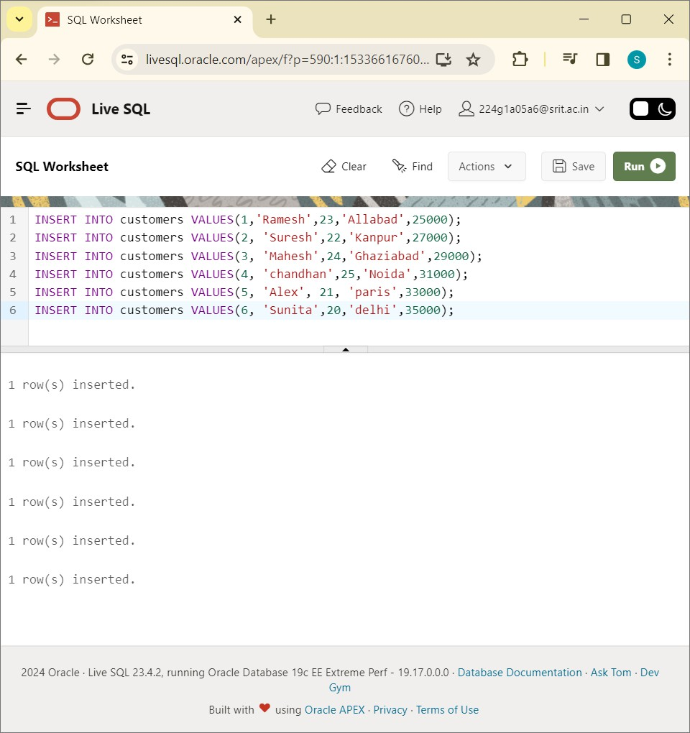

Declare Cursor:

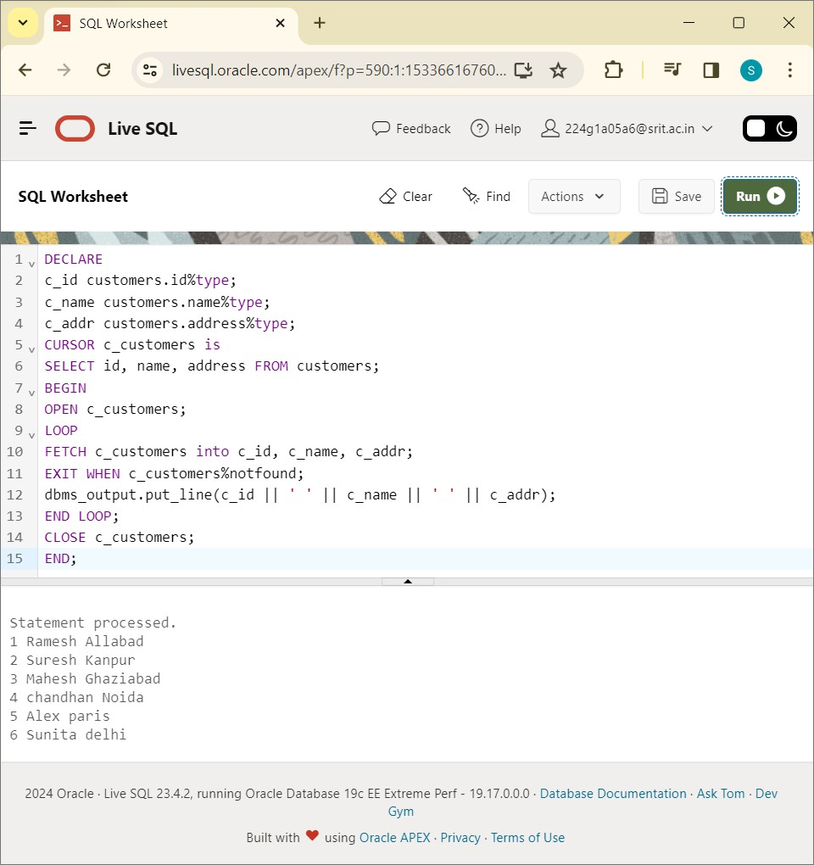

CONCLUSION: PL/SQL program to implement Cursor on table is successfully executed.